Kislev
כסלו

Dates to Note
1: Rosh Chodesh
25: Chanuka Begins

*9-10: Birthday & Passing of 2nd Chabad Rebbe
*14: Anniversary of Rebbe & Rebbetzin
*19: “Rosh Hashana” for Chabad Philosophy

I. The “Invisible”

My friend, my student, my child – is giving me bad vibes. It is totally “invisible”. How can I properly explain why I am hurt? Should I?
________________________________________________________________________
________________________________________________________________________

II. Theme of Kislev


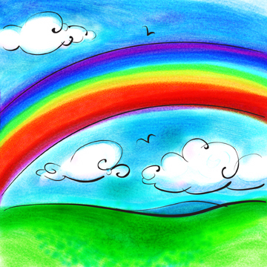 ס

(The Astrological Sign)
The Bow: ______________________________________________________________
The Rainbow: ___________________________________________________________

Genesis: Chapter 8: 20. And Noah built an altar to the Lord, and he took of all the clean animals and of all the clean fowl and brought up burnt offerings on the altar.
Genesis: Chapter 9: 12. And God said: "This is the sign of the covenant, which I am placing between Me and between you, and between every living soul that is with you, for everlasting generations. 13. My rainbow I have placed in the cloud, and it shall be for a sign of a covenant between Myself and the earth.

Samach – ס: _____________________________________________________________

כס – Kes: ______________________________________________________________
לו – Lo: _________________________________________________________________

Dreams in the Torah: 9 out of the 10 Dreams recorded in the Torah are read during the month of Kislev: Yaakov’s 2 dreams, Lavan’s dream, Yosef’s 2 dreams, the 2 dreams of Pharaoh’s ministers, Pharaoh’s 2 dreams…

The Theme: ____________________________________________________________ ________________________________________________________________________
________________________________________________________________________

Homework:
________________________________________________________________________
________________________________________________________________________

III. The Chassidic Month

What is “Chassidus”? (Interpreting the Dreams…) ________________________________________________________________________
________________________________________________________________________

Birth and Passing of the 2nd Chabad Rebbe
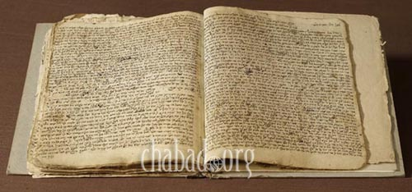
________________________________________________________________________
________________________________________________________________________
________________________________________________________________________

Anniversary of the Rebbe and Rebbetzin Chaya Mushka
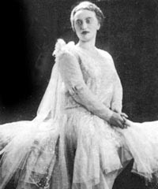
________________________________________________________________________
________________________________________________________________________
________________________________________________________________________

Rosh Hashana for Chabad Chassidus
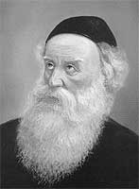
________________________________________________________________________
________________________________________________________________________
________________________________________________________________________

Pearls & Coals: __________________________________________________________
________________________________________________________________________

Homework:
________________________________________________________________________
________________________________________________________________________

