Av
אב

Dates to Note
1 Av: Rosh Chodesh, The 9 Days begin
9 Av: Fast Day
15 Av: Tu B’Av

I. Struggling with Belief

Most of us struggle with believing in Moshiach, rebuilding of the Holy Temple, the Resurrection of the Dead… What do you think makes these ideas challenging to believe? ________________________________________________________________________
________________________________________________________________________

III. G-ds Presence in Exile

Teacher/Pupil: ___________________________________________________________
________________________________________________________________________

Talmud: “When the pagans entered the Holy Temple, they saw the cherubs cleaving to each other. They took them out to the streets and said: ‘These Jews ... is this what they occupy themselves with?’ With this, they debased [the Jewish people], as it is written: ‘All who had honored her have despised her, for they have seen her nakedness.’”

Our Question on this piece of Talmud: ________________________________________ ________________________________________________________________________

Answer by Rabbi Dovber, Maggid of Mezritch: _________________________________ ________________________________________________________________________

“Sip of Inspiration”: _____________________________________________________

Homework: ______________________________________________________________
________________________________________________________________________
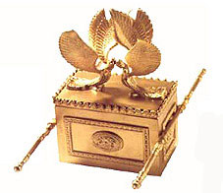

IV. The Holy Ark

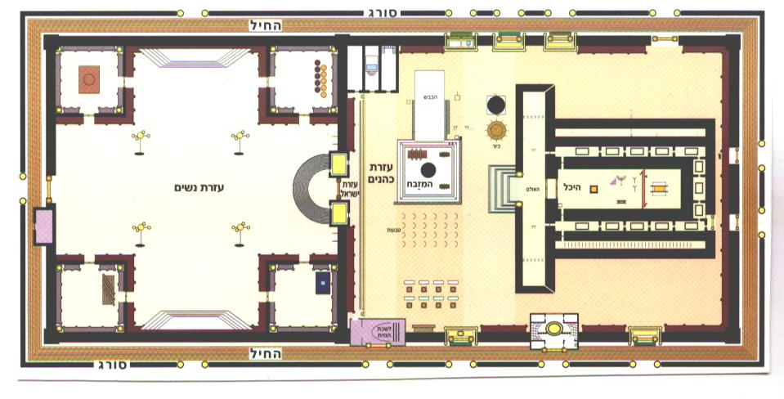
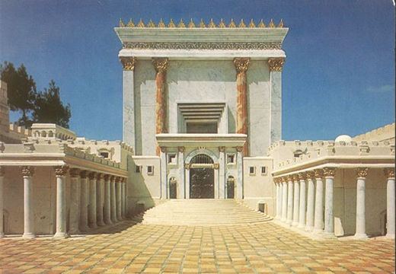

The Purpose of the Holy Temple:_____________________________________________
________________________________________________________________________

Rambam (HBH 4:1-2): There was a rock in the west of the Holy of Holies. Upon it the Ark was set, and the jar of manna and the staff of Aaron were placed before it. At the time when Shlomo (Solomon) built the Temple, knowing that in the end it would be destroyed, he built a place below, among deep, hidden, and winding tunnels, in which to hide the Ark. King Josiah gave the command and the Ark was hidden in the place that Shlomo built; as it says: “he said to the Levites, teachers of all Israel, who are holy to the L-rd: ‘Place the Holy Ark in the House that Shlomo son of David, King of Israel, built.’

Delving Deeper:

Questions on the Rambam: _________________________________________________
________________________________________________________________________

Explanation: ____________________________________________________________ ________________________________________________________________________
________________________________________________________________________

“Sip of Inspiration”: ______________________________________________________
________________________________________________________________________

Homework: ______________________________________________________________
________________________________________________________________________

Moshiach.com/temple/tour/ ChabadofOxnard.com/HolyTemple

