Tammuz
תמוז

Dates to Note
1 Tammuz: Rosh Chodesh
17 Tammuz: Shiva Asar BeTammuz

* 3 Tammuz: The Rebbe’s Day
12-13 Tammuz: Yom HaGeula

I. Pressure

Have you ever been under tremendous pressure… that brought out the BEST in you?
________________________________________________________________________
________________________________________________________________________

II. Historical Background

2448 from Creation, 17 Tammuz: The Tablets are shattered in the desert
9 Av: G-d decrees that generation of the Exodus shall die out in the desert…
2488 from Creation (1273 BCE): Jews enter Holy Land.
2935 from Creation: Dedication of the Holy Temple
3235 from Creation: Jews begin to stray from the Torah…
The Prophet Jeremiah
Nevuchadnezzar the Babylonian
3336 from Creation, 10th Teves: Jerusalem under siege for 2 ½ years
3339 from Creation, Tammuz: Walls of Jerusalem breached by the enemy
9 Av: Holy Temple set on fire by Babylonians.
Nation - prisoners to Babylon.
3829 from Creation, (69 CE)
17 Tammuz: Armies of Rome breach the walls of Jerusalem
9 Av: Holy Temple set aflame by Romans

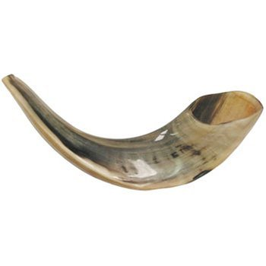
“You wept for no reason, and thus I shall set (this day) for you as a time of weeping throuout the generations” Talmud: Ta’anis 29b

III. The Pinch

Psalms 118:5 “From the straits I call G-d; He answers me with the expanse of the Divine” (recited before the sounding of the shofar on Rosh Hashana).

Jeremiah “Between the strictures” – בין המיצרים.
A Time of Mourning & Repentance
“Days of goodwill before G-d”
Days of opportunity to exploit the failings of the past as the impetus for a renewed and even deeper bond with G-d.

Exodus, Chapter 27:20. And you shall command the children of Israel, and they shall take to you pure olive oil, crushed for lighting, to kindle the lamps continually. וְאַתָּה תְּצַוֶּה אֶת בְּנֵי יִשְׂרָאֵל וְיִקְחוּ אֵלֶיךָ שֶׁמֶן זַיִת זָךְ כָּתִית לַמָּאוֹר לְהַעֲלֹת נֵר תָּמִיד:

Isaiah 27:13 “On that day the great shofar will be sounded. And they will come, those lost in the land of Assyria and those forsaken in the land of Egypt, and bow before G-d on the Holy Mountain, Jerusalem.”

“Sip of Inspiration”:
________________________________________________________________________
________________________________________________________________________

IV. Bitterness vs. Depression

“There is nothing as whole as a broken heart” – Chassidic Saying
“Depression is not a sin; but what depression does, no sin can do.” – Chassidic Saying

מרירות | עצבות
Bitterness | Depression
Constructive Grief | Destructive Grief
Springboard for self-improvement: recognize failings, but cares. Refuse to be indifferent to what is missing in self and world. | Bottomless pit: no hope, despair
Active | Passive
Turmoil | Apathy
Leads to Action | No (positive) Action

How does one ‘mourn’ during the Three Weeks?
________________________________________________________________________
________________________________________________________________________

Homework: Differentiating between the two categories of ‘tears’…
________________________________________________________________________
________________________________________________________________________

