Tammuz
תמוז

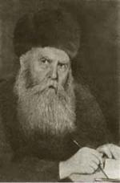
Dates to Note
1 Tammuz: Rosh Chodesh
17 Tammuz: Shiva Asar BeTammuz

* 3 Tammuz: The Rebbe’s Day
12-13 Tammuz: Yom HaGeula

I. Fruitless Effort

Have you ever put loads of effort into a positive project, and seen absolutely no result?

II. Arrest & Liberation
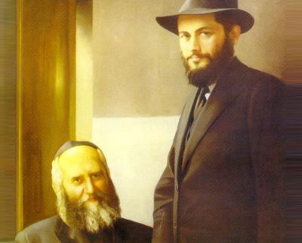

Rabbi Yosef Yitzchak Schneersohn, the sixth rebbe of Chabad-Lubavitch (1880-1950), was one of the most remarkable Jewish personalities of the twentieth century. In his seventy years, he encountered every conceivable challenge to Jewish life: the persecutions and pogroms of Czarist Russia, Communism's war on Judaism, and melting-pot America's apathy and scorn toward the Torah and its precepts. The Rebbe was unique in that he not only experienced these chapters in Jewish history -- as did many of his generation -- but that, as a leader of his people, he actually faced them down, often single-handedly, and prevailed.

Letter from the Previous Chabad Rebbe: “…Normally, an analogy is less earnest than its analog. Consider, then: If imprisoning a body in a jail of wood and stone is called suffering, then how intense must be the suffering of the Divine soul when it is imprisoned in the body and the animal soul. This is something worth thinking about deeply.”

A Promise from the Previous Chabad Rebbe:
חזקה על תעמולה שאינה חוזרת ריקם
“It is accepted that no effort will be spent without having an effect.”

“Sip of Inspiration”: _____________________________________________________
________________________________________________________________________

Homework:______________________________________________________________
________________________________________________________________________

