Lesson Plan
From:
“intimacy in flames” – yossi jacobson, theyeshiva.net
Inner.org – on the month of AV

I ended up teaching “G-d’s presence in exile” in Av2!. Just the “basic” concepts of galus/geula, etc. was enough to go through. I started class with AGAIN going through the “historical background from last week.

Homework Review:

First:

Set:

Stop:
I think its nothing external! The ability to HOLD ONTO faith during the most CRAZY difficult times, comes from our soul…. It’s a crazy power within that allows us to live a paradox… be in the dark, yet see the light, the bright future…. THAT’s the power of this month…
Lecture
Theme of month
Low – 9 av high – tu b’av
TES = shape of womb, = 9 = month of pregnancy, concentrated into 9 days – leading up to birth of MOshiach!
Menachem Av = customary to add that. Menachem is name of MOshiach.
Av = Father – colsoles us, read “nachamu” shabbos after 9 av
We comfort Hashem – tell Him even though so dark, we still have Emunah & Bitachon.
Diminish – but besimcha….
Ask rebbe: ivdu es Hashem besimcha.
What about when sitting shiva?
Rebbe – simcha that you’re doing Hashem’s ratzon…
Rambam: days of celebration…
This is the “Ground-breaking” for new building, built by G-d H/S!!!
GEULA – is NOT a whole new journey… its actually RETRACING our steps, ‘reliving” GOLAH – but now WITH the Alef. Its living the life we know, in the world we know, but with HASHEM revealed….. seing it from G-ds perspective….

THEME = lowest point that will bring to the highest point!!!

SIP = amazing, the REbbe’s approach. Farbrengen on 9 av that fell out on shabbos, shiker, totally besimcha… and yet an hour later, by eicha, serious, halacha, etc…
Ex: REbbe crying ad masay, and moment later, Rebbe sitting up and describing ‘emeseh simcha’ we must experience that Moshiach is coming any moment.
THE PARADOX that’s EXPECTED OF US…. Crazy. But possible!
HW – we cry for Sarena’s pain, that shes going through such a hard time, and we rejoice, in bitachon, that she WILL survive, and feel even stronger than ever!
(example: seudas Hoda’a for my mother while still not well….)

G-ds precense in exile. ‘
(talmud: what they actually dragged out was a decoration from the wall…. ‘berometer’ that reflected the aron. The actual keruvim on top of aron WEREN’T there! Come back next class to find out where THEY were ☺ )
Talmud: Back to back – bad news. Facing – good. Incredible – EMBRACE!
Maggid – halacha for man to be with his wife before journey….

WE HAVE CLUNG TO OUR FAITH during this terribly long and painful exile… because of that last intimate embrace… we have kept our passion, and G-d ‘reassured us” that there will be a ‘return”…. After this journey…

THEREFORE – Hashem “impregnated” us with a spark of LIFE>. … ON THE DAY that temple destroyed, Moshiach is BORN! Seed for future reunion……

Sip: feel the embrace…
HW: again, feel that closeness during the difficult moment… reach in for that EMUNAH and BITACHON we have….. its COMING!

If time:
Teacher/pupil:
Is GAlus a PUNISHMENT?
If it was, it would slowly lighten up as we do teshuva, and things clear.
But Galus seems to always get worse and worse… (assimilation, less sensitivity to G-dliness, etc… if you trace if from times of Talmud till today….)

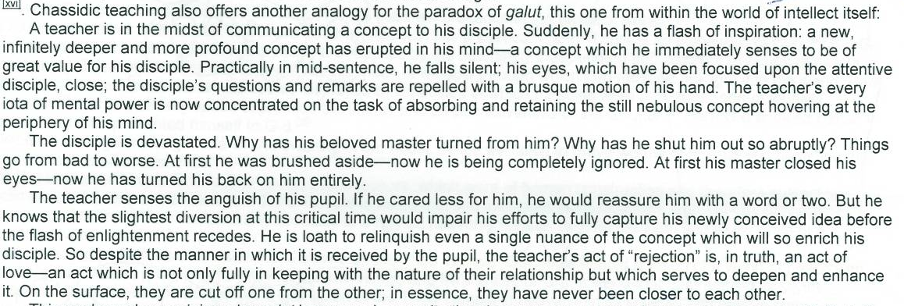

So reason gets “worse” is because something so high needs to be ‘acquired’ for us… deeper teacher delves, more he must retreat… but shows his greater commitment to student…

