Lesson Plan
From:
The yeshiva.net: “intimacy in flames”
Lekutey sichos, chelek chof alef, Teruma, Bais.
(or in English – JLI course on heaven on earth… (a virtual tour of the holy temple), page 128

Stop:
We only believe what was proven, what our eyes have seen… VERY HARD to believe in something out of no-where!!! Hard to believe in something we’ve never experienced… in radical changes….
TODAY – LET’S STRENGTHN OUR BELIEF>>>> and learn how to cont. to strengthen.
Lecture
- Review timeline again…

Teacher/pupil:
Is GAlus a PUNISHMENT?
If it was, it would slowly lighten up as we do teshuva, and things clear.
But Galus seems to always get worse and worse… (assimilation, less sensitivity to G-dliness, etc… if you trace if from times of Talmud till today….)

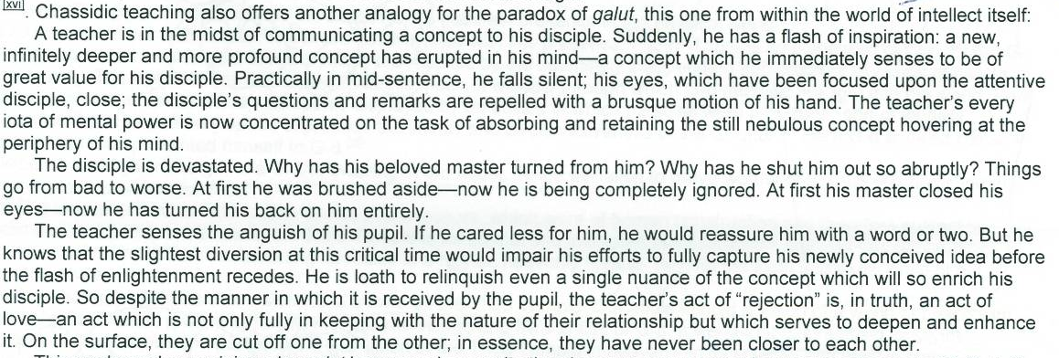

So reason gets “worse” is because something so high needs to be ‘acquired’ for us… deeper teacher delves, more he must retreat… but shows his greater commitment to student…

G-ds precense in exile. ‘
(talmud: what they actually dragged out was a decoration from the wall…. ‘berometer’ that reflected the aron. The actual keruvim on top of aron WEREN’T there! )
Talmud: Back to back – bad news. Facing – good. Incredible – EMBRACE!
Maggid – halacha for man to be with his wife before journey….

WE HAVE CLUNG TO OUR FAITH during this terribly long and painful exile… because of that last intimate embrace… we have kept our passion, and G-d ‘reassured us” that there will be a ‘return”…. After this journey…

THEREFORE – Hashem “impregnated” us with a spark of LIFE>. … ON THE DAY that temple destroyed, Moshiach is BORN! Seed for future reunion……

Sip: feel the embrace…
HW: again, feel that closeness during the difficult moment… reach in for that EMUNAH and BITACHON we have….. its COMING!

The Holy Ark
Purpose of Holy Temple _ a place where G-d is seen and felt. The anchor, the place where heaven touches earth constantly. Communication comes from there.
Word of G-d came from the Holy of Holies to Moses (by Mishkan).
Fire desends, accepts sacrifices… etc.

Q/ Why do we need these stories in a book of Jewish Law?
Q/ Why was Ark hidden, years before there was even a threat to Temple being destroyed?
Q/ Why was it done with joy, ceremoniously…? And not when its actually needed…

A/ King Shlomo “built in” to this Temple the possibility for it to be destroyed… IN ORDER that it be rebuilt again by the hand of G-d Himself!

The Aron wasn’t just 1 vessel… it was THE vessel that gave the Temple its status/holiness.

While speaking of laws of temple, we must know about its permanence… Even if physical Temple destroyed, What Temple represents can never be obliterated.

This ‘hidden’ cave, thru the tunnels, was dedicated t/g with the Holy of Holies at official temple dedication by King Shlomo! Had a status as official part of Temple. (not an emergency ‘back up’ plan!!!)
There were TWO options (equally sacred) for where the Aron should be. It was completely appropriate for it to be in hidden place. (directly beneath Holy of Holies!). (kedusha is below and above. Example: on roof – not allowed to walk directly above HH’s - put a curtain).

SO – building can be destroyed, but Ark being in its appropriate place, TEple still exists!

Temple #2, the aron remained in hidden spot! Until today. its there…

Sip We think its all “lost”. So dark and filthy, this galus.
But reality – the core still exists! For real! ARON IS THERE AS WE SPEAK, waiting waiting waiting of the end of the story!
THIS WAS ALL PART OF THE PLAN!!!

The “luz bone” – is from where the body gets re-built.
The hidden aron, is there waiting as well.

Hw
- Learn bais hamikdash!
- Believe it. I Have belief in me already.
- Think of any “lost case” in your life…. Realize that if this is a worthy project – you dig enough- you’ll be able to reach… (a damaged friendship… at core there is love. A mess up I’ve made. At core I can return, repent and fix!)

