Sivan
סיון
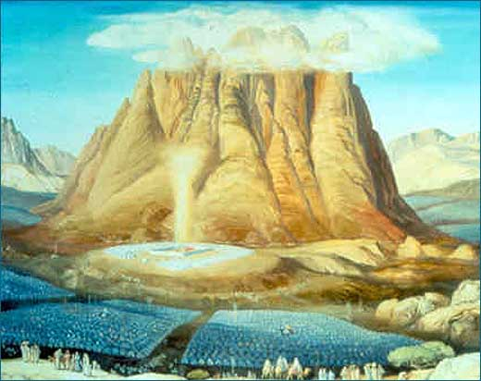
Dates to Note
1 Sivan: Rosh Chodesh
6-7 Sivan: Shavuos

I. Grounded or Inspired

Which moments feel inspiring to you?
□ Rabbi’s Sermon on Yom Kippur □ Changing a Diaper □ Paying Bills □ Praying □ A beautiful Sunset □ Painting □ Learning Torah □ Shopping □ Visiting the Sick □ Household Cleanup □ Sitting in Traffic □ Listening to Moving Music

II. Shavuos Basics

- 1 of the 3 Shalosh Regalim
- The name of the Holiday:
  - Weeks: _____________________________________________________
  - Oaths: ______________________________________________________
- The 50th Gate: ______________________________________________________
- Location: _________________________________________________________
  - Exodus: Chapter 19: 1. In the third month of the children of Israel's departure from Egypt, on this day they arrived in the desert of Sinai.
- Unity: ____________________________________________________________
  - 2. They journeyed from Rephidim, and they arrived in the desert of Sinai, and they encamped in the desert, and Israel encamped there opposite the mountain. וַיִּחַן שָׁם יִשְׂרָאֵל נֶגֶד הָהָר
    - Rashi: and Israel encamped there: Heb. וַיִחַן, [the singular form, denoting that they encamped there] as one man with one heart
- Men & Women: ____________________________________________________
  - 3. Moses ascended to God, and the Lord called to him from the mountain, saying, "So shall you say to the house of Jacob and tell the sons of Israel,
    - Rashi: to the house of Jacob: These are the women. Say it to them in a gentle language. — [from Mechilta] and tell the sons of Israel: The punishments and the details [of the laws] explain to the males, things that are as harsh as wormwood
- Our Response: _____________________________________________________
  - Chapter 24: 7. And he took the Book of the Covenant and read it within the hearing of the people, and they said, "All that the Lord spoke we will do and we will hear." כֹּל אֲשֶׁר דִּבֶּר ה נַעֲשֶׂה וְנִשְׁמָע
- G-d’s Move: _______________________________________________________
  - Chapter 19: 20. The Lord descended upon Mount Sinai, to the peak of the mountain, and the Lord summoned Moses to the peak of the mountain, and Moses ascended.
    - Rashi: The Lord descended upon Mount Sinai: I may think that He actually descended upon it. Therefore, Scripture says: “You have seen that from the heavens I have spoken with you” (Exod. 20:19). This teaches that [He did descend although still in the heavens,] He bent down the upper heavens and the lower heavens and spread them upon the mountain like a spread on a bed, and the Throne of Glory descended upon them
  - The Sanctity of the Mountain: ___________________________________ ____________________________________________________________
- Echo: ____________________________________________________________
  - Deuteronomy Chapter 5:19. The Lord spoke these words to your entire assembly at the mountain out of the midst of the fire, the cloud…, with a great voice, with no repeat… קוֹל גָּדוֹל וְלֹא יָסָף
- Consummating the Marriage: _________________________________________
  - Isaiah. The land will be filled with the knowledge of G-d as water fills the sea-bed.
- Our Guarantors:____________________________________________(Medrash)
- Holiday Customs:
  - Reading the 10 Commandments
  - Eating Dairy Foods
    - Kosher Laws Received
    - Torah = Milk
  - Learning All Night

III. Heaven on Earth

Removal of Decree: Medrash: Once there was a king who decreed: The people of Rome are forbidden to go down to Syria, and the people of Syria are forbidden to go up to Rome. Likewise, when G-d created the world He decreed and said: "The heavens are G-d's, and the earth is given to man." But when He wished to give the Torah to Israel, He rescinded His original decree, and declared: The lower realms may ascend to the higher realms, and the higher realms may descend to the lower realms. And I, Myself, will begin -- as it is written, "And G-d descended on Mount Sinai, and then it says, "And to Moses He said: Go up to G-d." (Midrash Tanchuma, Vaeira 15; Midrash Rabbah, Shemot 12:4)

Exodus: Chapter 20:1. God spoke all these words, to respond: לֵאמֹר
Everyone was present? To repeat to whom?
To Respond: Medrash (Mechilta):
- Rabbi Akiva: They responded to the positive commandments, “Yes” and to the negative commandments, “Yes”.
- Rabbi Yishmael: They responded to the positive commandments, “Yes,” and to the negative commandments, “No.”

Chapter 20: 15. And all the people saw the voices וְכָל הָעָם רֹאִים אֶת הַקּוֹלֹת
- Rabbi Akiva: Literally, SAW the thunder, HEARD the lightning!
- Rabbi Yishmael: Not literally, they saw what is normally seen, heard what is normally heard.

The Radical Change at Mount Sinai…. The Novelty: ____________________________ ________________________________________________________________________________________________________________________________________________

Theme of the Holiday: _____________________________________________________

Homework:
________________________________________________________________________
________________________________________________________________________

