Minyanim

שבעה עשר בתמוז
Sunday, July 21st (18th of Tamuz)
Fast Begins………………..…………….…………….3:40 a.m.
Shacharis / Selichot.………………..………………..8:20 a.m.
Mincha……………………………………...…….……7:45 p.m.
Fast Ends………………………………………………8:53 p.m.

שבת חזון
Friday, August 10th
Mincha / Maariv………...……………...…………….7:45 p.m.
Shabbos Chazon, August 11th
Morning………………………...…………………….10:00 a.m.

תשעה באב
Saturday night, August 10th (Tisha B’Av)
Fast of Tisha B’Av begins........................... ..…….7:58 p.m.
Shabbos ends………………………...………………..8:44 p.m.
Maariv / Reading of Eicha…..…..…….……………9:00 p.m.

Sunday, August 11th (Tisha B’Av)
Morning / Reading of Kinos...........................…….9:00 a.m.
Mid-day (Chatzos)…………………………………..12:55 p.m.
Mincha……………………………...………………….7:00 p.m.
Fast Ends…………………..…..…..……….…………8:28 p.m.

שבת נחמו
Friday, August 16th
Mincha / Maariv…………..……..…………..………7:30 p.m.
Shabbos Nachamu, August 17th
Morning..……………………...……..………………10:00 a.m.
Join us in studying

Hilchos Bais HaBechirah
(Laws of Building the Beit Hamikdosh)
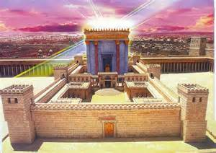
During the Three Weeks
Sunday evenings through Thursday evenings

~ ~ ~
July 21st – August 8th
8:30 p.m. – 9:00 p.m.
~ ~ ~
Taught by Rabbi Noach Kosofsky
At Lubavitcher Yeshiva Academy
1148 Converse Street
Longmeadow

Call 567-8665 or email info@LYA.org
for more information

