A Memorial Service honoring
Elmer Beckman
Eliyahu ben Max

Officiating Rabbi
Rabbi Shmuel Wineberg
Lubavitch Mesivta of Chicago
2756 W Morse Ave
Chicago, IL 60645
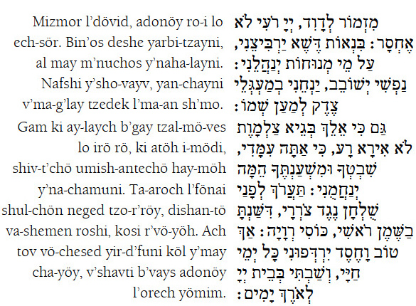
Psalm 23
Translation:
A Psalm by David. The Lord is my shepherd; I shall lack nothing.
He makes me lie down in green pastures; He leads me beside still waters.
He revives my soul; He directs me in the paths of righteousness for the sake of His Name.
Even if I walk in the valley of the shadow of death, I will fear no evil, for You are with me;
Your rod and Your staff -- they will comfort me.
You will prepare a table before my enemies; You have anointed my head with oil; my cup is full.
Only goodness and kindness shall follow me all the days of my life, and I shall dwell in the House of the Lord for many long years.
Kel Maleh Rachamim
Prayer for the Soul of the Departed

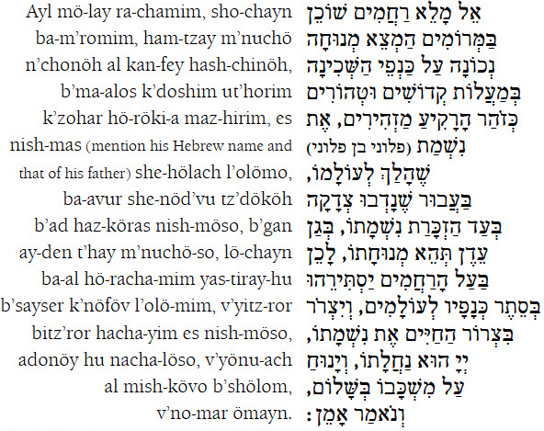
O G-d, full of compassion,
Who dwells on high,
grant true rest upon the wings of the Shechinah (Divine Presence), in the exalted spheres of the holy and pure, who shine as the resplendence of the firmament, to the soul of
Eliyahu ben Max Who has gone to his [supernal] world, for charity has been donated in remembrance of his soul; may his place of rest be in Gan Eden. Therefore, may the All-Merciful One shelter him with the cover of His wings forever, and bind his soul in the bond of life. The Lord is his heritage; may he rest in his resting-place in peace; and let us say: Amen.
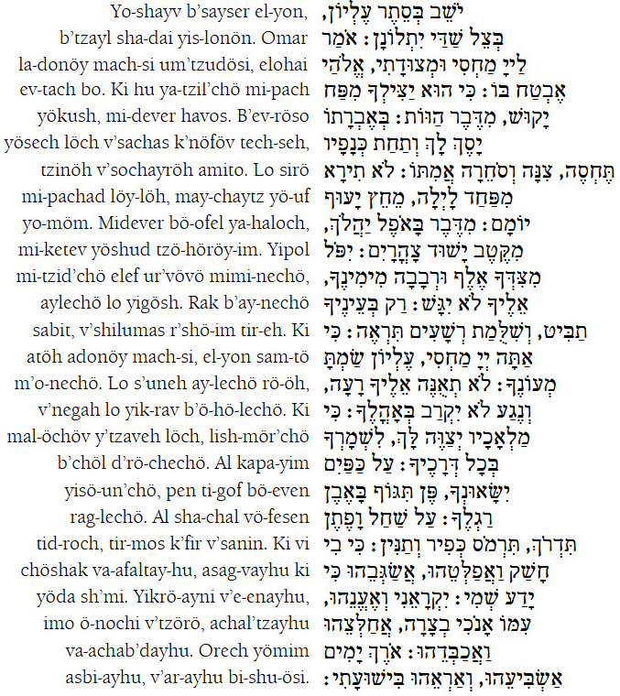
Psalm 91
Translation:
You Who dwells in the shelter of the Most High, Who abides in the shadow of the Omnipotent,
I say [to you] of the Lord Who is my refuge and my stronghold, my G-d in Whom I trust,
that He will save you from the ensnaring trap, from the destructive pestilence.
He will cover you with His pinions and you will find refuge under His wings; His truth is a shield and an armor.
You will not fear the terror of the night, nor the arrow that flies by day,
the pestilence that prowls in the darkness, nor the destruction that ravages at noon.
A thousand may fall at your [left] side, and ten thousand at your right, but it shall not reach you.
You need only look with your eyes, and you will see the retribution of the wicked.
Because you [have said,] "The Lord is my shelter," and you have made the Most High your haven,
no evil will befall you, no plague will come near your tent.
For He will instruct His angels in your behalf, to guard you in all your ways.
They will carry you in their hands, lest you hurt your foot on a rock.
You will tread upon the lion and the viper; you will trample upon the young lion and the serpent.
Because he desires Me, I will deliver him; I will fortify him for he knows My Name.
When he calls on Me, I will answer him; I am with him in distress, I will deliver him and honor him.
I will satisfy him with long life, and show him My deliverance.

Dayan Haemet Blessing
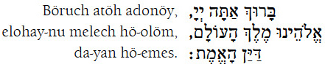
Translation:
Blessed are You, Lord our G-d, King of the universe, the True Judge
Acceptance of Judgement Prayer
The Rock, His work is perfect, for all His ways are justice; a G-d of faithfulness and without iniquity, righteous and just is He.
The Rock, perfect in all His works. Who can say to Him 'What have You done?' He rules below and above, He brings death and restores life, brings down to the grave and raises up from there.
The Rock, perfect in all His deeds. Who can say to Him, 'What do You do?' You Who says and fulfills, do undeserved kindness with us, and in the merit of him [Isaac] who was bound [on the altar] like a lamb, hearken and grant our request.
Righteous One in all His ways, O Rock Who is perfect, slow to anger and abundant in mercy, take pity and spare both parents and children, for to You, O Lord, pertain forgiveness and mercy.
Righteous are You, Lord, to bring death and to restore life, for in Your hands are entrusted all spirits. Far be it from You to erase our memory. Look towards us with mercy, for Yours, O Lord, are mercy and forgiveness.
A man, whether he be a year old, or whether he lives a thousand years, what does it profit him? For is it not as if he has never been? Blessed be the True Judge, Who brings death and restores life.
Blessed be He, for His judgment is true, as He scans everything with His eye, and He rewards man according to his account and his judgment. Let all give praise to His Name.
We know, Lord, that Your judgment is right. You are righteous when You speak and pure when You judge, and none shall question Your judgments. Righteous are You, Lord, and Your judgments are just.
You are the True Judge, Who judges with righteousness and truth. Blessed is the True Judge, for all of His judgments are righteous and true.
The soul of every living creature is in Your hand, righteousness fills Your right and left hand. Have mercy on the remnant of the flock under Your hand, and say to the angel of death, ‘Hold back your hand!'
You are great in counsel and mighty in action, Your eyes are watching all the ways of man, to give man according to his ways and according to the fruit of his deeds.
That is to say that the Lord is Just; He is my Strength, and there is no injustice in Him.
The Lord has given and the Lord has taken. May the Name of the Lord be blessed.
He, being compassionate, pardons iniquity, and does not destroy; time and again He turns away His anger, and does not arouse all His wrath.



2756 W Morse Ave Chicago, IL 60645
773 262-0430 Rabbiwineberg@lmchicago.org

