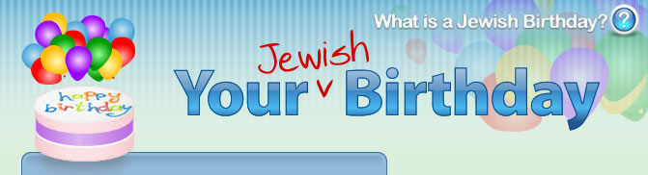

What's so great about a birthday? Wasn't it more comfy inside the womb?
But the day you were born was the day you became your very own person—no longer just a watermelon in your mommy's tummy. That's why it's a day to ponder: What have I accomplished by being here? Did the world change because I left that womb?
So when the Hebrew calendar comes back around to that wonderful day you were born, try some of these great customs:
- Find an enclave in time-space to think about the past year: what went right, what went not-so-right and what can be fixed.
- Take your life to a new level with a new mitzvah. Take your life to a new level with a new mitzvah.
- Give some extra charity today. Best just before the morning and afternoon prayers. If your birthday falls on Shabbat or a Jewish holiday, then give before the day begins and after it's out.
- Spend more time in your prayers. Say some extra Psalms. (Yes, Psalms are Jewish--King David wrote them.) Your mazel shines extra strong on your birthday, so ask for the right things.
- Every year of your life has a corresponding Psalm. It's your age+1. Learn it today and say it each day for the coming year.
- Add to your Torah study time. Share whatever you learn with friends.
- Farbreng. That's when friends sit together, make l'chaim and encourage each other to be better Jews. It's also a great way to publicly thank your Creator for creating your life.
- Eat a new seasonal fruit on your birthday just so you can say the Shehecheyanu blessing, thanking G-d for granting you life.
- For men: Get an aliyah on the Shabbat before your birthday. If the Torah is read on your birthday, get an aliyah on that day too.

