BS”D
LAWS OF TEFFILIN
Compiled by Rabbi Mordechai Z. Hecht
HEAD TEFILLIN - SHEL ROSH
Correct Position
"If one, G-d forbid, [is not careful to place the tefillin above his hairline and instead] puts the tefillin on his forehead, he is following a custom of the Karites, and has not fulfilled the mitzvah at all….and has said a bracha in vain." {Mishna Berura 27:33}
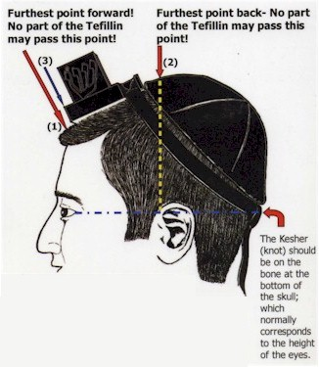
- The tefillin shel rosh must always be positioned within an area which begins at the hairline above the forehead, where the hairs sprout out from the scalp (the hairline roots), and terminates at the point where a baby's "soft spot" ends. {Shulchan A'ruch O"H 27:9}
- The end of the "soft spot" is normally found directly above the point where the front-upper ear is attached to the head.
- The tefillin should be placed slightly above and behind the hairline roots, leaving enough space to ensure that they will always remain in the correct placement area even if they slip down a little. {Mishna Berura 27:33}

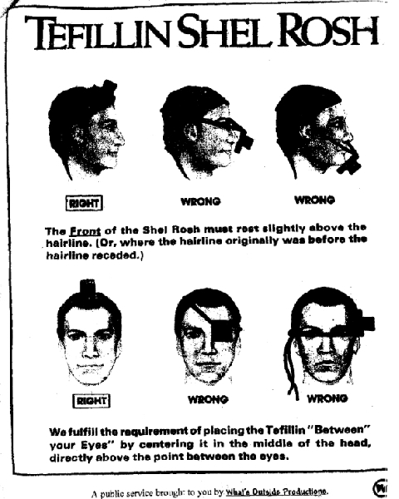
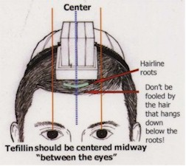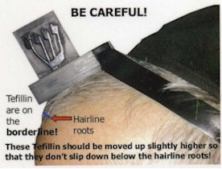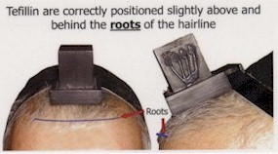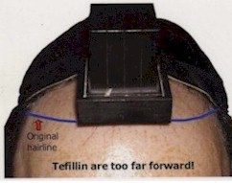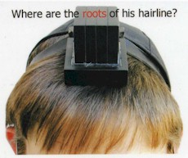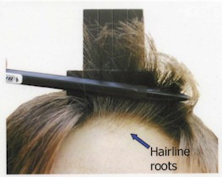

HAND TEFILLIN - SHEL YAD
Correct Position
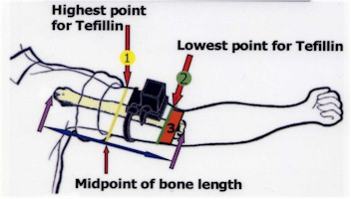
- Highest point for tefillin - The midpoint of the bone length between the elbow and the shoulder is the highest point on the arm for any part of the tefillin. They should be positioned on the biceps muscle below this point, slightly leaning towards the body. {Shulchan A'ruch O"H 27:1} In case of great necessity and with no other alternative, (i.e. when you only have very large tefillin available and they cannot fit in the proper area) you must ensure that the tefillin never pass below the lowest point (see below) by placing them higher up the arm, above the midpoint, making sure that the entire tefillin are always positioned only on the bulge of the biceps. {Mishna Berura 27:4 citing the Gaon meVilna}
- Lowest point for tefillin begins where the biceps muscle starts to elevate and is normally bulged. The tefillin must never pass below this point! {Mishna Berura 27:4} With your arm outstretched (according to the ruling of Harav Hagaon Rabbi Y. S. Elyashiv, shlita) as in the above diagram, you should carefully check your arm to recognize exactly where your biceps muscle starts to bulge, and always make sure the tefillin are positioned slightly higher than this point so that they will remain in the correct placement area even if they slip down a little.
- This is the area where the muscle is not normally elevated. No part of the tefillin may sit in this area! One should not wear very large tefillin because the front edge of the tefillin will almost certainly end up in this area, and you will lose the mitzvah. {Mishna Berura 27:4}

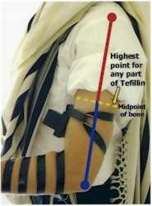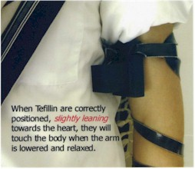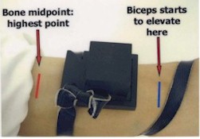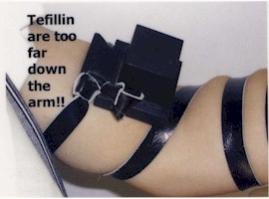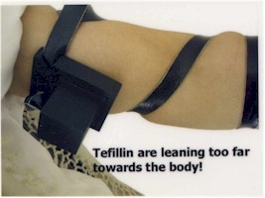
"So great is the mitzvah of tefillin that whoever wears them will live a long life.... and Raba said that all who wear tefillin and wrap themselves with a tallis, and say the Shema and pray are promised a place in Olam Haba,.... Abaye said that the fires of Gehinom will not affect him.... Rav Papa said that all of his sins are forgiven." [Tur O"H 37}

All material on this page has been approved by Harav Hagaon Rabbi Moshe Sternbuch, shlita
Pictures and text on this page designed and © 2003 by Rabbi M. Y. Sharaby
To obtain permission to use and/or reprint any text portions of the material on this page for your personal, non-commercial use please contact us at
Adapted from HASOFER.com

