the Rebbes horaos concerning the Mivtza Tzdoko pushkah
He asked
1) The Mivtzoim be pictured on the Pushkes and
2) That the option should be open to which charity to give. When Herson printed pushkes to give out with Rabbinical college on it; the Rebbe said these should be used for the baalei batim and in addition there should be Pushkes for Mivtzoim without the name (the moisad can write for info contact...but it needs to have a blank space for people to fill in their favorite charity..)
3) This was for childrens pushkes: to have Lamed Hey "vov and a place for their name, on this one I'm not clear,look it up in the sichos, after my Bochur years....

1) Cheapest option: buy plain pushkas from Jewish educational toys, and print a sticker.
For full service: mycharityboxes.com

2) https://www.shluchim.jewfadz.com/catalogsearch/result/?q=pushka

Pushka Options
Option 1: ARK Pushkas


Cost:
ARKs - $0.45 (minimum 50 pieces)
ARKs with branded insert - $0.75 (minimum 500 pieces)
Shipping - TBD

Processing:
ARKs - 1 day. Shipping 2 business days.
ARKs with branded insert - 3 business days. Shipping 2 business days.

To order
orders@changeourworldforgood.com

Option 2: 2"x3" Tin Pushkas
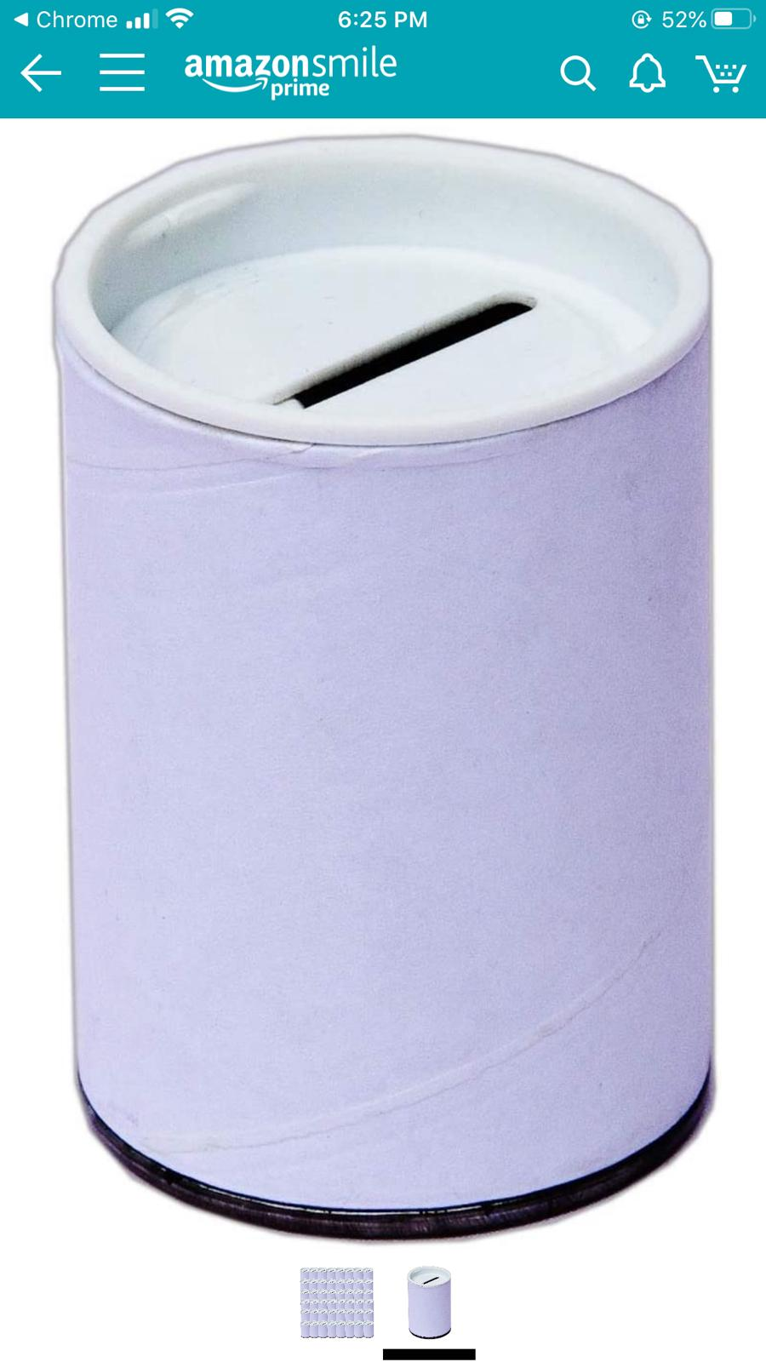

Cost:
Box of 100 pushkas - $54 (mention CYP)
Shipping - TBD

Processing:
1 day. Shipping 2-5 business days.

To order:
Avrohom Blumberger - 773-508-9134

Pushka Label Canva
https://www.canva.com/design/DAEDL4TbC7E/z8R4azZnH2s5ZCIyHzzviQ/view?utm_content=DAEDL4TbC7E&utm_campaign=designshare&utm_medium=link&utm_source=sharebutton&mode=preview

Put 3 designs on an 8.5x11 glossy label. Either print at a local printer and have them cut to size or print yourself and cut to size with a paper cutter.

https://www.iggudhashluchim.com/templates/articlecco_cdo/aid/5024925/jewish/Action.htm

