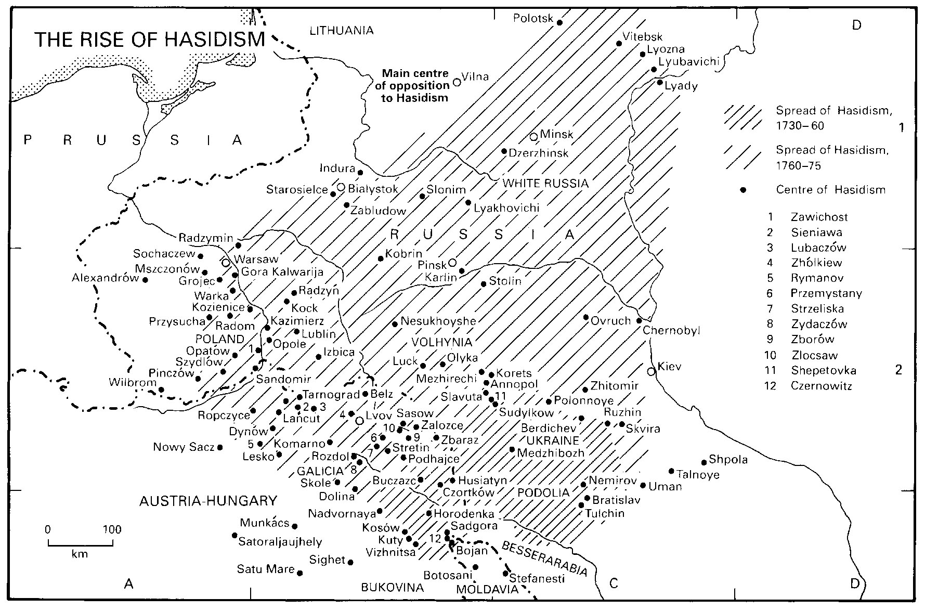

Hasidic dynasties (arranged alphabetically) with a large following include:
Name | Current (or last) Rebbe | Founder | Headquartered In | City/Town of Origin
Belz | Yissachar Dov Rokeach (II) | Sholom Rokeach (1781–1855) | Jerusalem, Israel | Belz, Galicia, Austria-Hungary / Poland (now in Ukraine)
Bobov | Ben Zion Aryeh Leibish Halberstam;  Mordechai Dovid Unger | Shlomo Halberstam of Bobov (1847–1905) | Borough Park, Brooklyn | Bobowa and Sanz, Galicia, Austria-Hungary (now in Poland)
Chabad Lubavitch | Menachem Mendel Schneerson (1902–1994) | Schneur Zalman of Liadi (1745–1812) | Crown Heights, Brooklyn | Lubavitch, Russia  http://www.chabad.org/
Ger | Yaakov Aryeh Alter (b. 1939) | Yitzchak Meir Alter (1799–1866) | Jerusalem, Israel | Góra Kalwaria, Russian Empire (now in Poland)
Karlin, or Karlin-Stolin | Baruch Meir Yaakov Shochet | Aharon the Great of Karlin (1736–1772) | Givat Zeev, Israel;  Jerusalem, Israel | Karlin, Belarus
Sanz Klausenberg | Tzvi Elimelech Halberstam;  Shmuel Dovid Halberstam | Chaim Halberstam of Sanz (1796–1876) | Boro Park, Brooklyn;  Kiryat Sanz, Netanya, Israel | Cluj-Napoca, Hungary (now in Romania), and Sanz, Galicia (now in Poland)
Satmar | Aaron Teitelbaum (b. 1947);  Zalman Leib Teitelbaum (b. 1952) | Moshe Teitelbaum of Ujhel (1759–1841) | Kiryas Joel, New York;  Williamsburg, Brooklyn | Satu Mare, Hungary (now in Romania)
Skver | David Twersky (b. 1940) | Yitzchak Twersky | New Square, New York | Skvira, Russian Empire (now in Ukraine)
Vizhnitz | Moshe Yehoshua Hager;  Mordechai Hager | Menachem Mendel Hager of Kosov (1830–1884) | Bnei Brak, Israel;  Kaser, New York | Vyzhnytsia, Bukovina, Austria-Hungary (now in Ukraine)

- Alesk (from Olesko, Ukraine)
- Anipoli (from Annopol, Ukraine)
- Apt/Zinkov/Mezhbizh (from Opatów, Poland)
- Avritch (from Ovruch, Ukraine)

[edit] B
- Baitch (from Biecz, Poland)
- Besermin (from Hajdúböszörmény, Hungary)
- Bender (from Bender, Moldova)
- Bertch (from Bircza, Poland)
- Białystok (from Białystok)
- Bialobrzeg (from Białobrzegi, Poland)
- Bilgoray (from Biłgoraj, Poland)
- Binding (From Elbing/Elbląg, Poland)
- Bluzhev (from Błażowa, Poland)
- Bikovsk (from Bikofsk)
- Bohush (from Bohushi, Romania)
- Bonia
- Boslover
- Botoshan (from Botoşani, Romania)
- Breslev from Uman
- Brod (from Brody, Ukraine)
- Brisdovitz (from Berezdivtsi, Ukraine)
- Bucharest (from Bucureşti, Romania)
- Burshtin (from Burshtyn, Ukraine)

[edit] C
- Chabad-Bobroisk (from Bobrujsk, Belarus)
- Chabad-Kapust
- Chabad-Liadi
- Chabad-Nezhin
- Chabad-Strashelye
- Chadusha
- Chernovitz (from Chernivtsi)
- Cieszanow
- Czortkow (from Chortkiv)
- Chust (from Khust)
- Cleveland
- Cracow (from Kraków)

[edit] D
- Deyzh (from Dej, Romania)
- Debrecen (from Debrecen)
- Dinev (from Dynów, Poland)
- Dobromil (from Dobromyl, Ukraine)
- Dombrova (from Dąbrowa Tarnowska, Poland)
- Drubitsh (from Drohobych, Poland)
- Dzirka (from Györke/Ďurkov, Slovakia?)
- Dzikov (from Tarnobrzeg, Poland)

[edit] E
- Eisysky (from Eišiškės, Lithuania)
- Erlau (from Eger/Erlau, Hungary)
- Etched (from Nagyecsed, Hungary)

[edit] F
- Faltichan (from Fălticeni, Romania)
- Frankfurt

[edit] G
- Gorlitz (from Gorlice, Poland)
- Gostynin (from Gostynin, Poland)
- Gvodzitz (from Hvizdets)
- Gribov (from Grybów, Poland)

[edit] H
- Hornsteipel (from Hornostaypil', near Chernobyl)
- Huvniv (from Hivniv, Ukraine)
- Husiatyn

[edit] K
- Kaliv (from Nagykálló, Hungary)
- Kaminka (from Kamianka-Buzka, Ukraine)
- Kaminetz
- Kunskvola (from Końskowola, Poland)
- Karlihaz
- Kashou
- Kerestir (from Bodrogkeresztur, Hungary)
- Khentshin (from Chęciny, Poland)
- Kielce (from Kielce, Poland)
- Kojdanov (from Koidanova, Belarus)
- Komarno (from Komarno, Ukraine)
- Kopyczynitz (from Kopychyntsi, Ukraine)
- Korets (from Korets, Ukraine)
- Koson (from Koson, Ukraine)
- Kosov (from Kosiv, Ukraine)
- Kotsk (from Kock, Poland)
- Kozlov
- Kozhnitz (from Kozienice, Poland)
- Krasna
- Krula
- Kshanov (from Chrzanów, Poland)
- Kutna (Hasidic dynasty)
- Kuzmir (from Kazimierz Dolny, near Warsaw)

[edit] L
- Łańcut (from Łańcut, Poland)
- Lebina
- Lelov (from Lelów, Poland)
- Lechovitch (from Lyakhavichy, Belarus)
- Leipnik (from Leipnik, Czech Republic)
- Leipzig
- Linitz
- Liske
- Lizhensk (from Leżajsk, Poland)
- Leva
- Liozna
- Lublin (from Lublin, Poland)
- Lutsk (from Lutsk, Ukraine)

[edit] M
- Madyer
- Malachim
- Margareten (from Marghita, Romania)
- Mattersdorf (from Mattersburg, Austria)
- Mezhbizh (from Medzhybizh), Ukraine; Also see Apter Rov
- Mishkoltz (from Miskolc, Hungary)
- Mogelnitz (from Mogielnica, Poland)
- Manestrishtze

[edit] N
- Nadvorna
- Narol
- Nadferli
- Neshchiz (from Nesukhoyezhe, Ukraine)
- Nikolsburg[disambiguation needed ] (from Mikulov/Nikolsburg)
- Nitra (from Nitra/Nyitra)

[edit] O
- Ostrof
- Ozherov (from Ożarów, Poland)

[edit] P
- Pashkan (from Paşcani, Romania)
- Philadelphia (from Philadelphia, Pennsylvania)
- Piasetzne
- Pietrokov (from Piotrków Trybunalski, Poland)
- Pilts (from Pilica[disambiguation needed ])
- Pilzno
- Pinsk (named for Pinsk, Belarus)
- Pintchiv (from Pińczów, Poland)
- Pistin
- Pishkivitcha
- Pittsburgh (from Pittsburgh, Pennsylvania)
- Porisov (from Parysów, Poland)
- Polonoye (from Polonne (Polonnoye), Volhynia)
- Premishlan (from Peremyshliany, Ukraine)
- Pshemishl (from Przemyśl, Poland)
- Pshevorsk (from Przeworsk, Poland)
- Pshiskhe (from Przysucha, Poland)

[edit] R
- Radomsk (from Radomsko, Poland)
- Radorztz
- Radoshitz (from Radoszyce, Poland)
- Radvil (from Radyvyliv, Ukraine)
- Ratzfert (from Újfehértó, Hungary)
- Rimenov (from Rymanów, Poland)
- Ribnitz (from Rybnitsa, Moldova or Transnistria)
- Roman (from Roman, Romania)
- Ropshitz (from Ropczyce, Poland)
- Ruzhin (from Ruzhyn, Ukraine)
- Rzeszów (Rzeszów, Galicia, Poland)

[edit] S
- Sadovna (from Sadowne, Poland)
- Sambur (from Sambir, Ukraine)
- Sadigura (from Sadhora, Ukraine)
- Sanz (from Nowy Sącz, Poland)
- Sasregen (from Szászrégen/Reghin, Romania)
- Serdahel (from Szerdahely)
- Sassov (from Sasiv, Ukraine)
- Savran
- Senta Serbia
- Seret (from Siret, Romania)
- Shedlitz (from Siedlce, Poland)
- Shepetivka from Shepetivka, Ukraine
- Shotz (from Suceava, Romania)
- Shidlovtza (from Szydłowiec, Poland)
- Shineva (from Sieniawa, Poland)
- Shpikov (from Shpykiv, Ukraine)
- Shpola (from Shpola, Ukraine)
- Shtefanesht (from Ştefăneşti, Romania)
- Siget (Sighetu-Marmaţiei/Máramarossziget, Romania)
- Sochatchov (from Sochaczew, Poland)
- Sokolov (from Sokołów Podlaski, Poland - there was a Hasidic dynasty in Sokołów Małopolski, Poland, as well)
- Stanislov (from Stanyslaviv, Ukraine)
- Stepan (from Stepan, Ukraine)
- Stichin (from Szczucin, Poland)
- Stretin (from Stratin, Ukraine)
- Strikov (from Stryków, Poland)
- Strizhov
- Sudilkov (from Sudylkiv, Ukraine)
- Sulitz (from Suliţa, Romania)

[edit] T
- Tenka (from Hungary?)
- Tartakov (from Tartakiv, Ukraine)
- Tetsh (from Técső - now Tyachiv, Ukraine)
- Temishvar (from Timişoara, Romania)
- Tolna (from Talne, Ukraine)
- Toldos Tzvi
- Toltchva (from Tolcsva, Hungary)
- Tosh (from Nyírtass, Hungary)
- Trisk (from Turiisk, Ukraine)
- Tseshenov (from Cieszanów, Poland)
- Tshakova (from Szczakowa, Poland)
- Tzehlim (from Deutschkreutz, Austria)

[edit] U
- Ujhel (from Újhely)
- Ungvar (from Ungvár)
- Unsdorf
- Ushpitzin (from Oświęcim, Poland)

[edit] VVasloi (from Vaslui, Romania)
- Vien (Rabbinical dynasty) (from Wien/Vienna)
- Voidislav (from Wodzisław, Poland)
- Volova (from Mizhhirya, Ukraine)
- Vorka from Warka, Poland
- Vulkan

[edit] Y
- Yeruslav (from Jarosław, Poland)
- Yoka

ZZablitov (Zabolotiv, Ukraine)
Zbarz (from Zbarazh, Ukraine)
- Zhmigrid (from Nowy Żmigród, Poland)
- Zhitomir (from Zhytomyr)
- Zibov
- Zidichov
- Zinkov
- Zlatipol (from Zlatopol)
- Zlotchov (from Zolochiv)
- Zolozitz
- Zychlin

