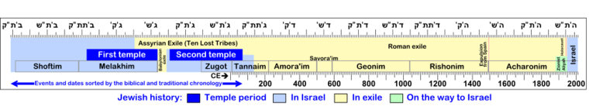
Rabbi Yehudah Hachasid,
Chasedei Ashekenaz
Biblical commentators
Ramban, Recanti, Rabeinu Bachya
Philosophy meets Kabbalah
Moshe de Leon, Discovery of Zohar Abraham Abulafia-prophetic Kabbala

Chassidic Movement
Rabbi Yisrael baal Shem Tov
Rabbi Schneur Zalman of Liadi
Rabbi Nachman of breslav
etc…
Sefardic Kabbalists
Ohr hachayim
Sharabi
Abuchatzeira
Circle of Tsfat
Rabbi Yosef Caro, Rabbi Shlomo Alkabetz, Rabbi Moshe Alshich, Rabbi Moshe Cordovero (RaMaK), Rabbi Eliyahu daVidas Rabbi Yitzchak Luria (Ari zal) Rabbi Chaim Vital

European Kabbalists
Maharal of Prague. Rabbi Yehudah ben Betzalel Loew,
Shaloh- Isaiah Horowitz

Nevuah –Age of Prophecy
Prophecies of the Torah and many unrecorded prophecies.
Schools for prophets
1.2 Million Prophets?
Circles of
Rabbi Akiva-Sefer Yetzirah
Rabbi Nechuniah ben Hakaneh-Sefer Habahir
Rabbi Yishmael ben Elisha –Heichalot rabbati
Rabbi Shimon Bar Yochai-Sefer Hazohar

