ARE YOU A GRAPE, ORANGE, BANANA, OR MELON?

We all have different styles, traits, and characteristics. The following exercise is a fun look at some of your general characteristics and personality traits!

Read across each row and place a 4, 3, 2, or 1 in the shaded box to rank how you would best describe yourself. A 4 means that this word best describes you. A 1 means that this word least describes you. Do this for each row.

Example:
Imaginative | 2 | Investigative | 4 | Realistic | 1 | Analytical | 3

Totals
Column 1 |  | Column 2 |  | Column 3 |  | Column 4
Imaginative |  | Investigative |  | Realistic |  | Analytical
Adaptable |  | Inquisitive |  | Organized |  | Critical
Relating |  | Creating |  | Getting to Point |  | Debating
Personal |  | Adventurous |  | Practical |  | Academic
Flexible |  | Inventive |  | Precise |  | Systematic
Sharing |  | Independent |  | Orderly |  | Sensible
Cooperative |  | Competitive |  | Perfectionist |  | Logical
Sensitive |  | Risk-Taking |  | Hard-Working |  | Intellectual
People-Person |  | Problem Solver |  | Planner |  | Reader
Associate |  | Originate |  | Memorize |  | Think Through
Spontaneous |  | Changer |  | Wants Direction |  | Judger
Communicating |  | Discovering |  | Cautious |  | Reasoning
Caring |  | Challenging |  | Practicing |  | Examining
Feeling |  | Experimenting |  | Doing |  | Thinking

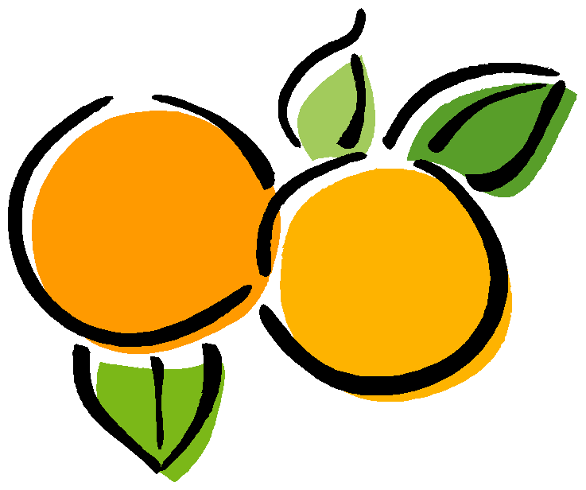Now, add up your totals (don’t include the examples of course!) for each column and place the total in the shaded boxes above.

If your highest score was in column 1, consider yourself a grape!
If your highest score was in column 2, consider yourself an orange! If your highest score was in column 3, consider yourself a banana!
If your highest score was in column 4, consider yourself a melon!

Now find your fruit below and review what this may mean to you.

Modified from The 7 Habits of Highly Effective Teens. By Sean Covey. 1998. Pg. 187.
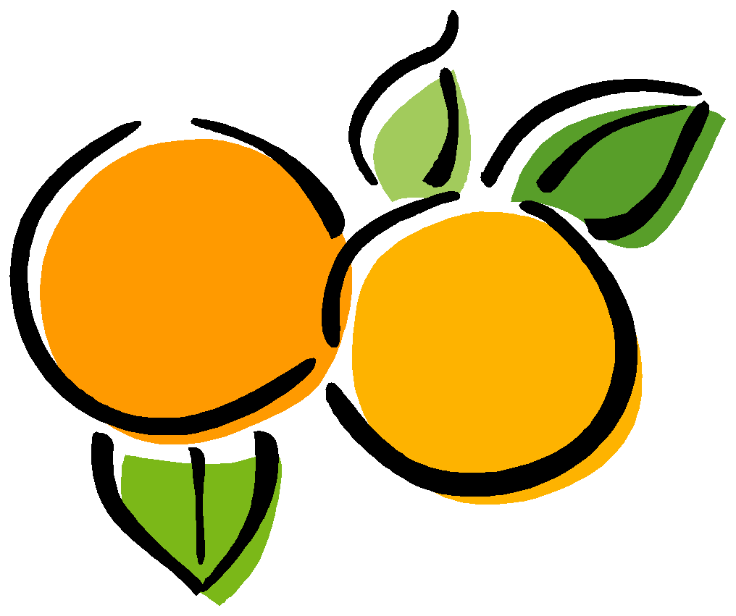GRAPES

Natural abilities include: Grapes may have trouble: Being reflective Giving exact answers
Being sensitive Focusing on one thing at a time
Being flexible Organizing
Being creative
Preference for working in groups

Grapes learn best when they: To expand their style, Grapes need to: Can work and share with others Pay more attention to details
Balance work with play Not rush into things
Can communicate Be less emotional when making some
Are noncompetitive decisions

ORANGES

Natural abilities include: Oranges may have trouble: Experimenting Meeting time limits
Being Independent Following a lecture
Being curious Having few options or choices
Creating different approaches
Creating change

Oranges learn best when they: To expand their style, Oranges need to: Can use trial and error Delegate responsibility
Produce real products Be more accepting of others’ ideas
Can compete Learn to prioritize
Are self-directed

BANANAS

Natural abilities include: Bananas may have trouble: Planning Understanding feelings
Fact-finding Dealing with opposition Organizing Answering “what if” questions Following directions

Bananas learn best when they: To expand their style, Bananas need to: Have an orderly environment Express their own feelings more
Have specific outcomes Get explanations of others’ views
Can trust others to do their part Be less rigid
Have predictable situations

MELONS

Natural abilities include: Melons may have trouble: Debating points of view Working in groups
Finding solutions Being criticized
Analyzing ideas Convincing others diplomatically
Determining value or importance

Melons learn best when they: To expand their style, Melons need to: Have access to resources Accept imperfection
Can work independently Consider all alternatives Are respected for intellectual ability Consider others’ feelings Follow traditional methods

