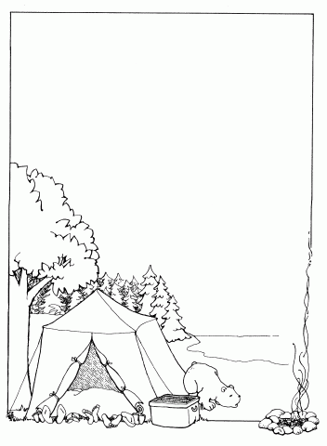
B”H Date: ______________

Dear _____________________,

I’m writing from Camp Gan Israel of Parksville, New York and from
1 to 10, I’m having a _____ experience so far!
The best parts of camp are…
- ______________________________________
- ______________________________________
- ______________________________________
My counselors are _______________________&______________________.
My learning teacher is ________________________ and we’re learning
_____________________________________________________________.
What I didn’t expect about camp is __________________________
______________________________________________________.
Did you know that _________________________________________
_________________________________________________________!

Love,

P.S. __________________________
______________________________
______________________________
______________________________

