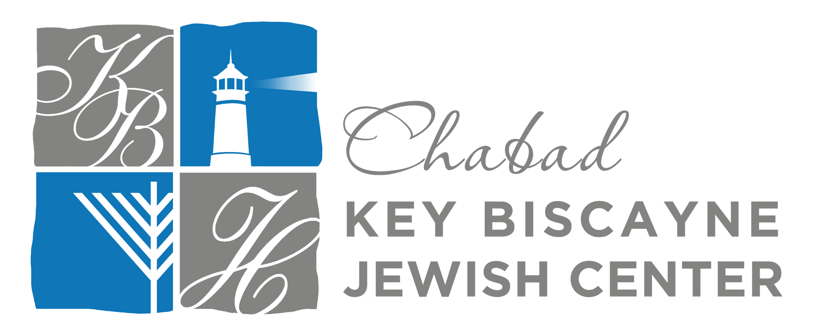

May 11, 2022
Iyar 10‏‎, 5782

Dear ,
I’m writing to thank you for your generous contribution of $--- to the Chabad Key Biscayne Jewish Center, received May 11, 2022.
On behalf of our entire community, I would like to express our appreciation and gratitude. Thank you!
Your donation is a beautiful gift to the Jewish people in Key Biscayne. By supporting a Jewish Center where they can experience and celebrate their Judaism together, you are giving each of them the gift of community and providing them opportunities to discover and learn about their rich heritage.
This is truly thanks to you. It would not be possible without the generosity of people like you, who care about our community and invest in its success.
With your partnership and the joint effort of the community, we will continue to grow, sharing the warmth of Judaism with the wonderful community we are blessed to have on this beautiful island!
My warmest wishes that you and your family be blessed with good health, happiness, and much success in everything you do.
Warmly,

Rabbi Avremel Caroline
Director

