

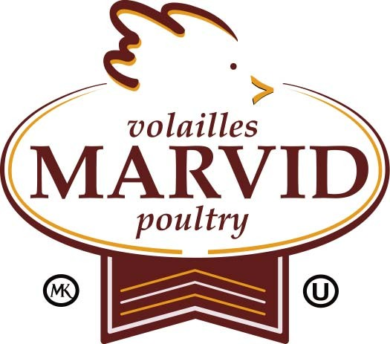
בס"ד
As a Service to the Jewish Community
The Rabbinical College of Canada
in conjunction with Marvid Poultry

will be having “Live”

Kapores - כפרות

Date:1) Tuesday, Oct. 4, 2011 ו' תשרי, תשע"ב -
Time: 3:00 pm – 9:00 pm Cost: $12.00 per chicken
Place: Rabbinical College of Canada
6405 Westbury corner Plamondon (Back Yard)

Date: 2) Friday, Oct. 7, 2011 - ט' תשרי, תשע"ב   
Time: 4:00 am – 6:00 am Cost: $15.00 per chicken
Place: Marvid Poultry 5671 Industrial Blvd.

On Friday, it will be on a first come first served basis, or you can guarantee your Kapores by advance payment.

PLEASE PURCHASE TICKETS IN ADVANCE AT THE YESHIVA OFFICE.

Send Order Form to: Rabbinical College of Canada
6405 Westbury Mtl. QC, H3W 2X5

Or Fax Order Form to: 514-345-0275

For further information please call 735-2201 ext.105.

Our sincere thanks and appreciation to Marvid, the only local producer of Lubavitch chickens in Montreal, for making this event possible.
Order Form:
□ I / We will attend in person.
Tuesday: $12 X____(tickets) Male____ Female____
Friday: $15 X____ (tickets) Male____ Female____
□ I cannot attend in person. Please make Kapores for me/my family. Please include names of all family members, For example: “Yaakov ben (son of) Rivkah”. ($12 per person)
- ________________________________
- ________________________________
- ________________________________
- ________________________________

Total Tickets: __________ Total Amount: _____________
Payment options: □ Cheque □ Visa □ MasterCard

Name: ________________________________________

Address: ______________________________________

Card Number:________________________Exp:_______

Signature: ______________________ Tel: ___________

Wishing everyone a Healthy and Happy New Year.

