Opening the Ark and taking out the Torah:
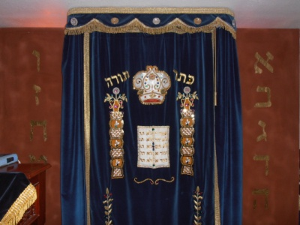
Curtain handle

- When the Leader nods, open the ark.
- Grasp the handle, open the curtain.
- Open the doors (left one does not open all the way).
- Leave the ark open for a few minutes.
- When the Leader nods again, unchain the Torah, take it out, and give it to the leader. (Usually the Torah on the right is used.)
- Then, shut the doors and the curtain.

Opening the Ark and taking out the Torah:

Curtain handle

- When the Leader nods, open the ark.
- Grasp the handle, open the curtain.
- Open the doors (left one does not open all the way).
- Leave the ark open for a few minutes.
- When the Leader nods again, unchain the Torah, take it out, and give it to the leader. (Usually the Torah on the right is used.)
- Then, shut the doors and the curtain.

Opening the Ark and taking out the Torah:

Curtain handle

- When the Leader nods, open the ark.
- Grasp the handle, open the curtain.
- Open the doors (left one does not open all the way).
- Leave the ark open for a few minutes.
- When the Leader nods again, unchain the Torah, take it out, and give it to the leader. (Usually the Torah on the right is used.)
- Then, shut the doors and the curtain.

Opening the Ark and taking out the Torah:

Curtain handle

- When the Leader nods, open the ark.
- Grasp the handle, open the curtain.
- Open the doors (left one does not open all the way).
- Leave the ark open for a few minutes.
- When the Leader nods again, unchain the Torah, take it out, and give it to the leader. (Usually the Torah on the right is used.)
- Then, shut the doors and the curtain.

