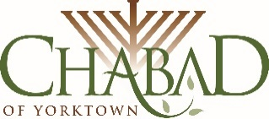
2629 Old Yorktown Rd.
Yorktown Heights, NY 10598
914-962-1111
www.ChabadYorktown.com

B”H
Instructions for the Lulav & Etrog

This year we will be shaking the Lulav and making the blessing for the first time on Thursday morning, October 5, 2017.
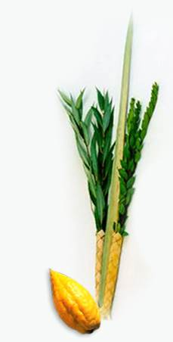
We shake the lulav and say the blessing every day of Sukkot (through Wednesday, October 11) except for Saturday-Shabbat.

Enclosed you will find 5 items:
1) Lulav (Palm branch).
2) Etrog (Citron fruit).
3) Three Hadasim (Myrtle branches).
4) Two Aravot (Willow branches).
5) A holder (made of palm leaves).

Place the lulav in the center of the holder. While the spine of the lulav is facing you, place the 2 hadasim in the opening on the right side of the holder, and the 2 aravot on the left side.

The lulav is taken in the right hand while the blessing is recited.
The blessing we say while holding the lulav is:
Baruch atah Adonai, Eloheinu, melech ha-olam asher kidishanu b'mitz'votav v'tzivanu al n'tilat lulav.
Blessed are you, Lord, our God, sovereign of the universe who has sanctified us with His commandments and commanded us to take the lulav.
Recite the following blessing the first time you shake the lulav this year:

Baruch atah Adonai, Eloheinu, melech ha-olam shehecheyanu V'kiyimanu v'higi'anu laz'man hazeh.
Blessed are you, Lord, our God, sovereign of the universe who has kept us alive, sustained us, and enabled us to reach this season.

The Etrog is then taken in your left hand. It should be held in the direction of its growth, (the bottom on the fruit, where it is connected to the tree, should be on the bottom).
Stand facing east, bring both hands together and shake the lulav and etrog together. Shake them in all 6 direction in this order: Right, left, forward, up, down, back.

When not in use, keep the lulav wrapped in a moist towel. Then cover the towel with plastic or foil to keep the moister in. Otherwise the leaves may dry up and wither quickly (especially the aravot). Alternatively, you may keep the lulav unwrapped, and change the aravot to new ones half way through sukkot.

If you have any question you may email me at Rabbi@ChabadYorktown.com, or call me at 914-962-1111.

Have a Happy Sukkot!
Rabbi Yehuda Heber

