Sung after each set of Ata Haraita:
1. Malchus’chah
Malchus’chah Malchus Kol Olamim U’memshaltecha bechol dor vador
[Your kingship is of all worlds, and Your rulership is in every generation.]

2. Ki MiTzion
Ki MiTzion Teitzei Torah Udvar Hashem Mirushalayim.
[For Torah will emanate from Zion and Hashem’s word from Jerusalem.]

Sung after each Hakafah:
Ad kahn Hakafa … (alef, beis, gimel, daled, hey, vav or zayin)

Hakafah 1:
1. R’ Leivik’s Nigun

2. Dovid Melech Yisra’el
Dovid Melech Yisra’el Chai V’kayam. Siman tov umazal tov yehay lanu u’lechol Yisrael amen.
[David the king of Israel, lives on. May it be a good sign for us and all Israel, Amen.]

3. Anachnu Maaminim
Yisrael betach BaHashem ezram umaginam hu
Anachnu maaminim bnei maaminim ve’ein lanu al me lehisha’en, ela ela al avinu, avinu shebashamayim
[Jews, trust in G-d; He is your helper and your protector! We are believers, children of believers, and we have no one to trust, besides our Father in Heaven!]

Hakafah 2:
1. Ufaratz-ta
Ufaratz-ta Yama Vakeidma Tzafona Vanegba.
[And you shall spread forth to the west, east, north and south.]

2. Ush’avtem Mayim
Ush’avtem mayim besason mimaanei hayeshuva. Mayim besason!
[Draw water in joy from the wellsprings of salvation.]

11. Eimasai
Eimasai Ko’osi Mar Lichsheyafutzu Mayanosecha Chutzah.
[When will Moshiach come? – When your wellsprings are spread to the outside.]

Hakafah 3:
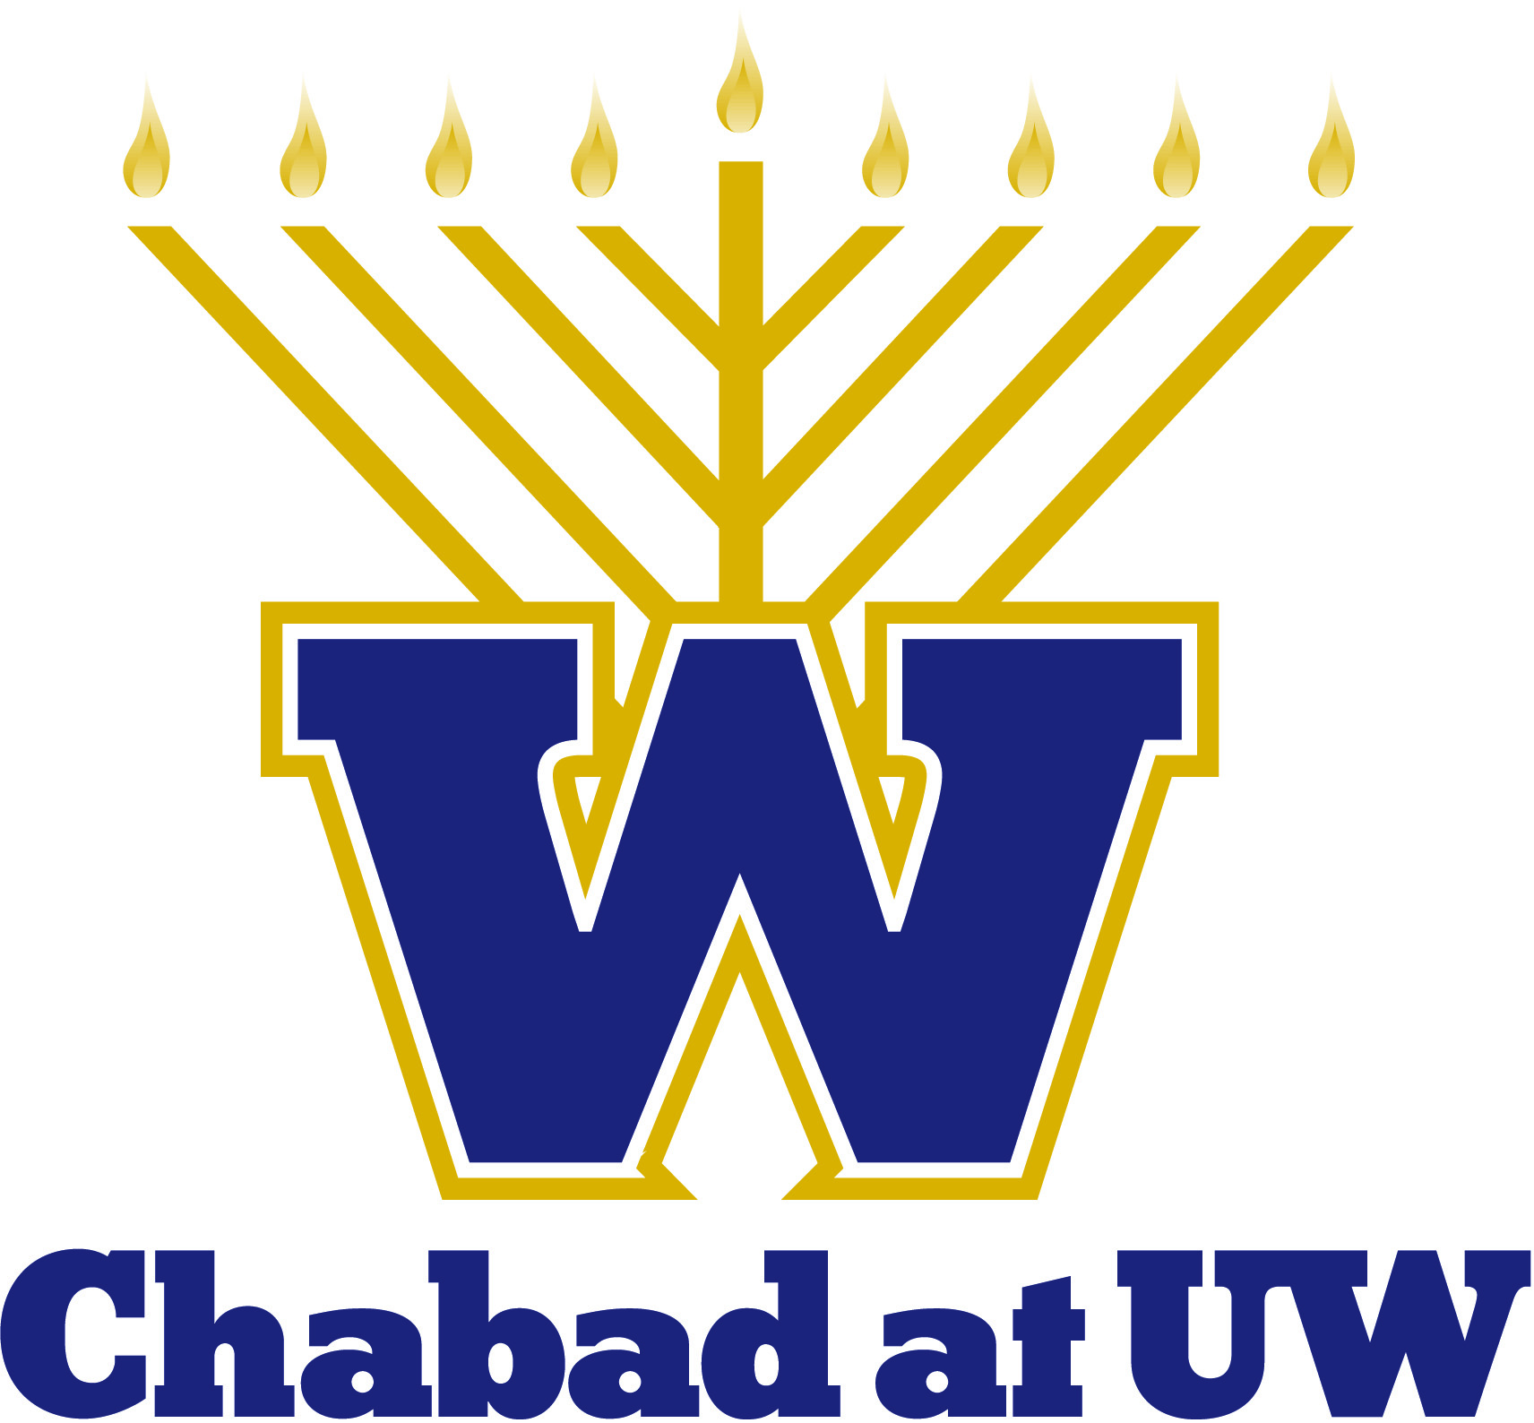
1. Al Hasela
Al Hasela Hoch … Va’yeitzu Mayim
On the rock – bang bang, and out came water!
[He hit the rock, and water came forth.]

2. Moshiach
Ani Ma’amin Be’emunah Shelaima B’vee’as HaMoshiach – Ani Ma’amin
Moshiach, Moshiach, Moshiach!
V’Af Al Pi Sheyismame’ah Im Kol Zeh Achakeh Loh Bechol Yom Sheyavoh.
[I believe with complete faith in the coming of Moshiach, and even though he may tarry, I still await his coming every day.]

3. Ad Mosai
Ad Mosai, do we have to wait? We want Moshiach now, we don’t want to wait!

Hakafah 4:
1. Nyet Nyekavo
Nyet, nyet, nyekavo, kromi Boga adnavo
[There’s no one besides G-d alone!]

2. Zol Shoin Zayn
Zol Shoin Zayn Di Ge’ulah, Moshiach Zol Shoin Kumen.
[The redemption should already arrive and Moshiach should come already!]

3. We Want Moshiach Now
Am Yisroel have no fear, Moshiach will be here this year. We want Moshiach now, we don’t want to wait!

Hakafah 5:
1. Atah V’chartanu
Atah V’chartanu Mikol Ha’amim, Ahavta Osanu V’ratzisa Banu. Veromamtanu Mikol Ha’l’shonos, V’kidashtanu B’mitzvosecha. V’keiravtanu Malkeinu La’avodasecha. V’shimcha Hagadol V’hakadosh Aleinu Karasa.
[You chose us from all the nations, loved and desired us, elevated us from all languages, and sanctified us with Your commandments. You brought us close to Your service, and declared Your great and holy name upon us]

2. Sheyibaneh
Sheyibane Beis Hamikdash, Bim’heira V’yameinu. Yidelach Shrayt Ad Mosai.
[May the Temple be rebuilt soon in our days. Jews, cry out: until when?]

3. Moshe Emes
Moshe Emes, V’soraso Emes.
[Moshe is true, and his Torah is true]

Hakafah 6:
1. Mipi Keil
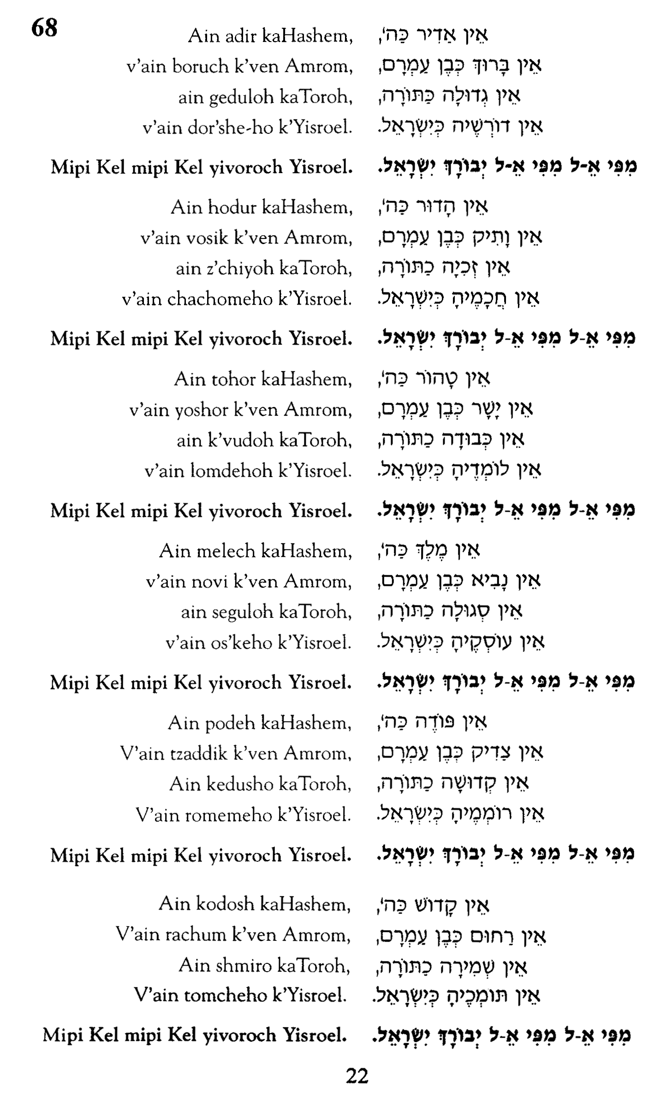

2. Me Hu Zeh (Chorus)
… Lechai Olamim.
Me Hu Ze, Ve’ayze Hu, Zeh Keili ve’anveihu
[… To the One who lives forever! Who is this, this is who? This is our G-d, and we will glorify Him!]

3. Vesamachta
Vesamachta B’chagecha V’hayisa Ach Samei’ach.
[And you should rejoice on your holiday, and only be happy

Hakafah 7:
1. Shema Yisrael
Shema Yisra’el Hashem Elokeinu Hashem Echad.
[Hear Israel, Hashem is our G-d, Hashem is One]

2. Am Yisroel Chai
Am Yisroel Chai, Od Avinu Chai.
[The nation of Israel lives forever, our father lives forever]

3. Napoleon’s March

After Hakafot:

Sisu Vesimchu
Sisu vesimchu besimchas Torah usnu kovod laTorah
[Rejoice and be glad with the joy of the Torah, and give honor to the Torah!]

