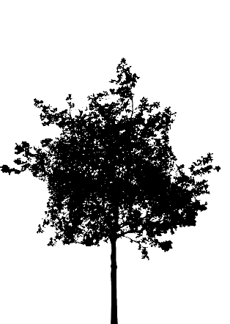
Eight Ways to Be Like a Tree

On the 15th of Shevat, we celebrate the New Year for Trees. Since the Torah compares man to “a tree of the field,” we’ve collected eight lessons that we can learn from trees.
- Always grow towards the light.
- Even the smallest scratch can have lasting effects.
- Grow deep roots.
“One whose deeds are greater than his wisdom, to what is he compared? To a tree with many roots and few branches, which all the storms in the world cannot budge from its place (Avot 3:17).”
- Provide refuge for others.
- Grow sweet fruits for others to enjoy…even if it takes many years for the seeds you sowed to come into their own.
- Let your leaves return to the earth.
- Be supple in the wind.
- Grow stronger through your life experiences.

