B”H
Women’s Weekly Tuesday Class
Tu B’Shvat 2012
Chabad of Potomac Instructor: Sara Bluming

Tu B'Shvat, the fifteenth day of the Hebrew month of Shevat, is one of the four days which are characterized as Rosh Hashanah -- the beginning of the year, for each one of these days begins the year in respect to a specific subject:
1. The first of Nissan is considered to be Rosh Hashanah for calculating the years of the reign of the Kings of Israel. Thus, if a king was anointed in the month of Adar, the following month of Nissan would be considered to be the beginning of the second year of his reign.
2. The first of Elul is considered to be Rosh Hashanah for the tithing of animals.
3. The first of Tishrei is considered to be Rosh Hashanah for the judgment of mankind, for the calculation of the sabbatical and jubilee years, and for the calculation of orlah (the first three years of a fruit tree when its produce may not be eaten), and for the tithes separated from grains and vegetables.
4. Tu b'Shevat, the fifteenth of Shevat, is considered to be Rosh Hashanah for trees, regarding the requirement of tithing their produce. The fifteenth of Shevat is the boundary between one year and another regarding fruit-bearing trees. Fruits that grow after this date are considered to be produce of a new year. It is also the day on which trees are judged –how much fruit each one will produce, etc…
Observances and Customs
On this day it is customary to partake of the fruit with which the Holy Land is praised (Deuteronomy 8:8): Olives, dates, grapes, figs and pomegranates.
The blessing recited on fruit is:
Transliteration: Baruch atah A-donoy, Elo-heinu Melech Ha’Olam borei pri ha-aitz
Translation: Blessed are You, L-rd our G-d, King of the universe, who creates the fruit of the tree.
• One should make an effort to eat at least one fruit which one has not eaten that entire season, and would require the blessing of Shehecheyanu. When eating such a fruit, the Shehecheyanu should be said prior to reciting the blessing of "Haetz."
The blessing of Shehecheyanu:
Transliteration: Ba-ruch A-tah Ado-nai E-lo-he-nu Me-lech Ha-olam She-heche-ya-nu Ve-ki-yi-ma-nu Ve-higi-a-nu Liz-man Ha-zeh.
Translation: Blessed are You, Lord our God, King of the universe, who has granted us life, sustained us, and enabled us to reach this occasion.
Tu B’Shvat Insights
Although this day is Rosh Hashanah for trees, we attach special significance to this holiday “For man is a tree of the field” (Deuteronomy 20:19). The following are some lessons we can learn from trees:
- The Tree & Man:
- A tree doesn’t start out being tall and strong. Its humble beginning is as a mere seed, and it takes many years before it grows to be a proud tree. So too, a person is born a child, and slowly develops into a mature adult. Also, a tree never stops growing. Every year another ring is added to its trunk. Likewise, a person can never be satisfied with his present self and must constantly strive to be better and attain perfection.
- If a full grown tree suffers a scratch it is no great catastrophe, but woe to the tree whose original seed was scratched, for a crooked and weak tree will emerge. In our case, every small blemish or lack of nourishment to a young child results in unwanted qualities in later life. Therefore, great care must be taken to give every child a true Torah education which will positively affect his entire life.
- Just as a tree produces fruit, and the seeds of these fruit may well grow into many more new trees some day, so too a Jew must do Mitzvot and influence others, so that they will be able to take their new-found knowledge and share it with others.
- He (Rabbi Eliezer the son of Azariah) would also say: One whose wisdom is greater than his deeds, what is he comparable to? To a tree with many branches and few roots; comes a storm and uproots it, and turns it on its face. As is stated, "He shall be as a lone tree in a wasteland, and shall not see when good comes; he shall dwell parched in the desert, a salt land, uninhabited" (Jeremiah 17:6). But one whose deeds are greater than his wisdom, to what is he compared? To a tree with many roots and few branches, whom all the storms in the world cannot budge from its place. As is stated: "He shall be as a tree planted upon water, who spreads his roots by the river; who fears not when comes heat, whose leaf is ever lush; who worries not in a year of drought, and ceases not to yield fruit" (ibid., v. 8). (Avot 3:17)
- The stronger the roots of the tree, the greater its ability to withstand the force of a hurricane. Similarly, a Jew must be rooted and firmly entrenched in Torah and Mitzvot so that he will be able to withstand even the greatest trials and tribulations.

- As many of our great Sages were wont to do, Rabbi Akiva taught his students outdoors. “Teach me about Emunah – faith,” a student requested.
Rabbi Akiva pointed to a minute plant and bid the student, “Pull up that tiny sprout.” The student easily fulfilled his teacher’s request.
Rabbi Akiva then pointed to a young sapling. “Pull that out,” he requested. This, too, the student uprooted, with just a little more difficulty.
Now Rabbi Akiva directed his glance at a small tree. The student pulled and tugged. Eventually, with both hands on the tree and his feet firmly planted on the ground, the student was able to pull out the small tree as well.
Finally, Rabbi Akiva walked over to a full grown tree with a trunk at least 2 feet wide. “Now uproot this tree,” he told his student. Try as he might, the student could not even shake a leaf on the tree let alone unearth it.
“So it is with faith,” said Rabbi Akiva. “If the roots of our faith run deep, no one can uproot it. Faith is always as strong and as powerful as its roots.”

- The Human Tree:

The tree's primary components are:
- The roots, which anchor it to the ground and supply it with water and other nutrients
- The trunk, branches and leaves which comprise its body
- The fruit, which contains the seeds by which the tree reproduces itself.

The spiritual life of man also includes roots, a body, and fruit:
- The roots represent faith, our source of nurture and perseverance.
- The trunk, branches and leaves are the body of our spiritual lives -- our intellectual, emotional and practical achievements.
- The fruit is our power of spiritual procreation -- the power to influence others, to plant a seed in a fellow human being and see it sprout, grow and bear fruit.

- Roots and Body
The roots are the least glamorous of the tree's parts--and the most crucial. Buried underground, virtually invisible, they possess neither the majesty of the tree's body, the colorfulness of its leaves nor the tastiness of its fruit. But without roots, a tree cannot survive. The roots must also keep pace with the body: If the trunk and leaves of a tree grow and spread without a proportional increase in its roots, the tree will collapse under its own weight.

Faith is the least glamorous of our spiritual faculties. Characterized by a simple conviction and commitment to one's Source, it lacks the sophistication of the intellect, the vivid color of the emotions, or the sense of satisfaction that comes from deed. And faith is buried underground, its true extent concealed from others and even from ourselves.

Yet our faith, our supra-rational commitment to G-d, is the foundation of our entire tree. From it stems the trunk of our understanding, from which branch out our feelings, motivations and deeds. And while the body of the tree also provides some of its spiritual nurture, the bulk of our spiritual sustenance derives from its roots, from our faith in and commitment to our Creator.

A soul might grow a majestic trunk, numerous and wide-spreading branches, beautiful leaves and lush fruit. But these must be equaled, indeed surpassed, by its roots. Above the surface, there might be much wisdom, profundity of feeling, abundant experience, copious achievement and many disciples; but if these are not grounded and vitalized by an even greater faith and commitment, it is a tree without foundation, a tree doomed to collapse under its own weight.
- Fruit and Seed

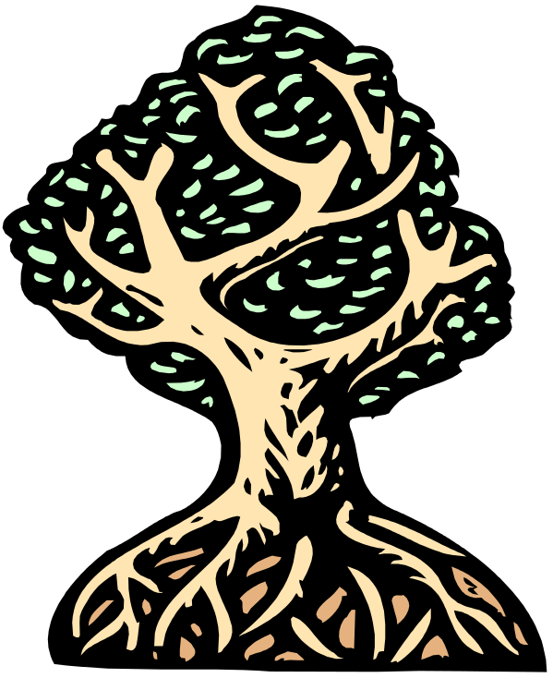
The tree desires to reproduce, to spread its seeds far and wide so that they take root in diverse and distant places. But the tree's reach is limited to the extent of its own branches. It must therefore seek out other, more mobile couriers to transport its seeds. So the tree produces fruit, in which its seeds are enveloped by tasty, colorful, sweet-smelling fibers and juices. The seeds themselves would not rouse the interest of animals and men; but with their attractive packaging, they have no shortage of customers who, after consuming the external fruit, deposit the seeds in those diverse and distant places where the tree wants to plant its seeds.
Roots-The bulk of a tree’s sustenance. Our faith and our Spiritual
sustenance.
Trunk, Branches and LeavesMaintains the form and the bulk of the Tree. Is the center for our intellectual, emotional and spiritual achievements.
Tu B’Shevat (The Jewish New Year for Trees)
“For Man is Like the Tree of the Field” Deuteronomy 20:19

Man is a spiritual being, which means that we not only reproduce physically -- by giving birth to children -- but also spiritually: we replicate ourselves by seeding our ideas, feelings and convictions in the minds and hearts of others. We find an interesting parallel between the way that the fruit tree dispatches its seeds and the way that we disseminate our thoughts and experiences.

The fruit tree's vehicle of reproduction consists of two basic components:
1) The seed, into which the tree distills its very self - its characteristics, its nature, its quintessential treeness;
2) The "packaging" that makes it attractive and palatable to its curriers and consumers.

Both are necessary. Without the packaging, the seed wouldn't get very far, or would do so only with great difficulty. On the other hand, if a tree were to produce a most luscious and attractive fruit but neglect to include a seed, nothing would happen. There would be no shortage of consumers, but no progeny.

When we seek to "reproduce" spiritually by communicating our thoughts and feelings to others, we, too, package our seeds to make our message attractive. We envelop them in intellectual sophistication, steep them in emotional sauce, dress them in colorful words and images. If we didn't, our message might not get very far.

But the important thing to remember is that there must be a "seed" in there; this is only the packaging--the fruit that contains the seed. The seed itself is essentially tasteless--the only way that we can truly impact others is by conveying our own simple faith in what we are telling them, our own simple commitment to what we are espousing. If the fruit of our mind doesn't encase a piece of our soul, what's the point? If the seed is there, our message will take root in their minds and hearts, and our own vision will be grafted into theirs. But if there is no seed, there will be no progeny to our effort, however tasty our fruit might be.

- A Tree’s Blessing

A man wandered in the desert – weary, hungry and thirsty. He came upon a tree with sweet fruits, a pleasant shade and a stream of water flowing beneath it. He ate from its fruits, drank from its water and relaxed in its shade. As he was about to depart, a refreshed traveler, he turned to the tree and said:
"Tree, oh tree, how can I bless you? Shall I bless you that your fruits should be sweet – they are already so! Shall I bless you with a pleasant shade – you already have it! Shall I bless you that a stream of water pass beneath you – one already does! All I can bless you with is that all the trees which are offspring of you, shall be like you." (Talmud Taanit 5B)

Fruit for Thought: Did I shelter the seedlings that live in my shade -- so they will grow up to be a next generation like myself? Did I ensure that my fruits were sweet and nourished all that came to enjoy them? Did everyone walk away from me with a smile? Am I a good example to my children? Do I want my children to be like me?
- Fruits of our Labor
One day, as Choni was traveling along the road, he saw a man planting a carob tree. Choni asked him, "How long will it take for this tree to bear fruit?" "Seventy years," the man replied.
"Do you think that you will live another 70 years?" Choni asked. The man replied, "I found carob trees growing when I was born, because my forefathers planted them for me, so I, too, plant them for my children."
Thereupon Choni sat down to have a meal, and sleep overcame him. As he slept, a rock formation grew around him, hiding him from sight. He continued to sleep for 70 years. When he woke up he saw what looked like the same man gathering beautiful fruit from the carob tree.
"Are you the man who planted this tree?" Choni asked. "No, I am his grandson," the man replied. Choni then realized that he had slept for 70 years! (Talmud , Taanit 23a).
Fruit for Thought: Every single Mitzvah that we do, every one of our positive actions, is a planted seed that will one day blossom and bear fruit. It may take years to see the results of our hard labor, to realize the impact of our good deeds, but they will come to fruition. Our deeds enrich the lives of our children and grandchildren forever. Just as those before us sowed those seeds for us, so must we resolve to sow those seeds too. We must keep planting-our children and grandchildren are depending on us.

- “When you plow and you sow, things will grow” (Hayom Yom, Cheshvan 25)
- “Those who sow in tears will reap with songs of joy. He goes along weeping, carrying the bag of seed; he will surely return with songs of joy, carrying his sheaves.” (Psalms 126)

