Iterator Lab
What I Learned:
From

Issues I Encountered:
The

What I Would’ve Done Differently:
One

How I Will Apply Iterators in the Future:
I

Console Screenshot 1 (Close Game w/ Loss):
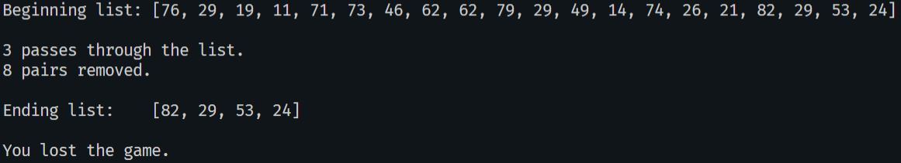

Console Screenshot 2 (Total Loss):
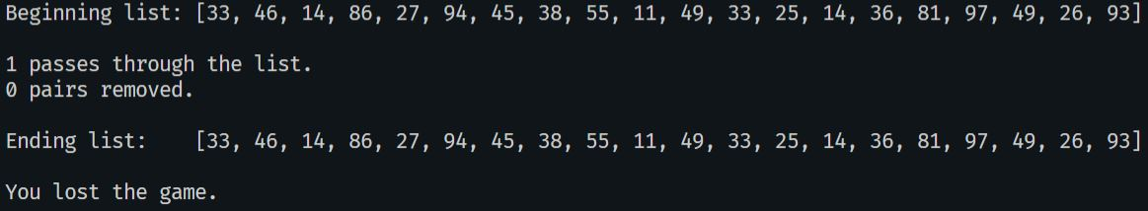

Console Screenshot 3 (Won Game):
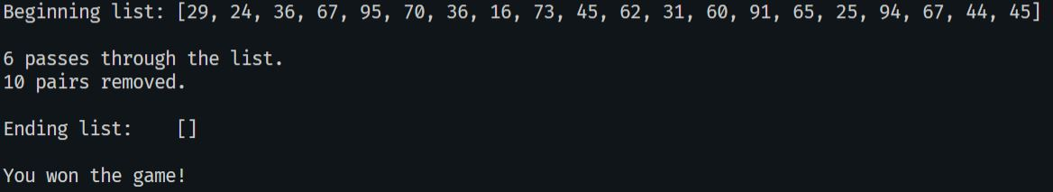

GitHub Repository:
