Recursion Lab
What I Learned:
T

Issues I Encountered:
While

What I Would’ve Done Differently:
One

How I Will Apply Queues in the Future:
I
Console Screenshot:
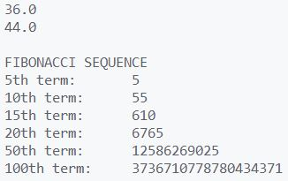

GitHub Repository:
