Sets & Binary Files Lab
What I Learned:
In this week’s lab, I learned different ways of representing sets and how to read and write binary files. I was given the elements of two sets, setA and setB, and tasked with writing the explicit and implicit representations of the sets. Doing this part of the lab helped me to learn the differences between explicit and implicit set representations. I learned that an explicit representation requires a piece of data for all elements in the base type. The base type for the two sets was all even integers from 1 to 50. So, I created represented the sets with a 1 or 0 for all numbers 2, 4, 6, …, 50. After doing this, I needed to determine the union, intersection, and difference of setA and setB. I used some functions that come with Google Sheets. To determine the union of the sets, I used the BITOR() function. To determine the intersection, I used BITAND(). To determine the difference of setA and setB, I created my own function: IF((setA-setB)<=0,0,1). In this function, if the difference between the set elements floors at 0, where an element was in both sets, or an element was in setB but not is setA. I found that the implicit representation was much easier to work with. To perform union implicitly, I inserted all the elements of setA and setB into a new set and removed any duplicates. To perform an intersection, I went through each element of setA and checked if it appeared in setB. If the element appeared, I added it to a new set. To determine the difference, I went through setA and added elements to a new set that did not appear in setB.
For the part of this lab where I manipulated files, I improved my ability in writing to ASCII text files and learned how to read and write a binary file. I created two methods, generateRandomIntegers() and checkBinaryFile(). In the first method, generateRandomIntegers(), I created an ArrayList that was populated with 50,000 integers that ranged from 1000 to 9999. I then created an ASCII file and wrote the numbers in the ArrayList, each on their own line. The last part of the method involved writing the ArrayList numbers to a binary file. This part caused the most difficulties for me, so I will discuss it further in “Issues I Encountered”.

Issues I Encountered:
The main issue I encountered was the difficulty of writing the random numbers to a binary file. I attempted many different ways of going about solving this issue, but when I was checking the binary file with my method, checkBinaryFile(), I never read the same results from when I wrote the numbers. Of course, it is hard to debug a file that contains 50,000 numbers, so as I was attempting to debug my program I only used 10 randomly generated numbers. Because I was still having difficulties with the binary file, I looked back to the lecture slides for this week and decided to do more research and deepen my understanding of serialization. When I updated my code to serialize the ArrayList object, my code worked, the checkBinaryFile() returned true, and I was satisfied with the results.

File Sizes of the binary and ASCII files
The file size of the ASCII file was 293 KB, and the file size of the binary file was 489 KB. Before I saw this question, I assumed that the binary file would be smaller, if not the same size. Then, I remembered I chose to save the ArrayList to the binary file by serialization. I am assuming that for this reason, the binary file required more space to store the numbers than the ASCII file.

What I Would’ve Done Differently:
If I completed this lab again, I would have spent more time trying to store the numbers in the binary file without serialization. If I tried this, I think it would have been interesting to see I could get the file sizes of the ASCII and binary files to be the same.

How I Will Apply Sets and Binary Files in the Future:
I plan on continuing my attempts to make the binary file part of this lab work without serialization. I also plan on using either ASCII files or binary files to store logs of errors or store data that will be needed the next time a user starts the program. For example, if a user spent the time and effort to enter data into my application and will be returning to the application in the future, I would store the data they entered in a file and use that file whenever they return instead of having them enter the data all over again.
Generated Files (ascii.txt and binary.dat):
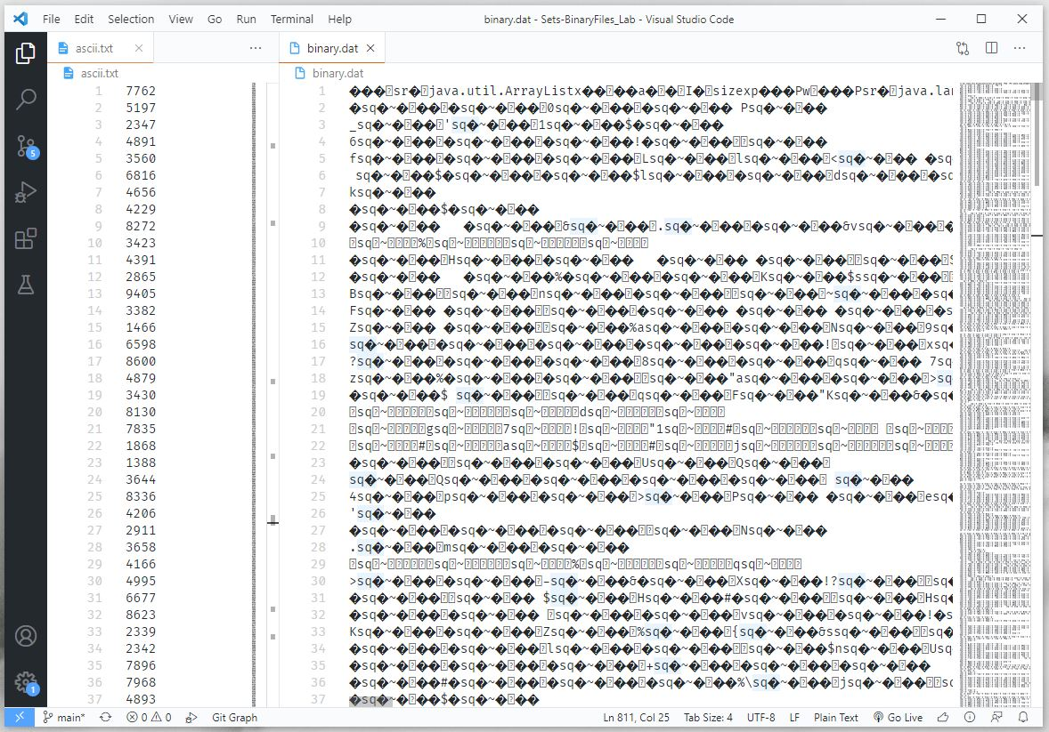

GitHub Repository:
