Project 3: Doubly Linked Lists
In Project 3, I am tasked with making a JavaFX GUI function by implementing two classes, BasicDoubleLinkedList and SortedDoubleLinkedList. I was provided Javadoc files as guidelines for creating the two classes. Both classes are made iterable by implementing the java.lang.Iterable interface. This also means that both classes implement an iterator() method. BasicDoubleLinkedList is a generic double-linked list, meaning that there are both a head reference and a tail reference to locate the first and last nodes in the linked list respectively. The class for these node objects is an inner class that stores references to the next and previous node elements in the linked list. Another inner class within BasicDoubleLinkedList is MyIterator, which implements java.util.ListIterator and only defines the hasNext(), next(), hasPrevious(), and previous() methods. SortedDoubleLinkedList is a class that extends BasicDoubleLinkedList and is a sorted version of a generic double-linked list. The class uses a provided Comparator to compare data elements for sorting. Unlike BasicDoubleLinkedList, SortedDoubleLinkedList does not support adding elements to the front or end of the linked list because doing so would destroy the sorted aspect of the generic double-linked list.

Assumptions:
- Package statements in provided files can be discarded
- The GUI works and will work with BasicDoubleLinkedList and SortedDoubleLinkedList if implemented correctly
- …
UML Class Diagram:
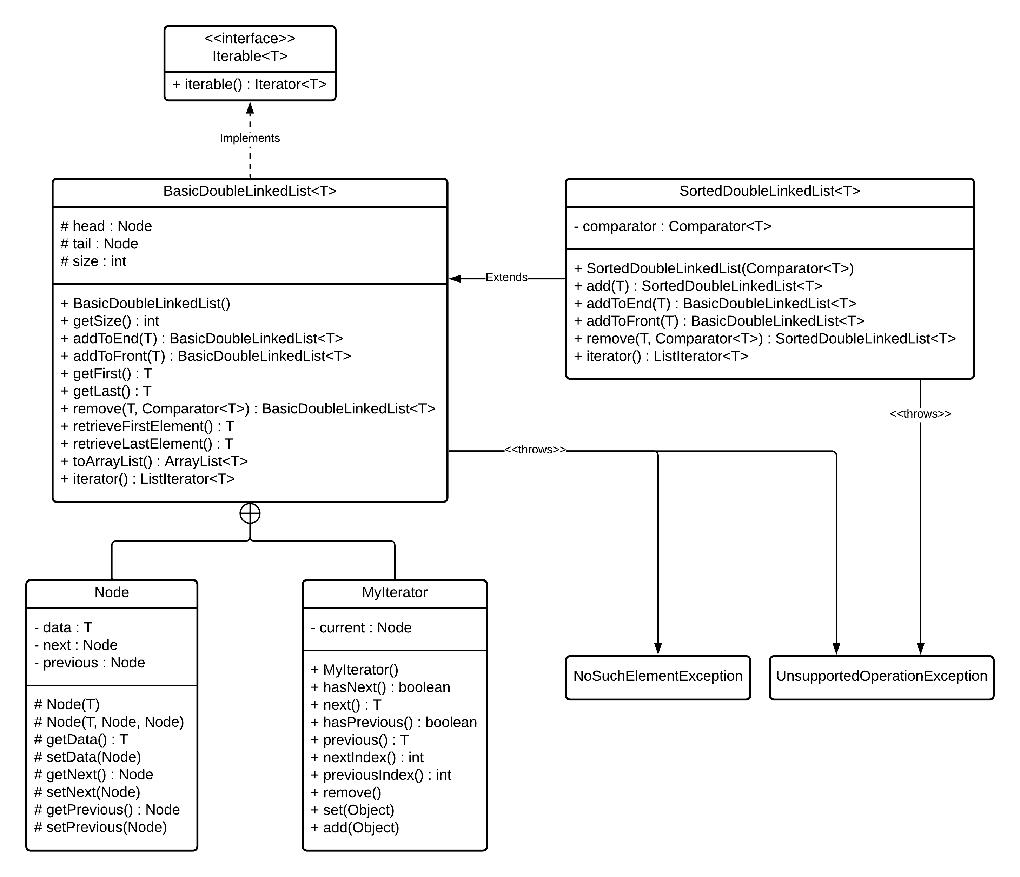

Test Plan
# | Input | Expected Output | Actual Output | Pass?
1 |  |  |  | Y
2 |  |  |  | Y
3 |  |  |  | Y
4 |  |  |  | Y
5 |  |  |  | Y
6 |  |  |  | Y
7 |  |  |  | Y
8 |  |  |  | Y
9 |  |  |  | Y
10 |  |  |  | Y
11 |  |  |  | Y
12 |  |  |  | Y
13 |  |  |  | Y
14 |  |  |  | Y
15 |  |  |  | Y
16 |  |  |  | Y
17 |  |  |  | Y
18 |  |  |  | Y
19 |  |  |  | Y
20 |  |  |  | Y

Test Screenshots
Test 1
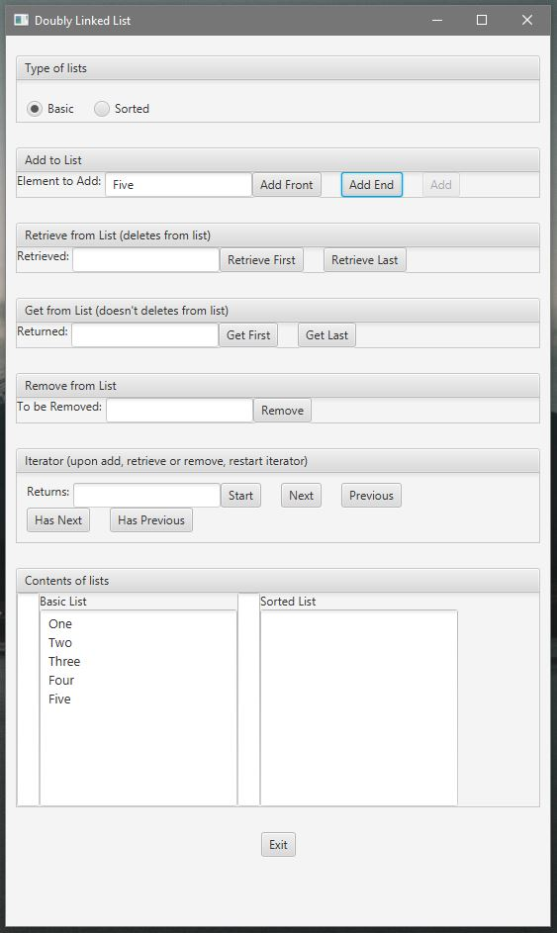
Test 2
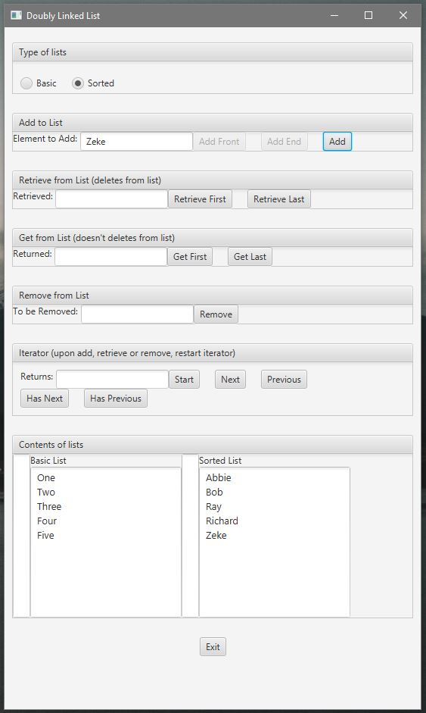

Test 3
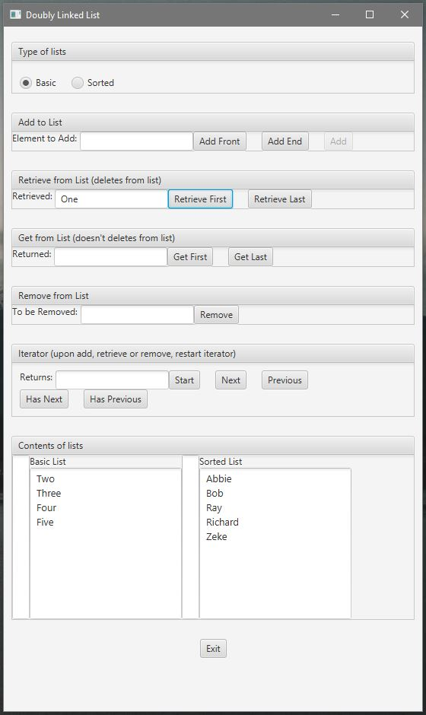

Test 4
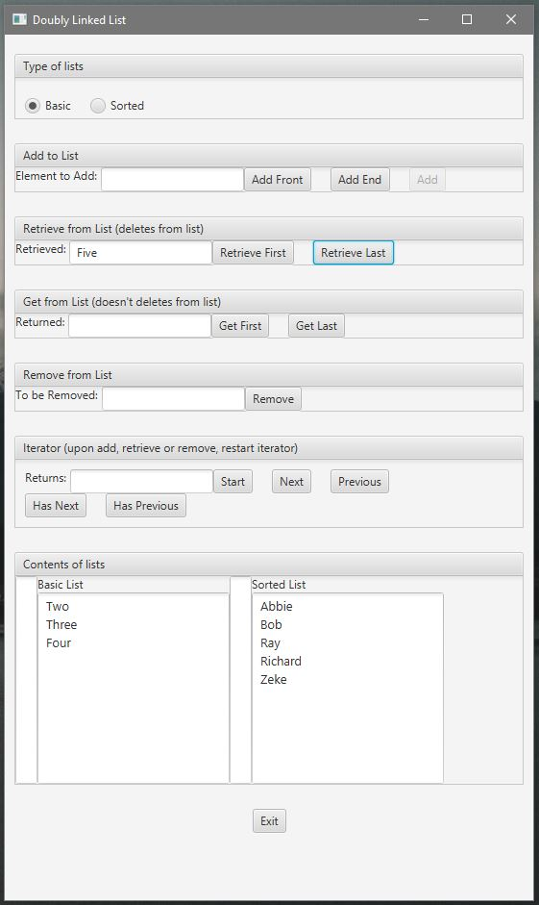

Test 5
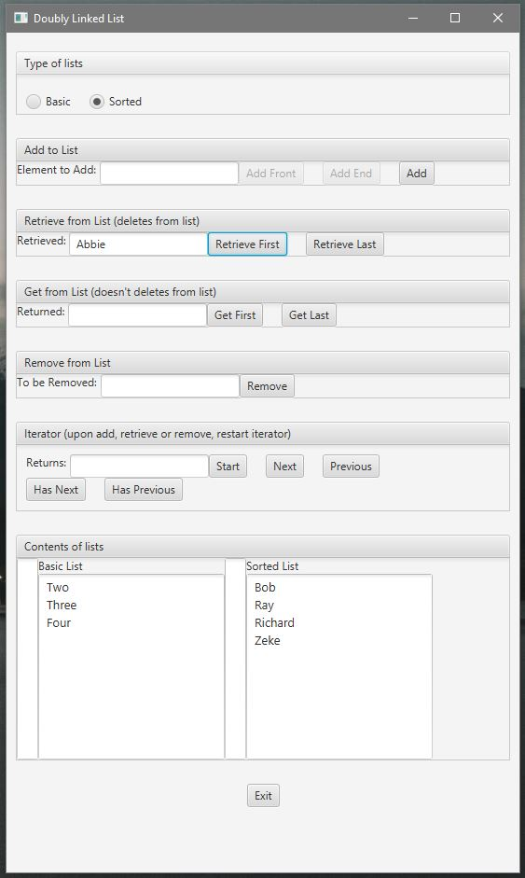

Test 6
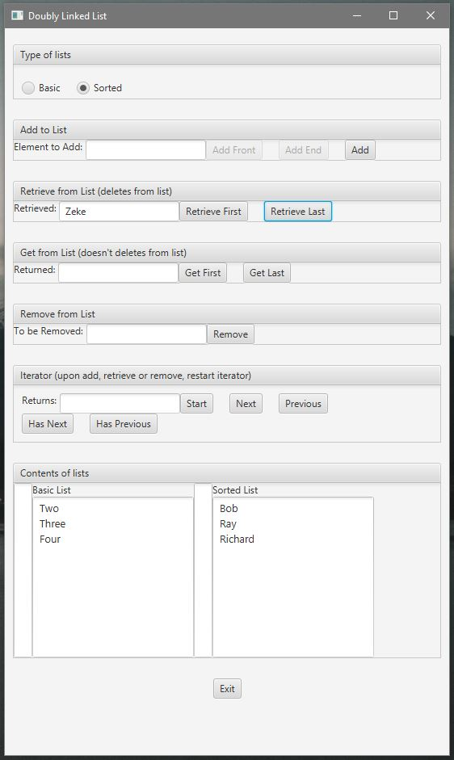

Test 7
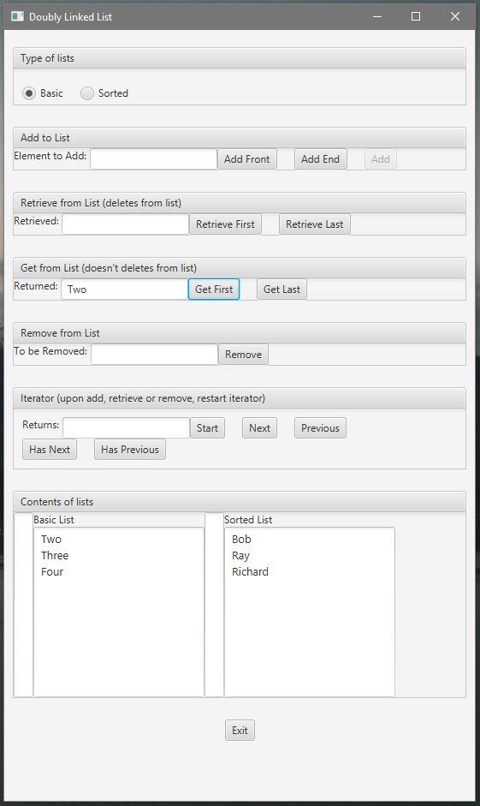

Test 8
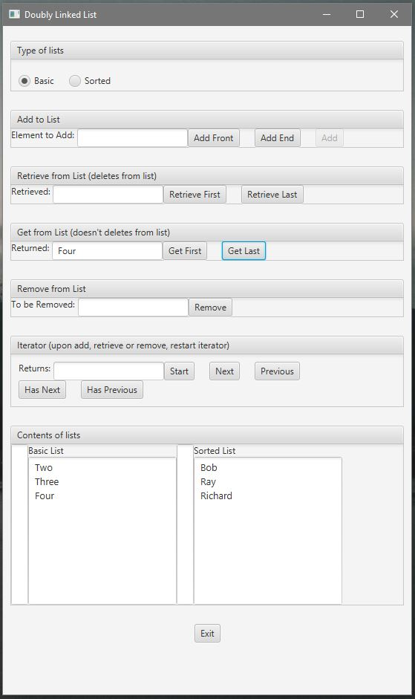

Test 9
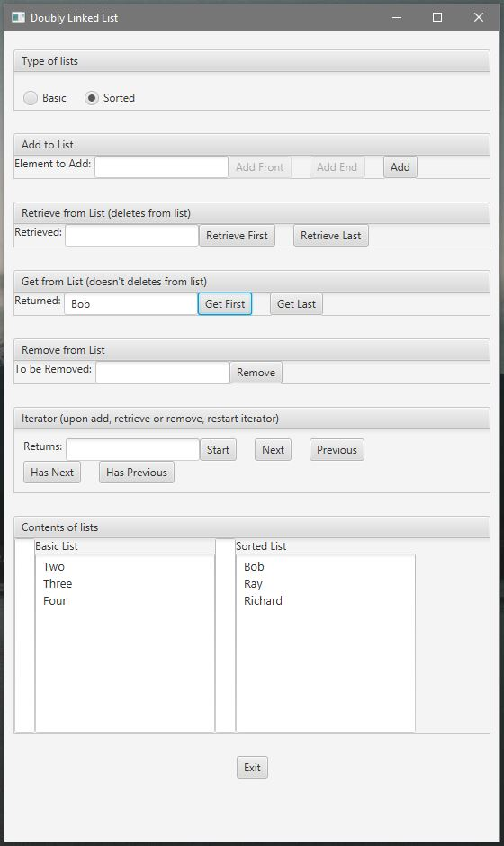

Test 10
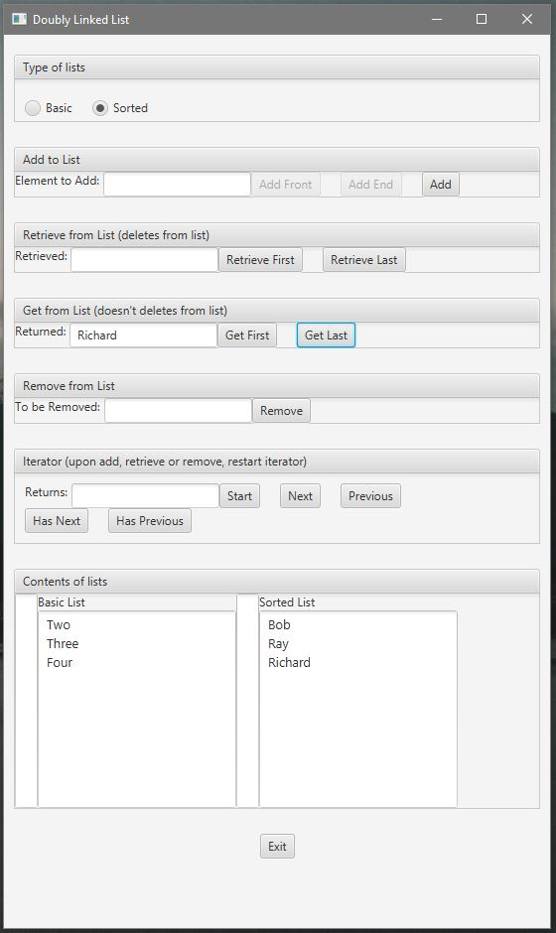

Test 11
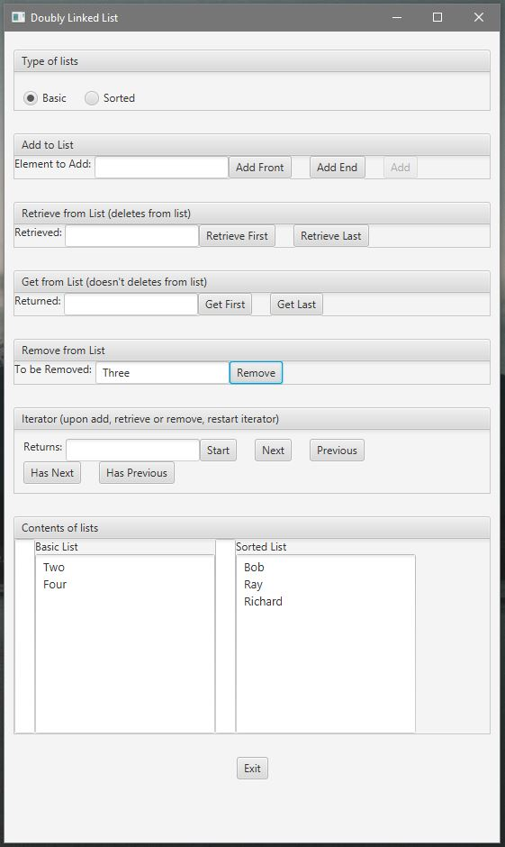

Test 12
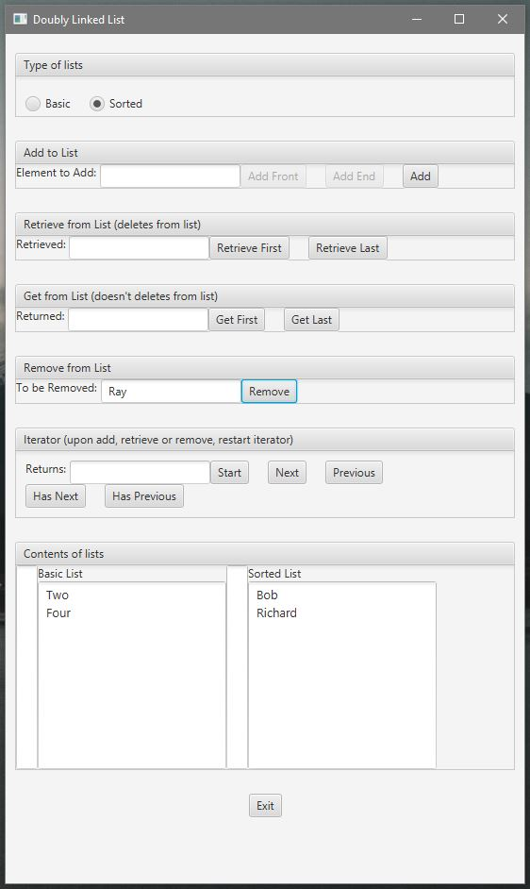

Test 13
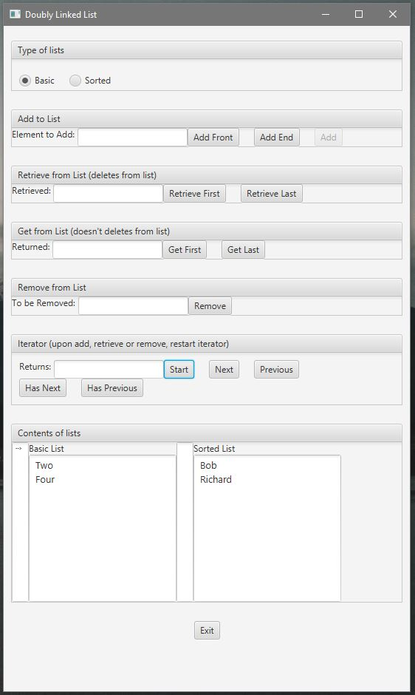

Test 14
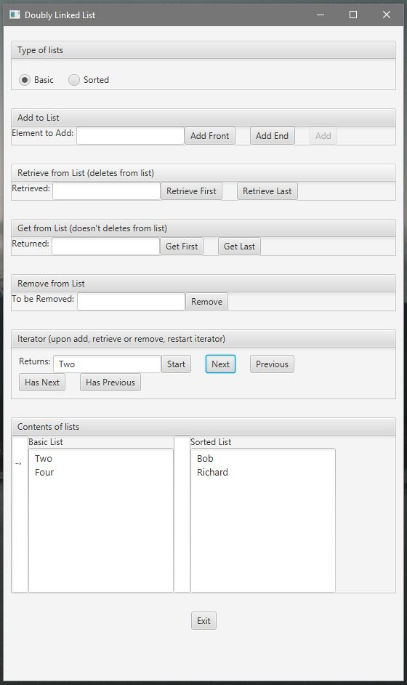

Test 15
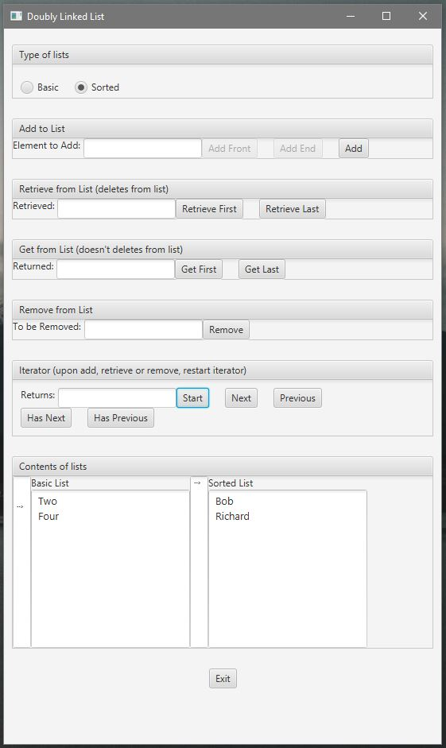

Test 16
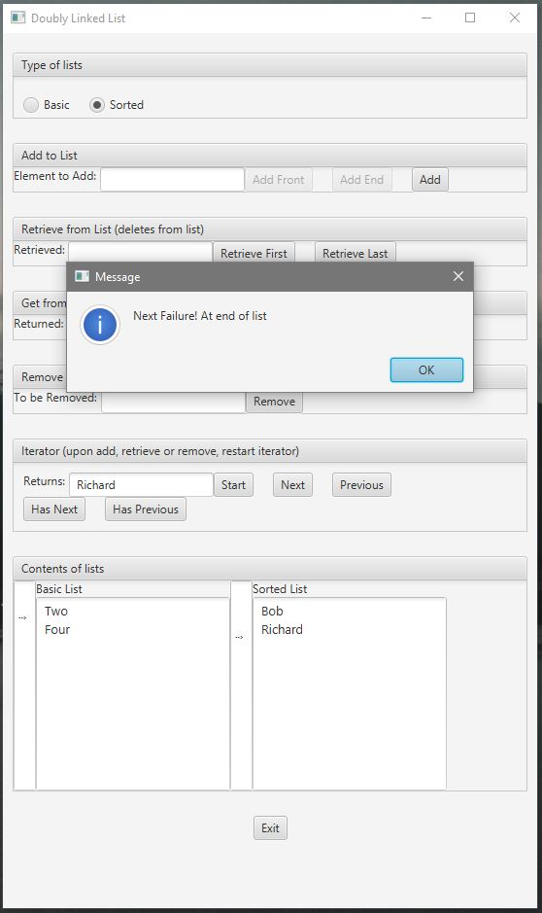

Test 17
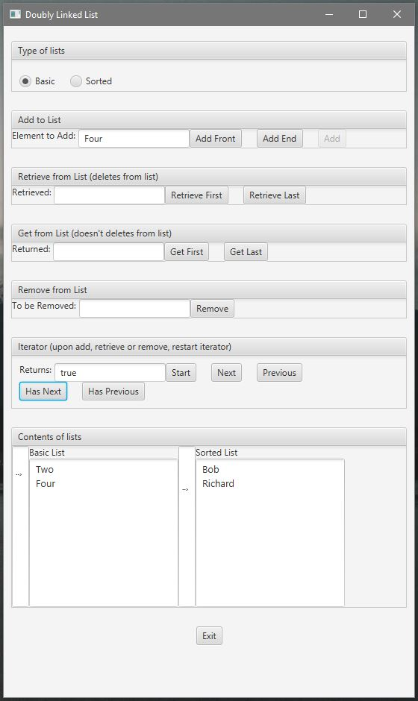

Test 18
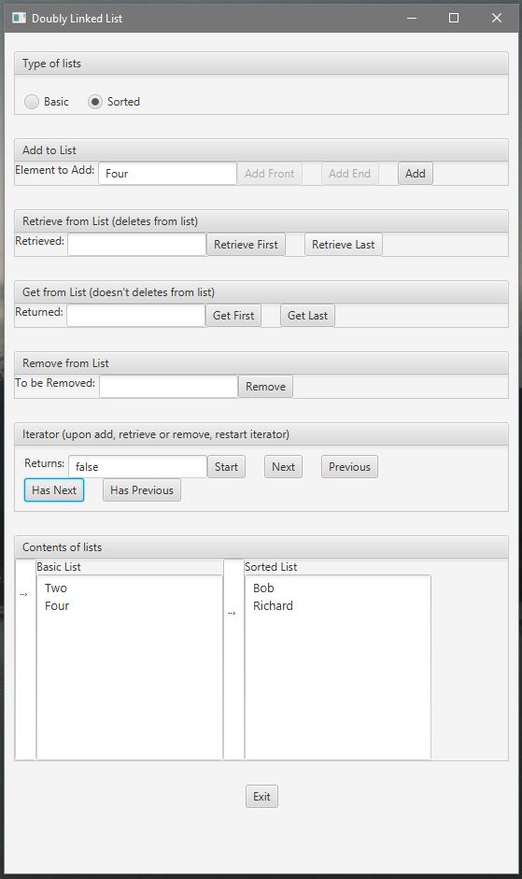

Test 19
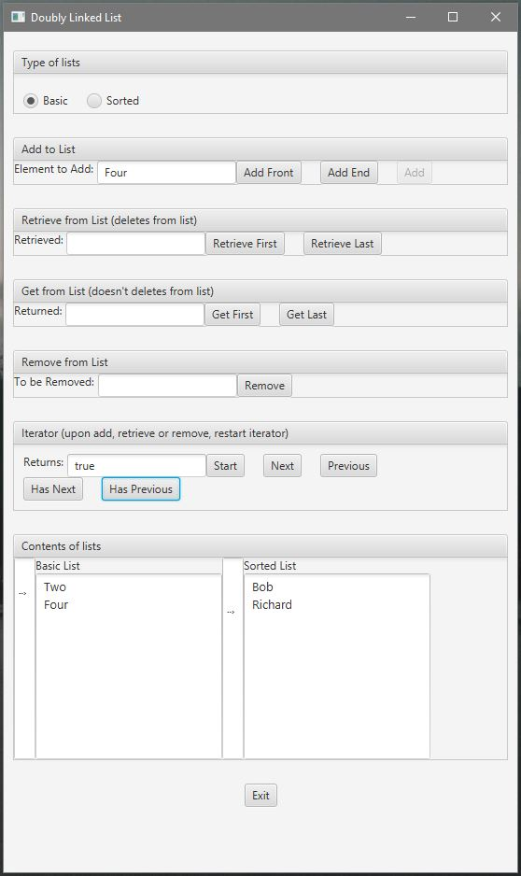

Test 20
