Queue Lab
What I Learned:
This lab combined what I learned in the past two labs: linked lists and generics. I used both of these concepts to implement a linked queue. My first step was to copy the method definitions and Javadoc comments from QueueInterface.java into a new file LinkedQueue.java. This class, LinkedQueue, was given a generic parameter, <T>, and uses a custom Node class to link the queue entries. I had no trouble referencing the textbook and reviewing the algorithms of queue methods, such as enqueue() and dequeue().

Issues I Encountered:
While programming LinkedQueue, I was unsure if the methods dequeue() and getFront() should have a throws clause in their headers. Doing this would have required the interface header definitions to include the throws clause, which I was not allowed to change. And not adding the throws clause was giving my IDE an error saying “unhandled exception”. Asking our learning assistant, Catherine, she recommended I review the PowerPoint slides for the lecture on Exceptions. This reminded me of what exception classes the compiler checks for. By changing the ExptyQueueException to extend RuntimeExcpetion instead of Exception, the compiler ignored the exception until the program runs.

What I Would’ve Done Differently:
One thing I would have done differently in this lab is asking questions before spending too much time trying to figure out the solution to a problem. I spent a lot of time thinking about all these possibilities of how I could solve the problem mentioned above, but taking the advice to revisit the PowerPoint slides really helped me.

How I Will Apply Queues in the Future:
I plan on using this concept of queues to solve problems where I have to process a certain number of tasks in order of when they were submitted. I am looking forward to later in the course when I will learn how to implement a priority queue. I am hoping that learning about priority queues broadens what I am able to program in Java and other languages.
Console Screenshot 1:
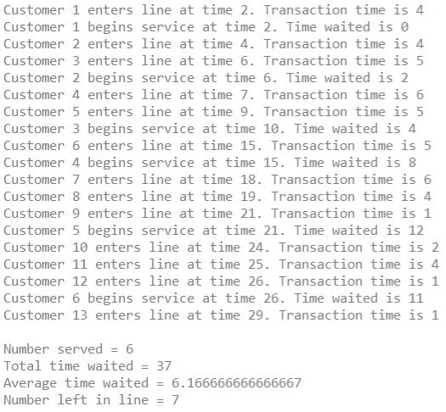

Console Screenshot 2:
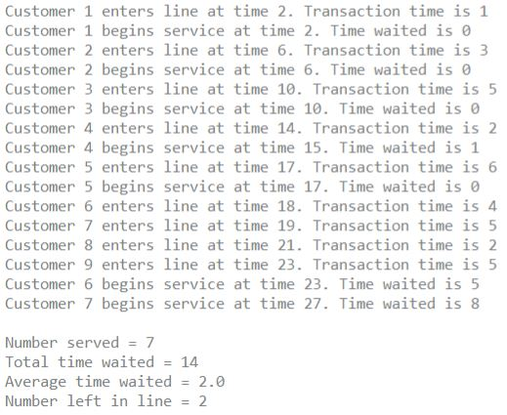

GitHub Repository:
