Project 5: Morse Code Converter
…

Assumptions:
- Package statements in provided files can be discarded
- The GUI will work as described if the MorseCodeConverter, MorseCodeTree, and TreeNode classes are implemented correctly.
- All thrown errors from the implemented classes will be handled and interpreted by JavaFX file(s).
- All text cases performed by the instructor that read an ASCII text file with MorseCodeConverter will follow the required format.

UML Class Diagram:
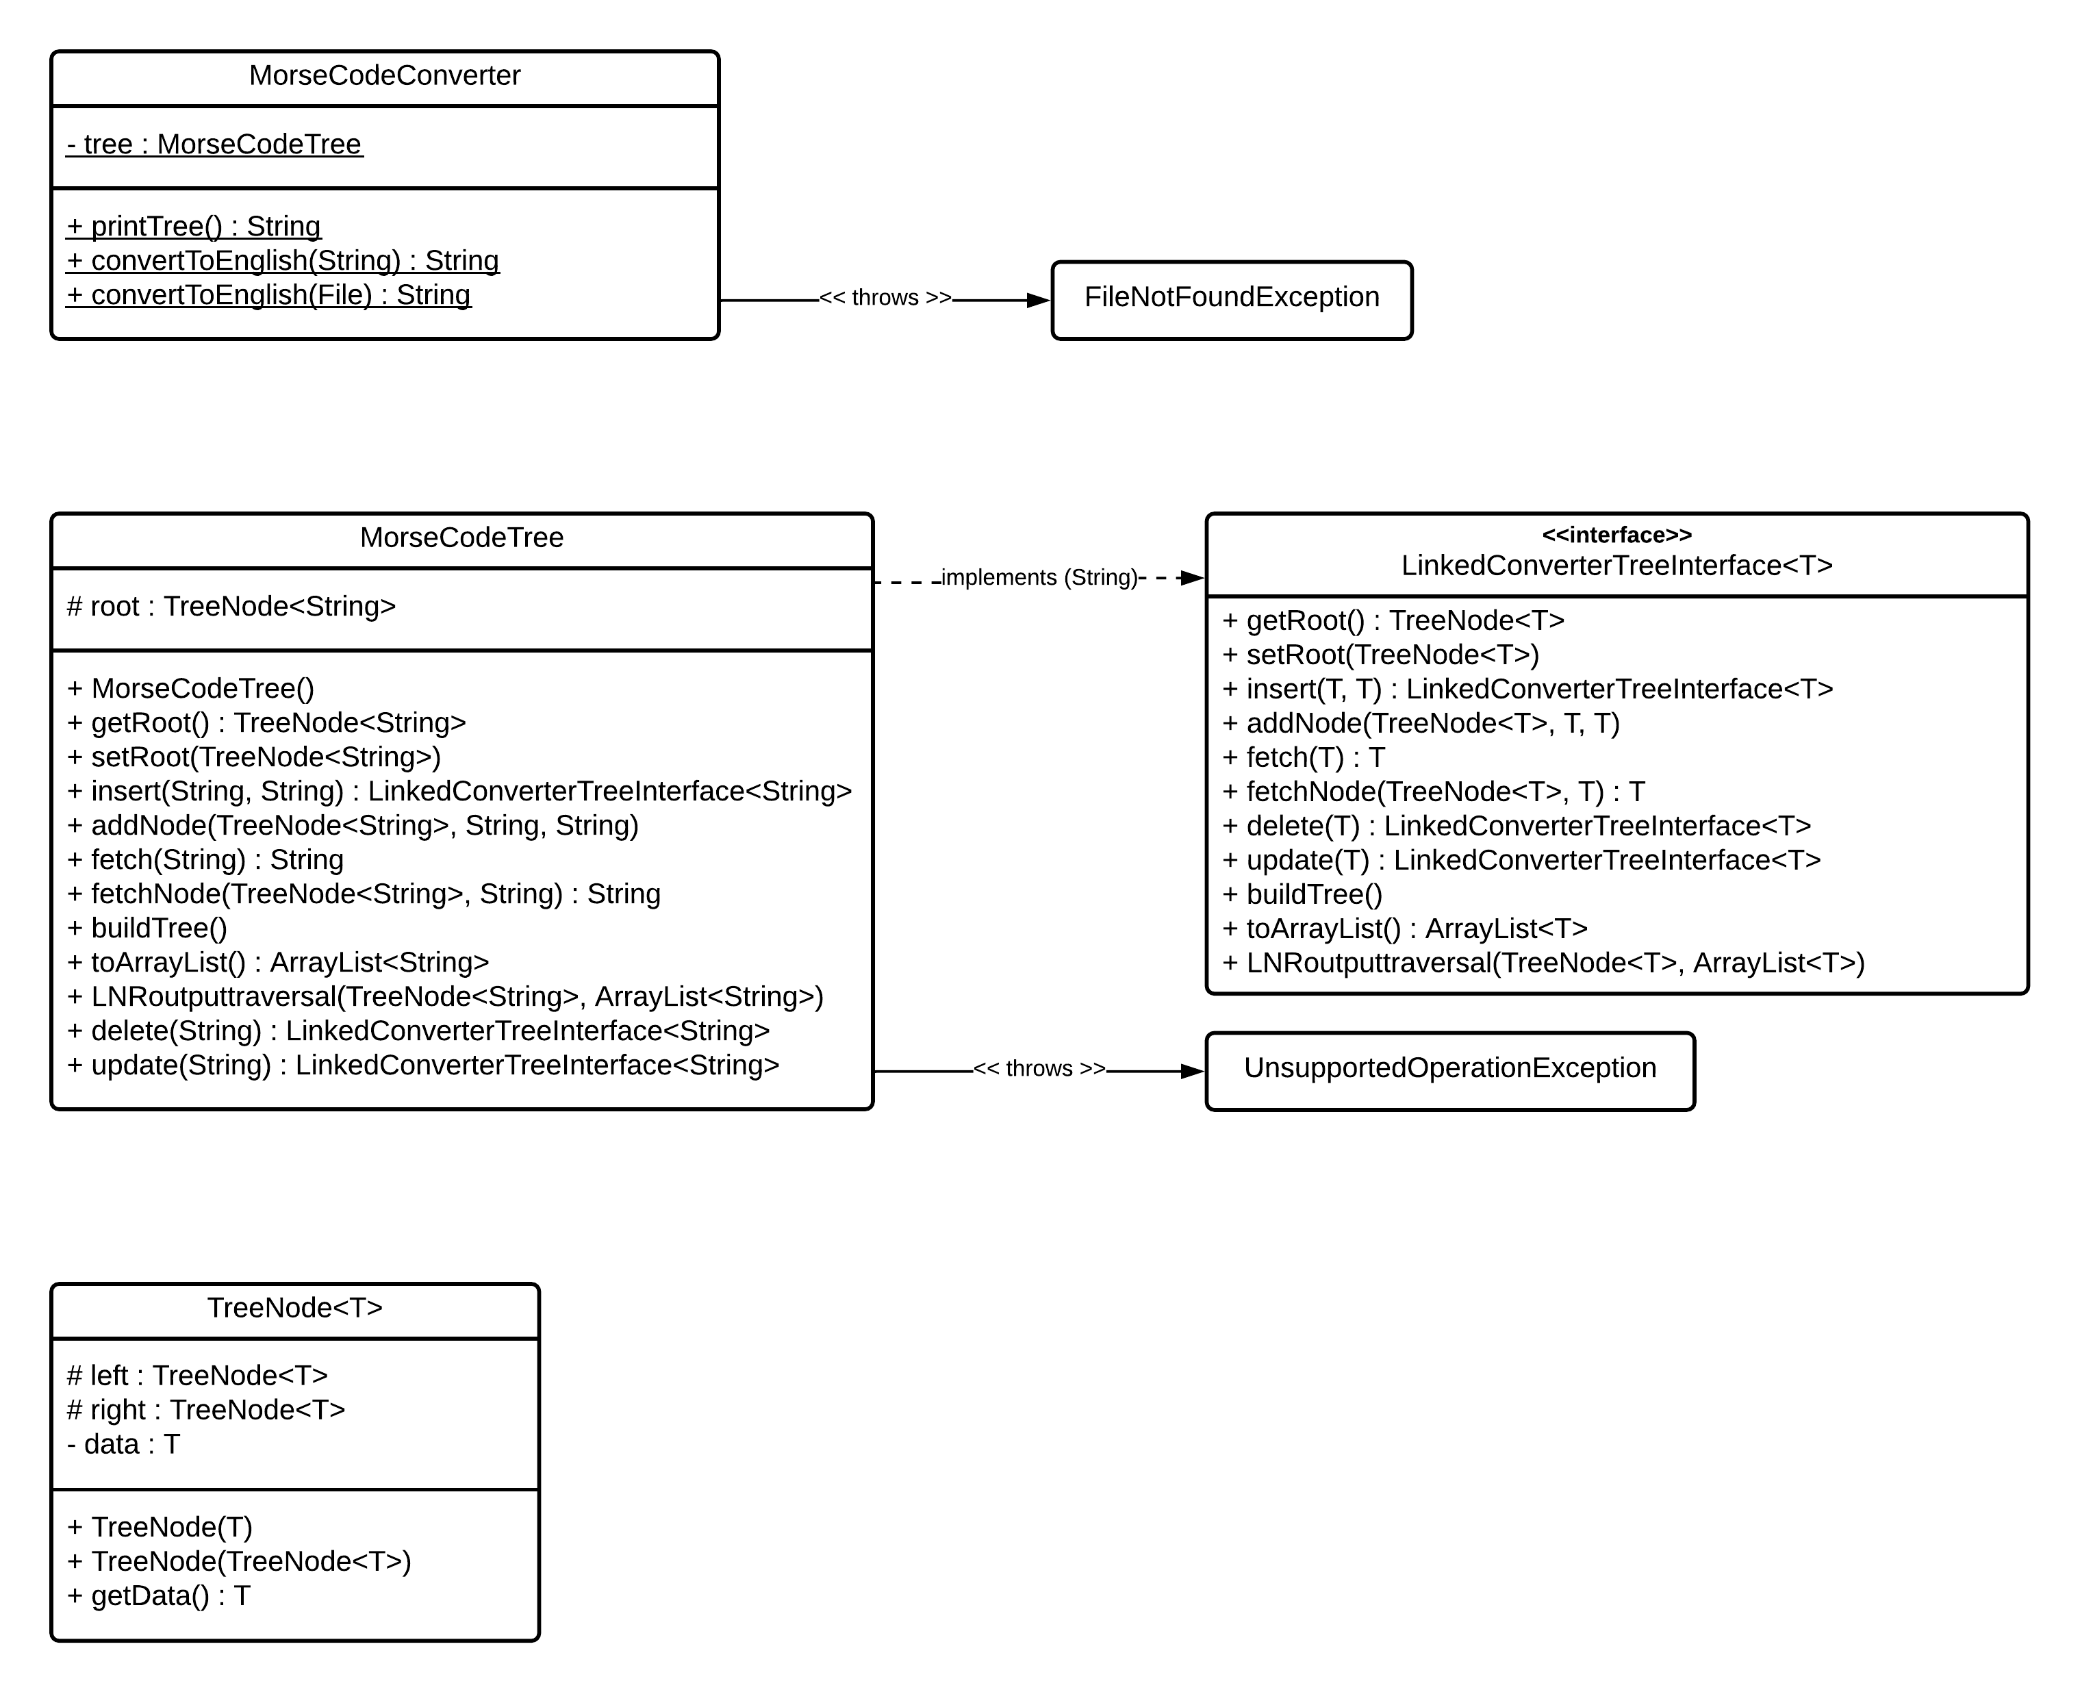

Test Plan
# | Input | Expected Output | Actual Output | Pass?

Test Screenshots
Test 1

Test 2

Test 3

Test 4

Test 5

Test 6

Test 7

Test 8

Test 9

Test 10

