Hashing Lab
What I Learned:
I learned from completing this lab how to perform multiple hashing algorithms by hand. Given 10 array elements, I was tasked with calculating the final hash table when using the linear probing, quadratic probing, linear-quotient, and bucket hashing algorithms. The easiest algorithms for me to calculate were the linear probing and bucket hashing. With linear probing, all I needed to do was evaluate a modulo expression and increase the hash code by one while any collisions occurred. Bucket hashing was also simple because if a collision occurred I wrote down the new key next to the original key to represent a linked list. The quadratic probing and linear-quotient algorithms were more involved and required more concentration. Quadratic probing was similar to the linear probing algorithm where instead of adding one to the modulo evaluation, I added 2 to the power of the collision counter. Lastly, the linear-quotient algorithm was the most tedious because it involved a sequence of steps that varied from key to key. However, performing all of these algorithms by hand increased my understanding of them.

Issues I Encountered:
The main issue I encountered was quickly resolved by communication from Professor Thai. The issue involved the challenge problem in which I picked a hashing algorithm, a custom 15 element array, and a hash table with the size of 20. The communication from Professor Thai stated that the hash table should be of size 21. When reading this statement I remembered from his lecture on Hashing that hash tables should be of an odd size. When the hash table was of size 20, I ran into a situation where I was in an infinite loop trying to hash a certain number. I was not able to hash this number when the hash table with of size 20 because the offset was 2 and every even hash code was already taken. I encountered another issue, however, after increasing my hash table size to 21. The hashing algorithm I chose to use for the challenge problem was linear-quotient and I selected the 4K+3 prime of 7. I found myself in an infinite loop once again when trying to hash a certain key. My hypothesis for this issue is that the 4K+3 prime cannot be a multiple of the hash table size. I included a picture of this situation with the rest of the screenshots in this document.

What I Would’ve Done Differently:
Something I would have done differently in this lab is start with the algorithms that I was most unfamiliar with and knew would take longer. These algorithms include the quadratic probing and linear-quotient. If I stated on these more involved algorithms I would have had more time to discover issues and ask questions to my professor and our learning assistant.

How I Will Apply Hashing in the Future:
I plan on using hashing in the future when I need to store a linked collection of objects that will require multiple instances of searching. If I had a collection of phone numbers and I needed to check if a given phone number already existed, then I would use hashing to check the hash code with entries in the hash table. This would be a better alternative than constantly traversing the collection to check if a phone number existed, which sometimes might involve traversing the whole collection. With hashing, I can create a hash code and check if the value is stored in the hash table. While this could potentially be more than a one-step algorithm concerning collisions, it would be much faster than traversing the collection for each search.

Console Screenshot 1 (Close Game w/ Loss):
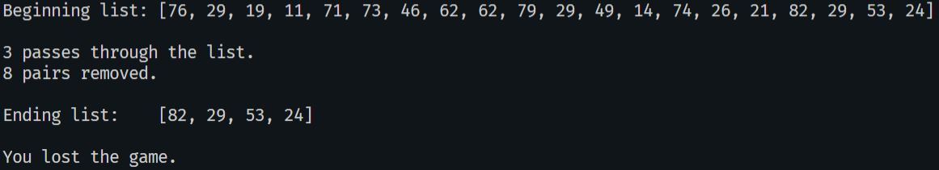

Console Screenshot 2 (Total Loss):
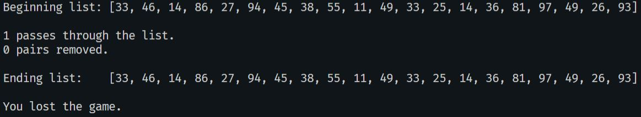

Console Screenshot 3 (Won Game):
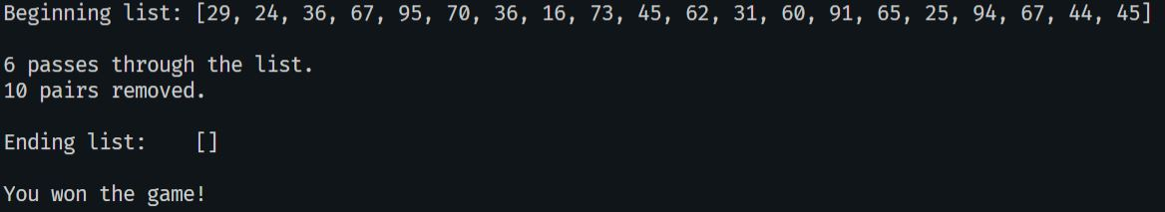

GitHub Repository:
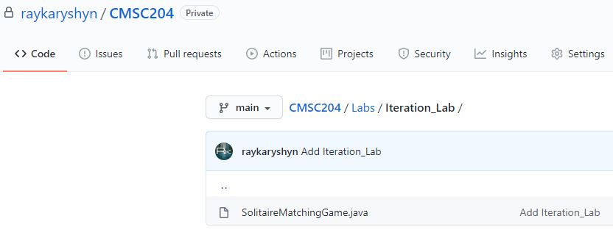

Infinite Hashing Loop w/ 4K+3 as a multiple of N
