Project 6: Dijkstra’s Shortest Path
…

Assumptions:
- Package statements in provided files can be discarded
- The GUI will work as described if the Town, Road, Graph, and TownGraphManager classes are implemented correctly.
- All thrown errors from the implemented classes will be handled and interpreted by JavaFX file(s).
- All text cases performed by the instructor that read an ASCII text file with TownGraphManager will follow the required format.

UML Class Diagram:
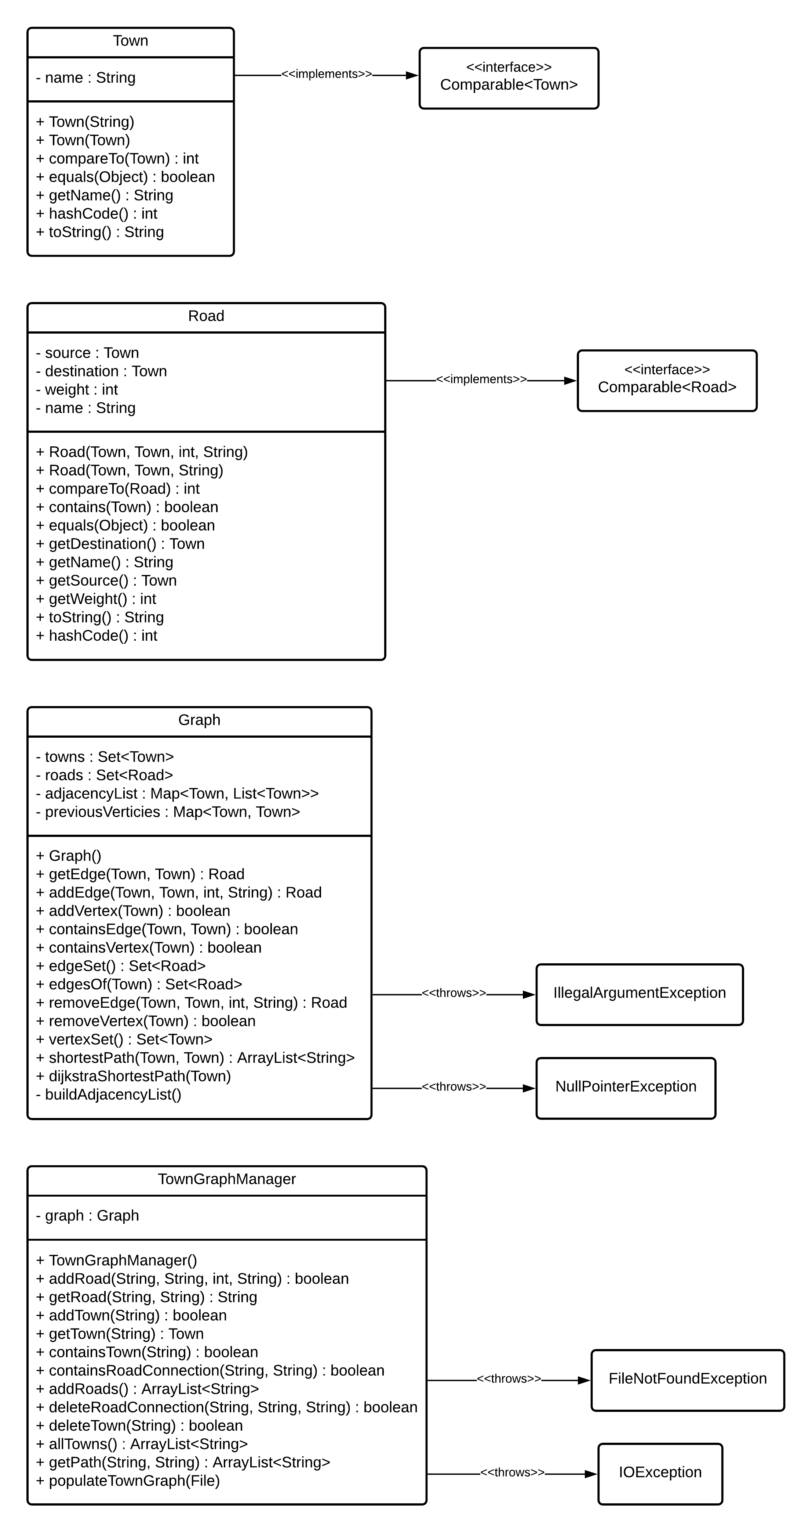
Test Plan
# | Input | Expected Output | Actual Output | Pass?
1
2
3
4
5
6
7
8
9
10

Test Screenshots
Test 1

Test 2

Test 3

Test 4

Test 5

Test 6

Test 7

Test 8

Test 9

Test 10

