Project 4: Course Database
In Project 4, I was tasked with creating three classes that are needed for the provided JavaFX GUI to function. The three classes are: CourseDBElement, CourseDBStructure, and CourseDBManager. The CourseDBElement class models objects that contain various pieces of information about a course (i.e. the ID of the course, the instructor’s name, how many credits will be awarded, etc.). The CourseDBStructure class models a hash table that stores CourseDBElement objects. The CourseDBManager class uses a CourseDBStructure object and also adds the functionality for a user to read courses from an ASCII text file.
The information stores by CourseDBElement objects is: course ID, CRN, number of credits, room number, and name of the instructor. For example, I can store an object with the following information (expressed with JSON): {courseID: MATH284, crn: 1234, numberOfCredits: 4, roomNumber: SC456, instructorName: Prof. Gary Thai}. The class contains two constructors, one to initialize an empty element and the other that requires all course information attributes. There are getters and setters available for all course information attributes. For use with CourseDBStructure, there is a hashCode() method. The hash code for CourseDBElement objects is calculated with the CRN, where it is converted to a string and returns that strings hashCode(). Another method included in CourseDBElement is compareTo(). This is because the class implements the java.lang.Compareable<CourseDBElement> interface. The compareTo() method returns the provided object’s crn from the current’s. The final method in CourseDBElement is toString() that represents the current object as: "\nCourse:courseId CRN:crn Credits:numberOfCredits Instructor:instructorName Room:roomNumber”. Because there was no Javadoc provided or instructions concerning the output of the toString() method, this format was determined from the provided Junit tests.

Assumptions:
- Package statements in provided files can be discarded
- The GUI will work as described if the CourseDBElement, CourseDBStructure, and CourseDBManager classes are implemented correctly.
- All thrown errors from the implemented classes will be handled and interpreted by JavaFX file(s).

UML Class Diagram:
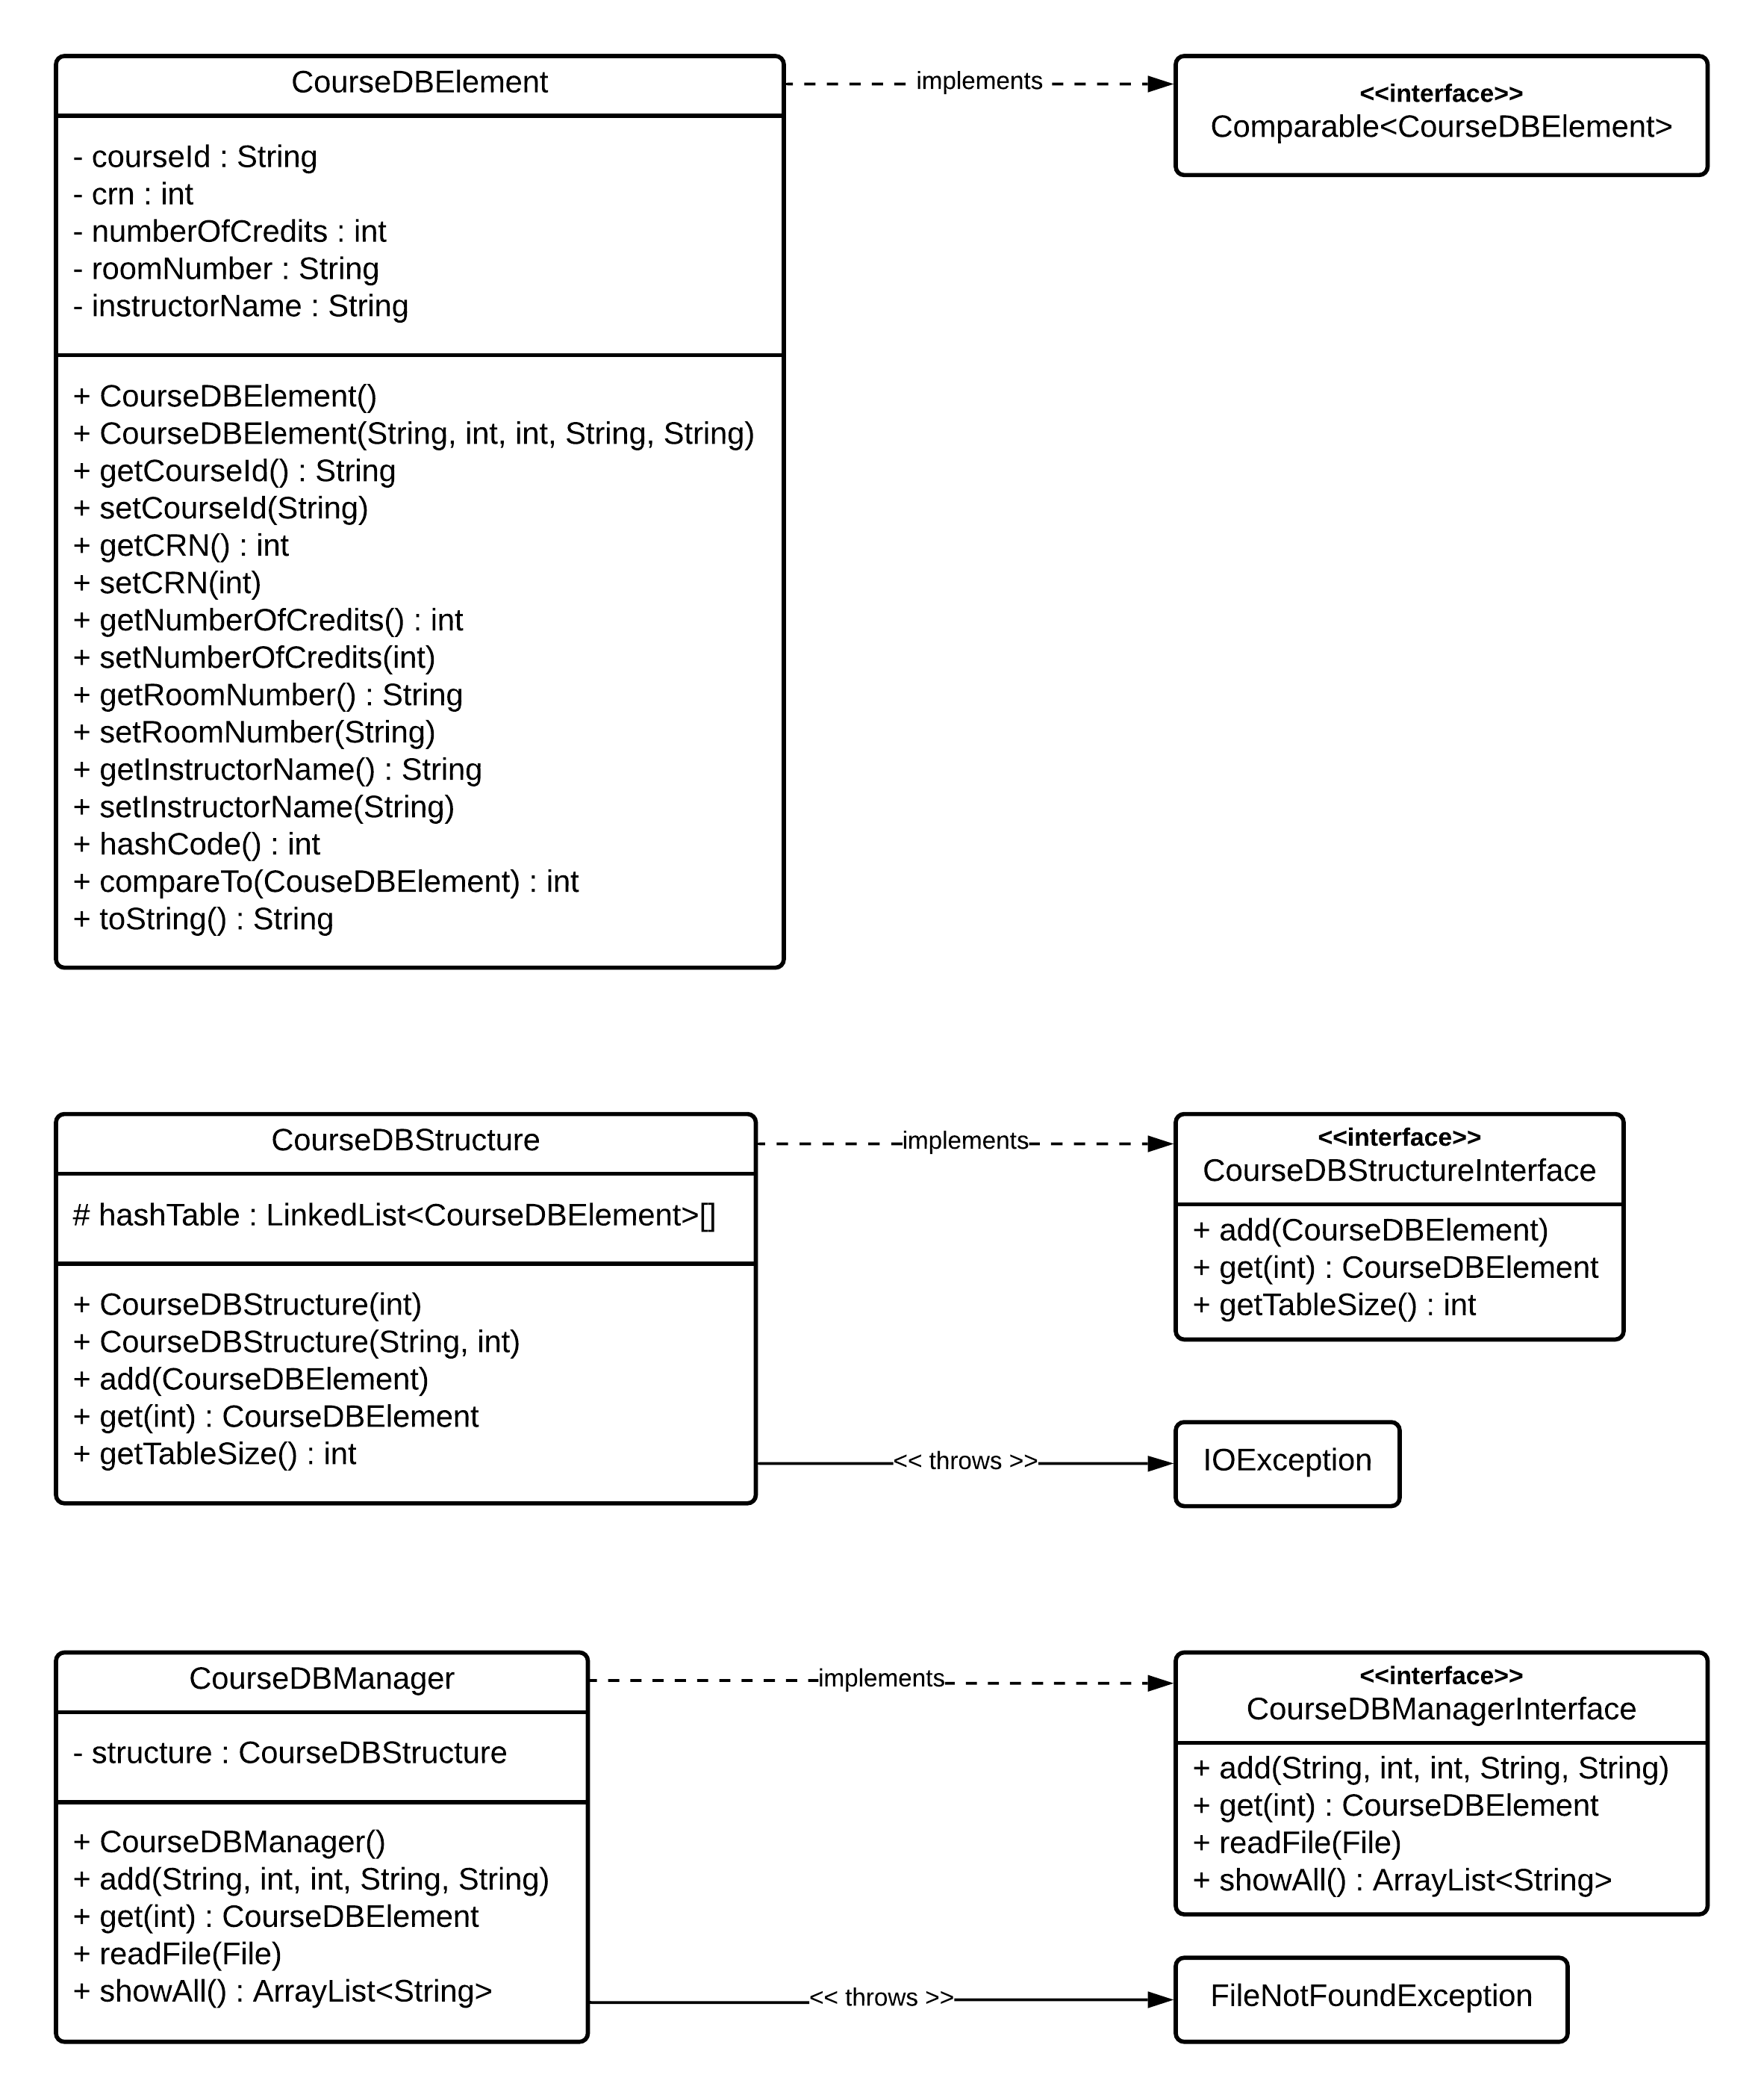

Test Plan
# | Input | Expected Output | Actual Output | Pass?
1 | a) Select the provided course.txt file  b) Click “Show DB” | All elements in the file shown in the dialog box | All elements in the file shown in the dialog box | Y
2 | a) Create a new file, courses_STUDENT.txt  b) Select file  c) Click “Show DB” | All elements in the file shown in the dialog box | All elements in the file shown in the dialog box | Y
3 | a) Add to database with fields  b) Click “Show DB” | Element located in the dialog box | Element located in the dialog box | Y
4 | a) Add to database with fields  b) Click “Show DB” | Element located in the dialog box | Element located in the dialog box | Y
5 | a) Add to database with fields  b) Click “Show DB” | Element located in the dialog box | Element located in the dialog box | Y
6 | Search for CRN “123456” | Display correct element | Display correct element | Y
7 | Search for CRN “234567” | Display correct element | Display correct element | Y
8 | Search for CRN “123” | Display correct element | Display correct element | Y

Test Screenshots
Test 1a
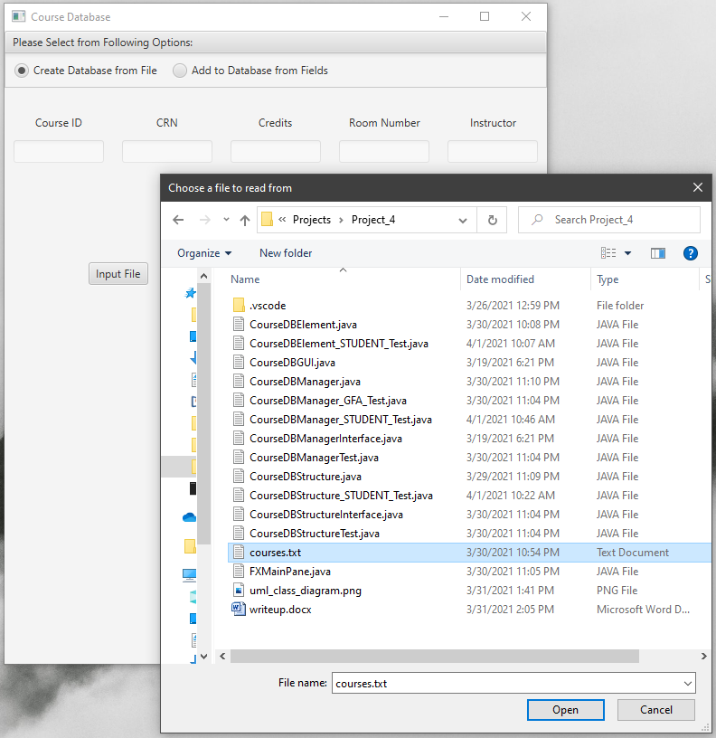

Test 1b
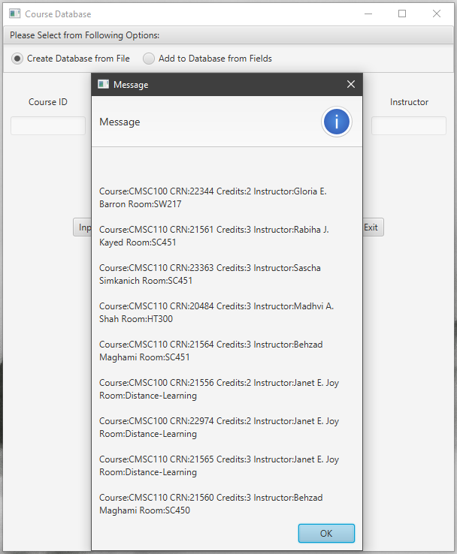

Test 2a
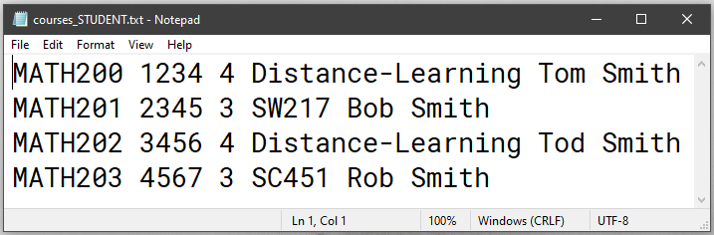

Test 2b
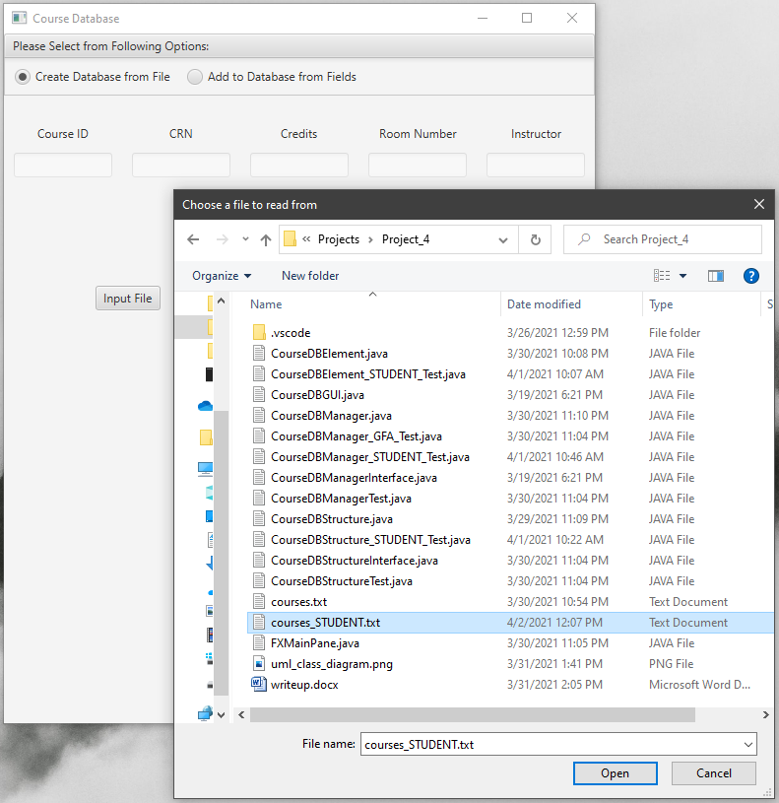

Test 2c
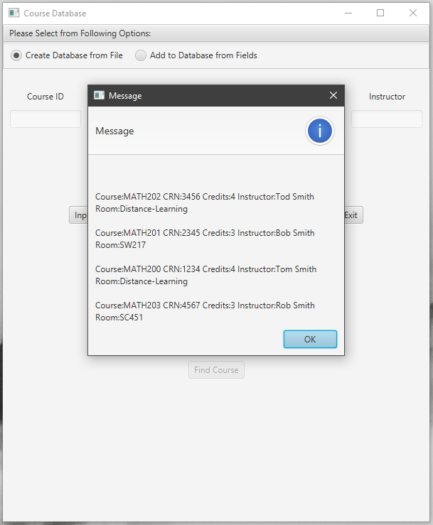

Test 3a
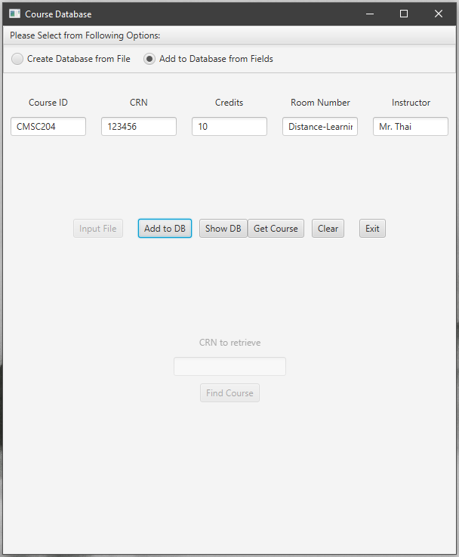

Test 3b
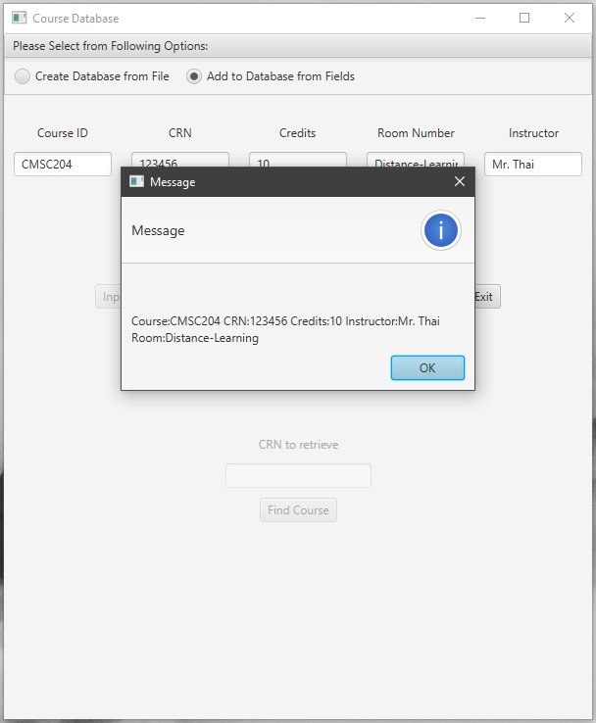

Test 4a
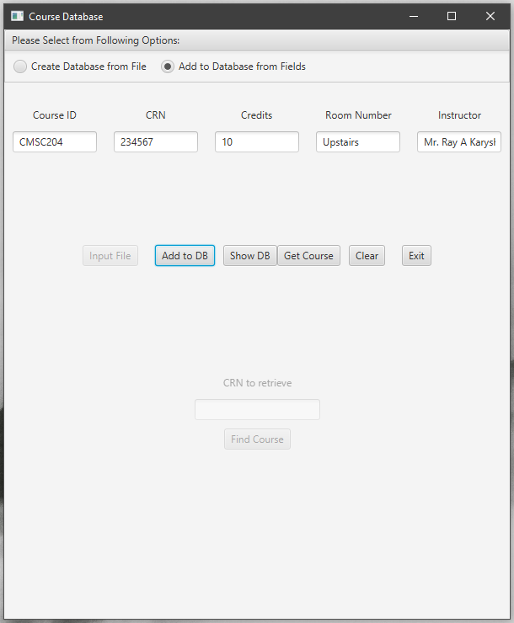

Test 4b
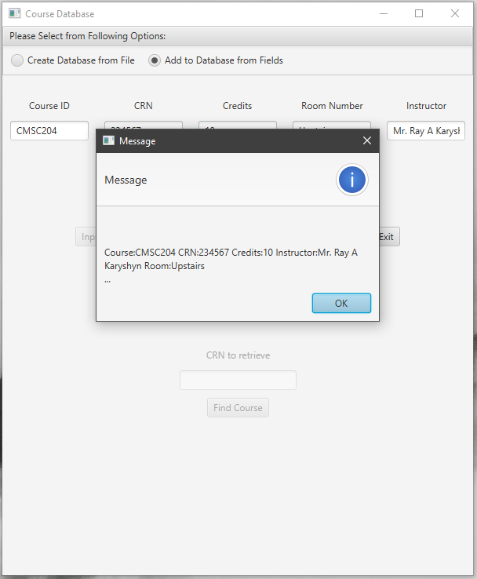

Test 5a
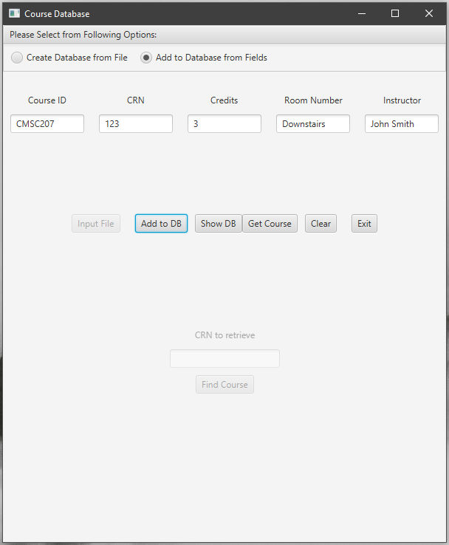

Test 5b
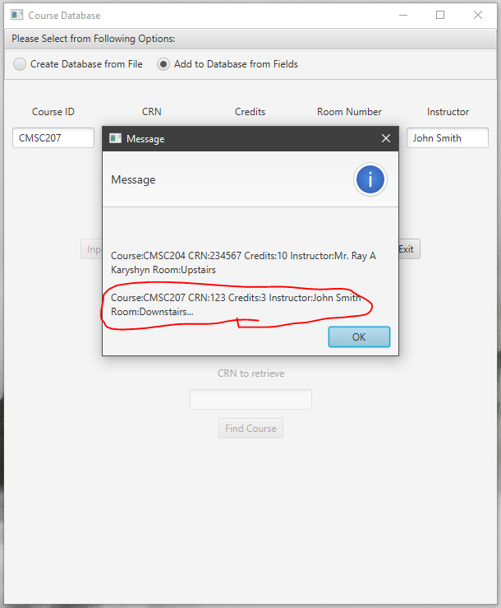

Test 6
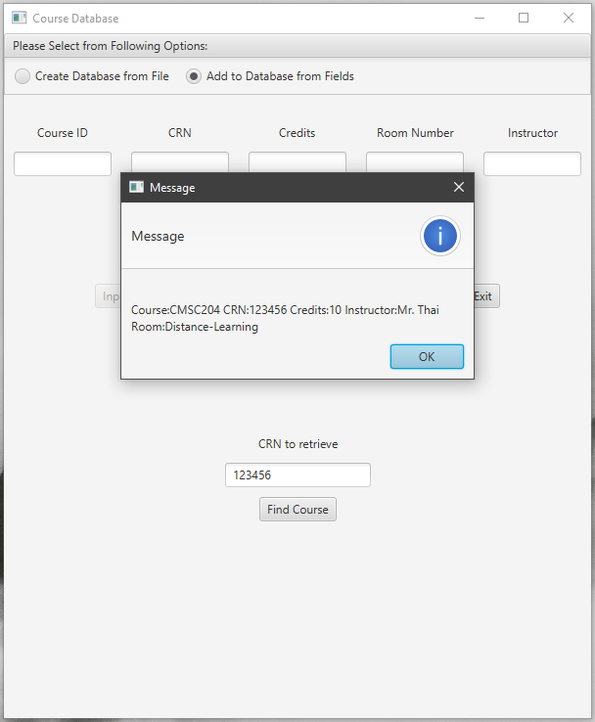

Test 7
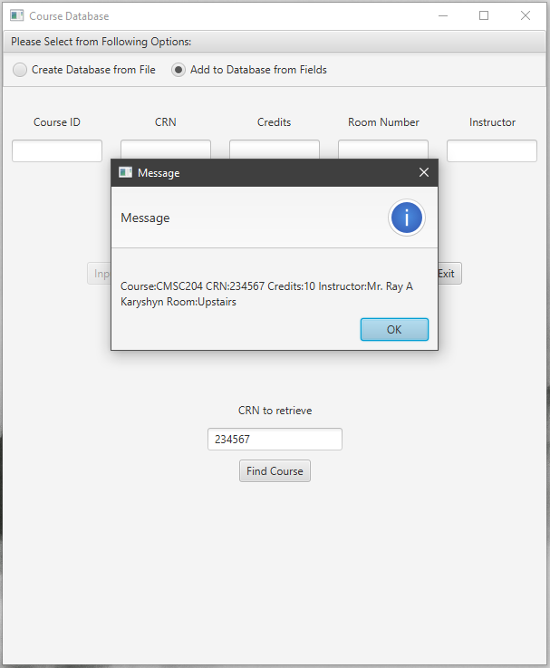

Test 8
