Chat Room Lab
What I Learned:
In this lab, I learned how to develop a chat room application that supports multiple users. The powerhouse of the chat room is the server, which continually “listens” for users (or clients) to join. The server initializes a socket on localhost using the port defined with CHAT_ROOM_PORT (5001 via ChatRoomMainFX). Similarly, each client has a dedicated socket that connects to the localhost on the port CHAT_ROOM_PORT. When the server socket is made aware of a client's request to come in over the network, a reference to the client’s socket is created and is used to enable IO communication. The server and each of the clients have a BufferedReader object for accepting input and a PrintWriter object for sending output. I also was able to use my new knowledge of threads from last week.

Issues I Encountered:
One minor issue that I encountered while I was completing this lab occurred when I was creating the thread to run in startServer() of ChatServerExec. Performing this task was the first step outlined in the release details, so I created a thread with a ChatServer object. However, I was getting an error that the constructor for the thread was undefined for the type ChatServer. After thinking about it, I remembered that my thread should be given a class that implements Runnable. When I looked at the code for ChatServer, there was a TODO comment that I overlooked that recommended I add something to the class header so that I could use an instance of ChatServer in a thread. The addition was simply to append “implements Runnable”.

What I Would’ve Done Differently:
…

How I Will Apply Sockets in the Future:
…

GUI Screenshot:
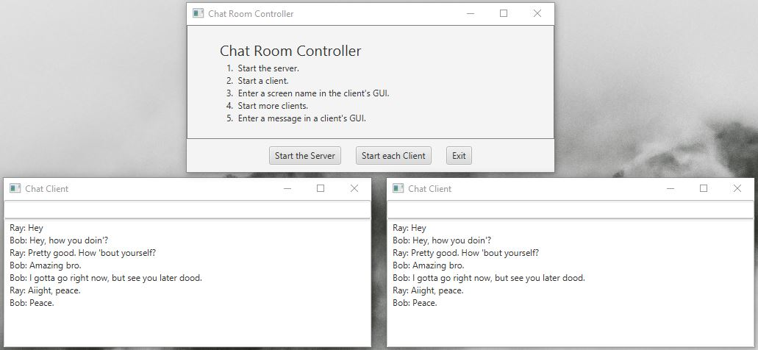

Console Screenshot:
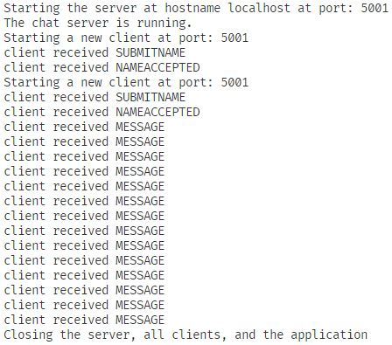
GitHub Repository:
