Project 2: Infix & Postfix Notations
For this project, I was tasked with making a JavaFX GUI of an infix-postfix calculator functional by creating a utility class. The utility class, Notation, was described by a Javadoc file and consists of three methods: convertInfixToPostfix, convertPostfixToInfix, and evaluatePostfixExpression. convertInfixToPostfix converts an expression from infix notation to postfix notation using a custom queue, NotationQueue. convertPostfixToInfix converts an expression from postfix notation to infix notation using a custom stack, NotationStack. Both convertInfixToPostfix and convertPostfixToInfix, take in a string and return a string. The last method, evaluatePostfixExpression evaluates a postfix expression by taking in a string and returning a double. Implementing NotationStack and NotationQueue was simple, as it involved using the interfaces StackInterface and QueueInterface, respectively, and referencing the textbook for guidance on the insides of methods. The part of this project that took the most time was developing the Notation class methods.
In addition to the utility class, custom stack, and custom queue, I created 5 custom exceptions. One exception, InvalidNotationFormatException, was to be thrown when the format given to the Notation utility class is incorrect. QueueOverflowException and QueueUnderflowException are thrown then the queue methods are called on a full and empty queue, respectively. Likewise, StackOverflowException and StackUnderflowException are thrown then the stack methods are called on a full and empty stack, respectively.
I learned as I was completing this project is how much the UML class diagram helped to see how classes interact and are related to each other. The visual representation that I created shows the exceptions potentially thrown by classes. The UML class diagram also shows how the exceptions are related to each other through extending the RuntimeException. Not only did the UML class diagram help grasp the big picture of the program structure, but it helped me keep track of how everything is related to each other.
For the next assigned project, I plan on still working on the design first, but working on the Java implementation further along the 2-week timeline. The first week of this project I spent mostly on the design and reviewing the Java files that were given. I wish, however, that I started working on coding and not leaving myself only a week left to finish the project.
One thing I would recommend to my instructor is to spend more time covering the postfix to infix algorithm and evaluating postfix expressions during the lecture before this project. We spent enough time on converting infix expressions to postfix expressions that I felt comfortable implementing the algorithm in Java, but I had a difficult time coding the reverse algorithm and that which evaluates postfix expressions.

Assumptions:
- Package statements in provided files can be discarded
- The GUI works and will work with Notation, if implemented correctly
- Exceptions thrown by NotationStack and NotationQueue methods will not be checked
- Exponents are not required to be handled correctly
- Spaces are ignored and no spaces are shown in the calculated conversion
- Only numbers of single digits can be entered for the calculator to work correctly since spaces are ignored

UML Class Diagram:
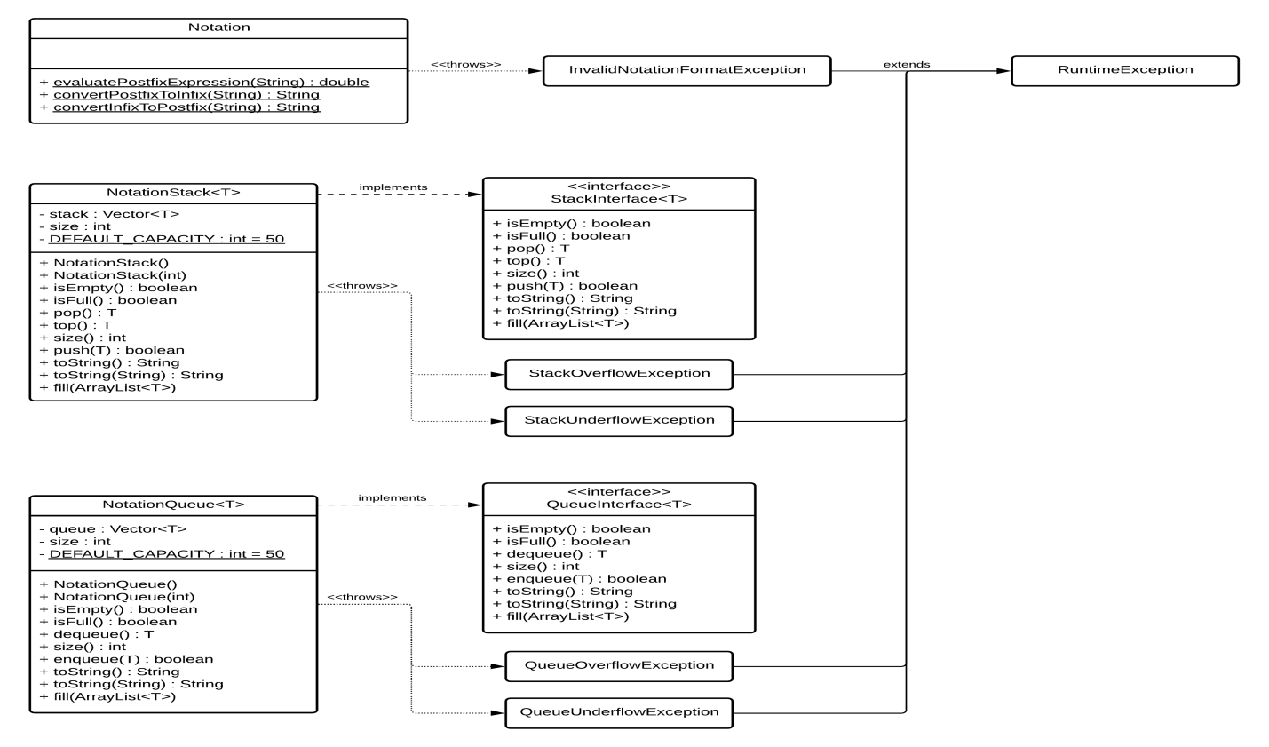

Test Plan
# | Input | Expected Output | Actual Output | Pass?
1 | Conversion  Infix: (1+2+3) | Postfix: 12+3+ | Postfix: 12+3+ | Y
2 | Conversion  Infix: ((1+2)/(3*4))/5 | Postfix: 12+34*/5/ | Postfix: 12+34*/5/ | Y
3 | Conversion  Infix: 1+2*3+4/5 | Postfix: 123*+45/+ | Postfix: 123*+45/+ | Y
4 | Conversion  Postfix: 123+ | A Notation format was incorrect. | A Notation format was incorrect. | Y
5 | Conversion  Postfix: 12+3-5/8/ | Infix: ((((1+2)-3)/5)/8) | Infix: ((((1+2)-3)/5)/8) | Y
6 | Conversion  Postfix: b2%4a*c*- | Infix: ((b%2)-((4*a)*c)) | Infix: ((b%2)-((4*a)*c)) | Y
7 | Evaluation  12+3-5/8/ | 0.0 | 0.0 | Y
8 | Evaluation  12+3+ | 6.0 | 6.0 | Y
9 | Evaluation  12+34*/5/ | 0.05 | 0.05 | Y
10 | Evaluation  123*+45/+ | 7.8 | 7.8 | Y

Test Screenshots
Test 1
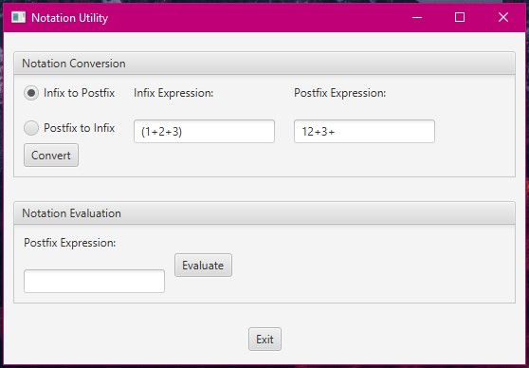

Test 2
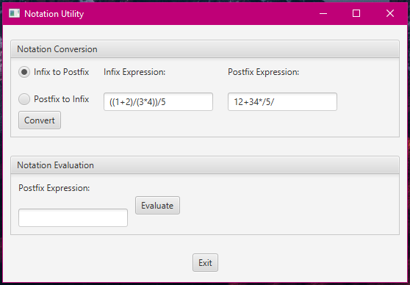
Test 3
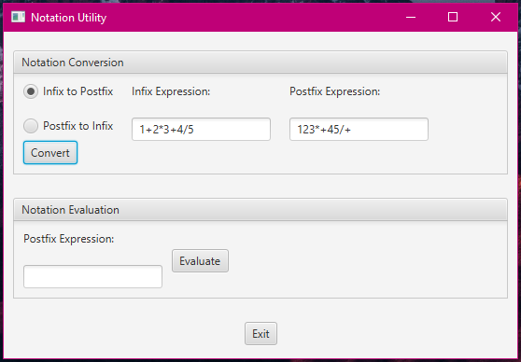

Test 4
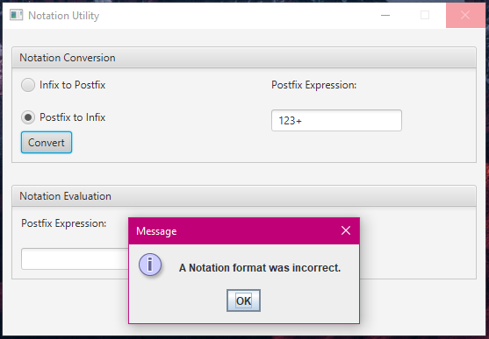

Test 5
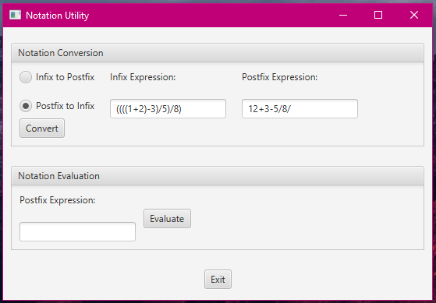

Test 6
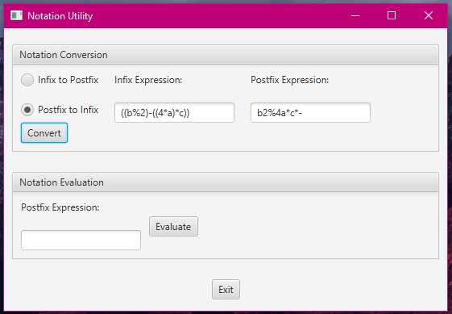

Test 7
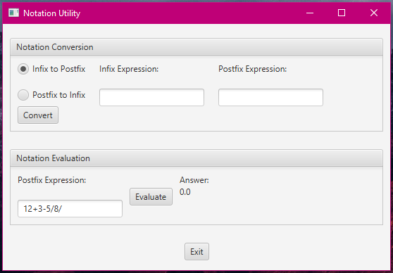

Test 8
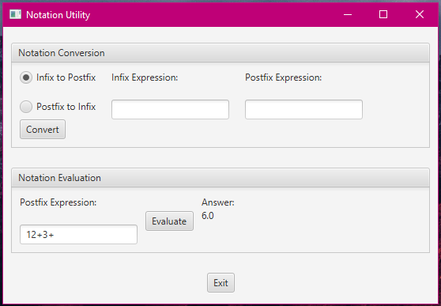

Test 9
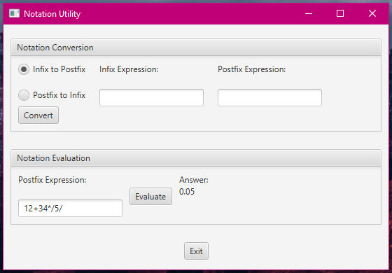

Test 10
