Scenario 1: Passenger searches for flights, view available seats, and makes booking

Phase 1: Flight Discovery (Search)
Goal: Quickly display available flight options for the chosen route.
Step 1 — User Action: Passenger enters Origin (SIN), Destination (NRT), and Date (2024-12-20) and clicks "Search".
Step 2 — UI → Flight Service (Atomic): UI calls Flight Service directly via HTTP GET.
- URL: GET /flights?origin=SIN&dest=NRT&date=2024-12-20
- Flight Service queries Flight DB and returns:
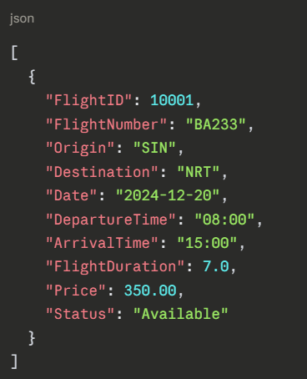
Step 3 — UI Rendering: UI displays the flight cards.
Phase 2: Seat Selection (Detail View)
Goal: When a user selects a flight, use the Flight Search Composite to aggregate, filter, and shape the flight details and seat map before returning to the UI — ensuring no sensitive data like PassengerID is exposed.
Step 4 — User Action: Passenger clicks on a specific flight card.
Step 5 — UI → Flight Search Composite: UI calls the composite via HTTP GET.
- URL: GET /search/details?FlightID=10001
Step 6 — Flight Search Composite → Flight Service (Atomic):
- URL: GET /flights/10001
- Returns full flight details to composite:
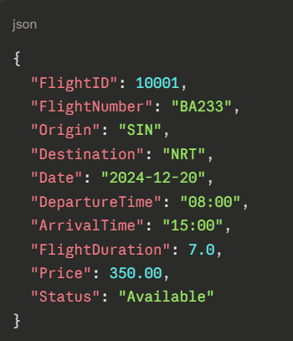
Step 7 — Flight Search Composite → Seat Service (Atomic):
- URL: GET /seats?FlightID=10001
- Returns full seat records to composite:
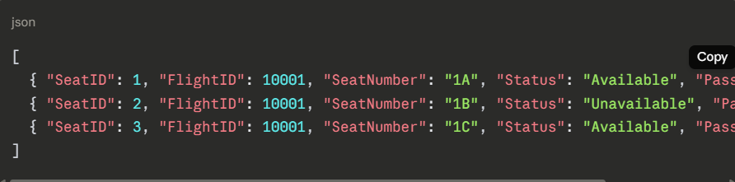
Step 8 — Composite Logic: Composite merges both responses, strips sensitive fields (PassengerID, SeatID, FlightID) from the seat data, and shapes the response for the UI.
Step 9 — Flight Search Composite → UI: Returns the cleaned, merged response:
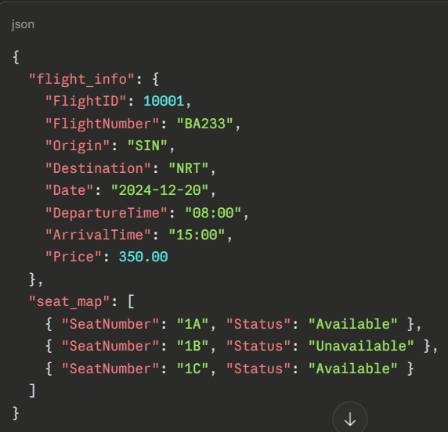
Step 10 — UI Rendering: UI renders the flight details alongside a visual seat map showing available and unavailable seats.

Phase 3: Transaction Orchestration (The "Booking")
Goal: Coordinate the booking transaction across Passenger, Seat, Booking Record, and Payment services.
Step 11 — User Action: Passenger selects seat 1A and clicks "Book Now".
Step 12 — UI → Booking Composite: UI calls the Booking Composite via HTTP POST.
- URL: POST /booking
- Payload:
json
{ "PassengerID": 5, "FlightID": 10001, "SeatID": 1 }
Step 13 — Validate Passenger: Booking Composite calls Passenger Service (OutSystems).
- URL: GET /passengers/5
- Returns:
json
{ "PassengerID": 5, "FirstName": "Adrian", "LastName": "Tan", "Email": "adrian@gmail.com" }
Step 14 — Hold Seat: Booking Composite calls Seat Service.
- URL: PUT /seats/1/hold
- Returns:
json
{ "SeatID": 1, "Status": "Hold" }
Step 15 — Create Booking Record: Booking Composite calls Booking Record Service.
- URL: POST /records
- Payload:
json
{ "PassengerID": 5, "FlightID": 10001, "SeatID": 1, "AmountPaid": 385.00, "BookingStatus": "Pending" }
- Returns:
json
{ "BookingID": 999, "BookingStatus": "Pending" }
Step 16 — Process Payment: Booking Composite calls Payment Service (wrapper microservice).
- URL: POST /payments
- Payload:
json
{ "BookingID": 999, "PassengerID": 5, "Amount": 385.00 }
- Internal: Payment Service creates a Stripe Checkout Session, verifies payment, and records StripeSessionID, StripeChargeID, and IdempotencyKey in Payment DB.
- Returns:
json
{ "PaymentID": 1, "Status": "Completed", "StripeChargeID": "ch_3PkAmNLkZw1FgY28a0" }

Phase 4: Finalisation & Async Notification
Goal: Update all statuses and trigger a confirmation email via RabbitMQ.
Step 17 — Confirm Booking Record: Booking Composite calls Booking Record Service.
- URL: PUT /records/999
- Payload:
json
{ "BookingStatus": "Confirmed" }
Step 18 — Confirm Seat: Booking Composite calls Seat Service.
- URL: PUT /seats/1/book
- Payload:
json
{ "PassengerID": 5 }
- Seat Service updates Status to Unavailable and records PassengerID.
Step 19 — Publish to RabbitMQ: Booking Composite publishes to RabbitMQ exchange.
- Routing Key: booking.confirmed
- Payload:
json
{
"type": "booking.confirmed",
"email": "adrian@gmail.com",
"data": {
"BookingID": 999,
"FlightNumber": "BA233",
"Origin": "SIN",
"Destination": "NRT",
"Date": "2024-12-20",
"DepartureTime": "08:00",
"SeatNumber": "1A",
"AmountPaid": 385.00
}
}
Step 20 — UI Feedback: UI displays "Booking Confirmed!"
Step 21 — Async Email Notification: Notification Service (wrapper microservice) consumes the booking.confirmed message from RabbitMQ and calls SendGrid API to send a booking confirmation email to the passenger in the background.

Type | Microservice
Atomic | Flight Service
Atomic | Seat Service
Atomic | Record Service
Atomic | Passenger Service (OutSystems)
Wrapper | Payment Service
Wrapper | Notification Service
Composite | Flight Search Composite
Composite | Booking Composite

