FLOW OF CONTROL
[SET – 2]
Question 1 Write a program to print number from 1 to 10.
Question 2 Write a program to print number from 10 to 1.
Question 3 Write a program that inputs 5 numbers from the user and the display their sum and average.
Question 4 Write a program to calculate the sum of first 10 natural number.
Question 5 Write a program that display odd numbers from 1 to 100.
Question 6 Write a program that display Sum of odd numbers from 1 to 100.
Question 7 Write a program that display product of odd numbers from 1 to 100.
Question 8 write a program that inputs number and then display the table of enter no.
Question 9 write a program that inputs number and length, then display the table.
Question 10 Write a program to find the factorial value of any number entered through the keyboard.
Question 11 Two numbers are entered through the keyboard. Write a program to find the value of one number raised to the power of another.
Question 12 Write a program that enter a number from the use. The program reveres the given integer number and display it on the screen.
Question 13 Write a program to reveres any given integer number.
Question 14 Write a program that enter a number from the use. The program find the sum of all digits of this number and display the sum on the screen.
Question 15 Write a program that inputs numbers from your till user enters negative number. At the end program calculates the average, sum, maximum, and minimum, of all positive numbers.
Question 16 Write a program to sum of digits of given integer number.
Question 17 Write a program that accept no from the user. It check the given number is prime or not.
Question 18 Write a program to enter the numbers till the user wants and at the end it should display the count of positive, negative and zeros entered.
Question 19 Write a program to enter the numbers till the user wants and at the end it should display the maximum and minimum number entered.
Question 20 Write a program to print out the enter number is Armstrong numbers or not. If sum of cubes of each digit of the number is equal to the number itself, then the number is called an Armstrong number.
For example 153 = (1 * 1 * 1) + (5 * 5 * 5) + (3 * 3 * 3)
Question 21 Write a program to print out all Armstrong numbers between 1 and 500.
Question 22 Write a program to print Fibonacci series of n terms where n is input by user:
0 1 1 2 3 5 8 13 24.....
Question 23 Write a program to calculate the sum of following series where n is input by user.
1 + 1/2 + 1/3 + 1/4 + 1/5 +…………1/n
Question 24 Write a program to calculate the sum of following series where n is input by user.
1 - 1/2 + 1/3 - 1/4 + 1/5 -... 1/n
where n is a positive integer and input by user.

Question 25
i) | **********  **********  **********  ********** | ii) | *  **  ***  ****  ***** | iii) | *  **  ***  ****  *****
iv) | 1  12  123  1234  12345 | v) | 1  21  321  4321  54321 | vi) | Assignment  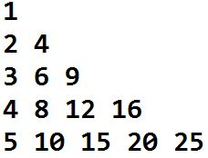
vii) | Assignment  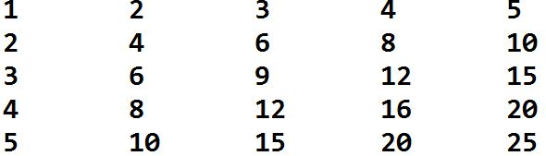 | viii) | A  A B  A B C  A B C D  A B C D E | ix) | *  ***  *****  *******  *********
x) | Assignment  BBBBBBBBB  BBBBBBB  BBBBB  BBB  B | xi) | Assignment  1  222  33333  4444444  555555555 | xii) | Assignment  1  212  32123  4321234  543212345
 |  | xiii) | Assignment  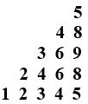
Question 26 Find the sum of first five terms of the following series.
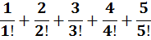
Question 27 Find the sum of first five terms of the following series.
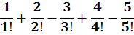
Question 28 Display the prime numbers form 1 to 500.

