# Overview

The JDElite diagram editor is a powerful interactive tool for creating and editing directed graph diagrams of any complexity in a Web browser. The user chooses or changes the positions of the nodes on the canvas grid, specifies the connections between nodes interactively by the mouse, and the editor performs an automatic routing or re-routing of the edges.

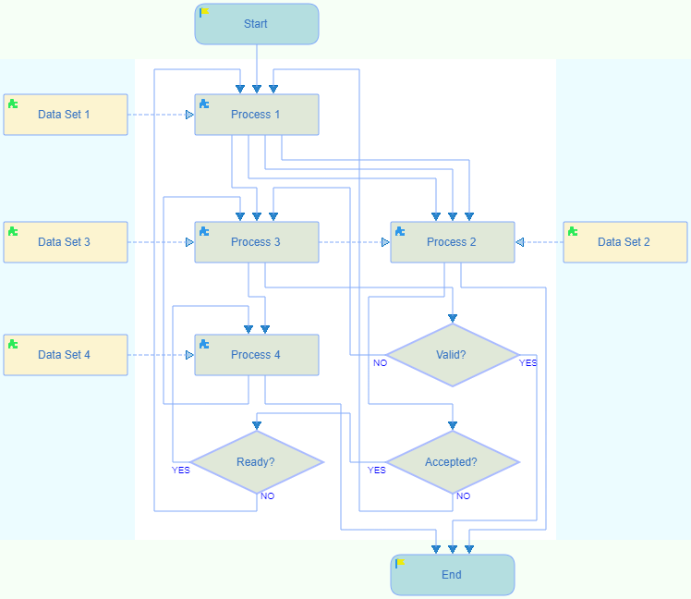

The flow direction of the diagram can be either top to bottom or left to right and can be switched at any time. The positions of the nodes are mapped to a rectangular grid that consists of layers across the flow direction and lanes along the flow direction, where the nodes are positioned in the cells at the intersections. The layers are separated by layer pipes and the lanes are separated by lane pipes, where the edges are routed. The canvas structure is optionally highlighted on mouse move.

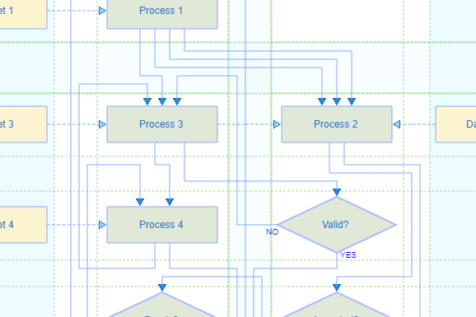

The user specifies each edge connection between two nodes interactively by using the mouse pointer, and the editor generates the edge immediately. The edges are created as orthogonal polygonal chains of line segments. Each edge corresponds to a separate edge connection between two nodes. The automatic routing assigns the segments to layer pipes or to lane pipes along the calculated shortest paths. The segments are positioned on segment tracks along the pipes. In most cases the shortest paths are allowed to cross through empty cells. The routing process excludes any overlapping of segments, as well as any crossings of the edges over the nodes. Moreover, the routing techniques that are implemented in this editor provide a highly efficient reduction of the crossings between the edges themselves (patent pending).

The editor offers a wide range of features, accessible from the toolbar and from the context menus.

* New diagrams are created and saved on the file system using a server connection. The existing diagrams can be opened in the editor for editing. The files are stored in JSON format. The demo version of the editor does not provide the server connection. New diagrams can be created and edited using all the functions of the editor without saving. To illustrate the functionality, two sample hardcoded diagrams are provided to be opened and modified without saving the edits.

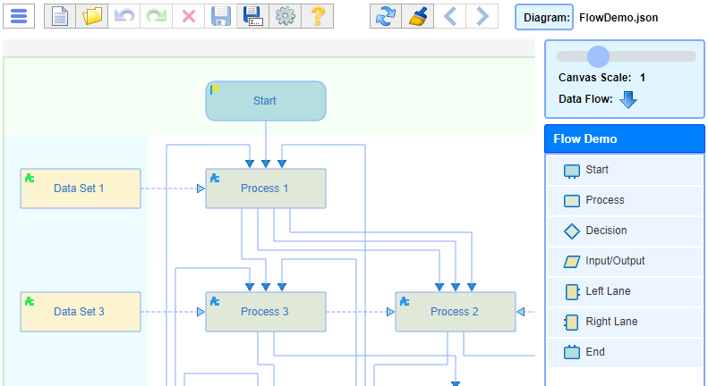

* The nodes are created either by dragging node samples from the provided palette to the canvas over an accepting cell, or by selecting a node type from a context menu in an empty cell under the mouse pointer.

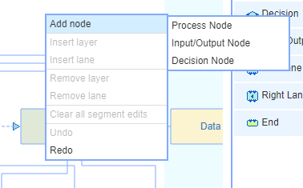

* The connections between the nodes are created by dragging the mouse between the connection handles that are popping up on the outlines of the accepting nodes under the mouse pointer. The connection is routed after the mouse is dropped over an accepting handle. Later a connection can be reassigned by dragging one of the ends of the edge to an accepting handle of a different node.

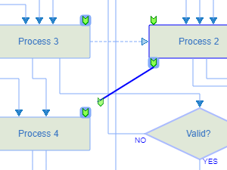 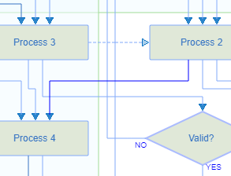

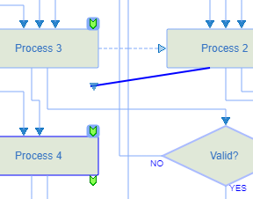 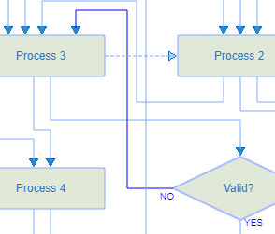

* The dimensions of the initially specified canvas grid can be changed at any time by adding new layers or lanes, or by removing empty ones, using the context menus in the appropriate locations.

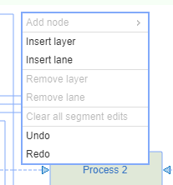 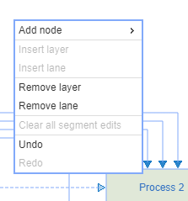

* There are specific start and end layers, as well as left and right swim lanes. They all accept their specific node types from the palette or from the mouse context menus. These layers and lanes can be added or removed through the settings dialog.

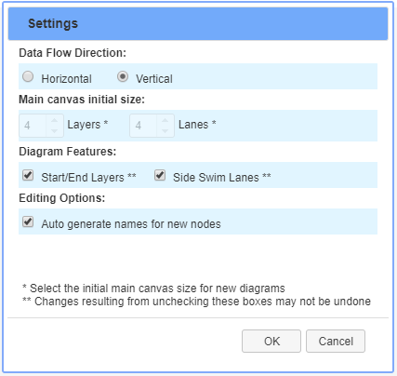

* In addition to the standard edge connections, there is a complementary category of reference links. The latter are processed in a similar way as the standard connections, and are represented with dashed lines, as shown on the diagrams.
* The flow direction can be initially selected to be either top to bottom or left to right, and can be changed and switched back at any time using the on-screen button above the palette or through the settings dialog, without otherwise affecting the diagram.
* Nodes can be moved at any time during the design process by simply dragging them with the mouse to new locations. The dragged node can be dropped over an empty cell, or over a layer pipe or lane pipe. In the latter case a new layer and/or a new lane are first created, then the node is positioned in the new cell under the mouse pointer. The connecting edges are re-routed automatically.

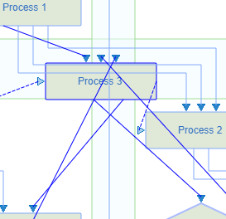 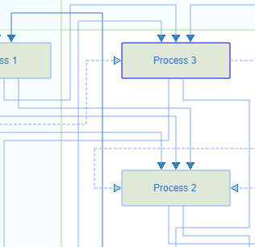

* Segments can also be moved, with certain restrictions, to accepting parallel pipes. The actions to modify the size of the canvas grid reset these edits.

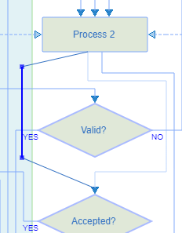 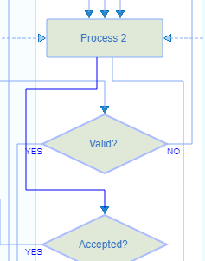

* The nodes and the edges can be selected by the mouse. Single or multiple selections can be removed using the toolbar button, the context menu, or the keyboard.
* The configuration of the outputs of the decision nodes can be edited in the edit dialog that is called from the context menu or double clicking on the node and selecting the desired layout with the help of the arrow buttons. The connected destinations are preserved.

Before:

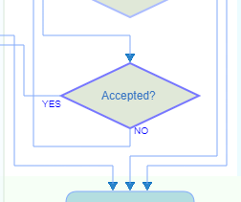

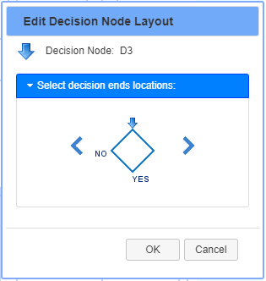

After:

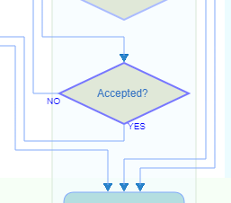

* The created nodes are assigned names that are either automatically generated or are user provided and have to be unique. The names can be inline edited at any time.

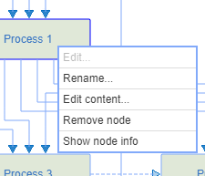 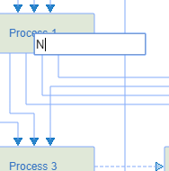

* It is possible to provide some user defined text content to the node that is displayed within its graphical shape. The name itself is still internally preserved and is shown on mouse hovering.

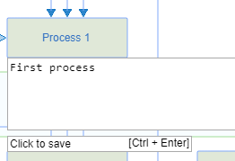 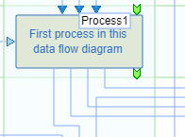

* All of the above described actions are undoable with unlimited undo/redo steps.

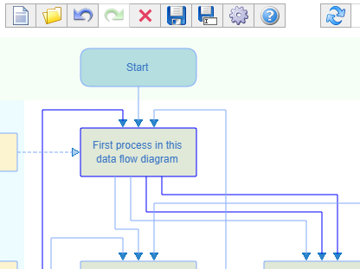

The flexible framework architecture of this editor can be adapted easily to most Web diagramming applications.