ARB SPOTTER CODE EXPLANATION

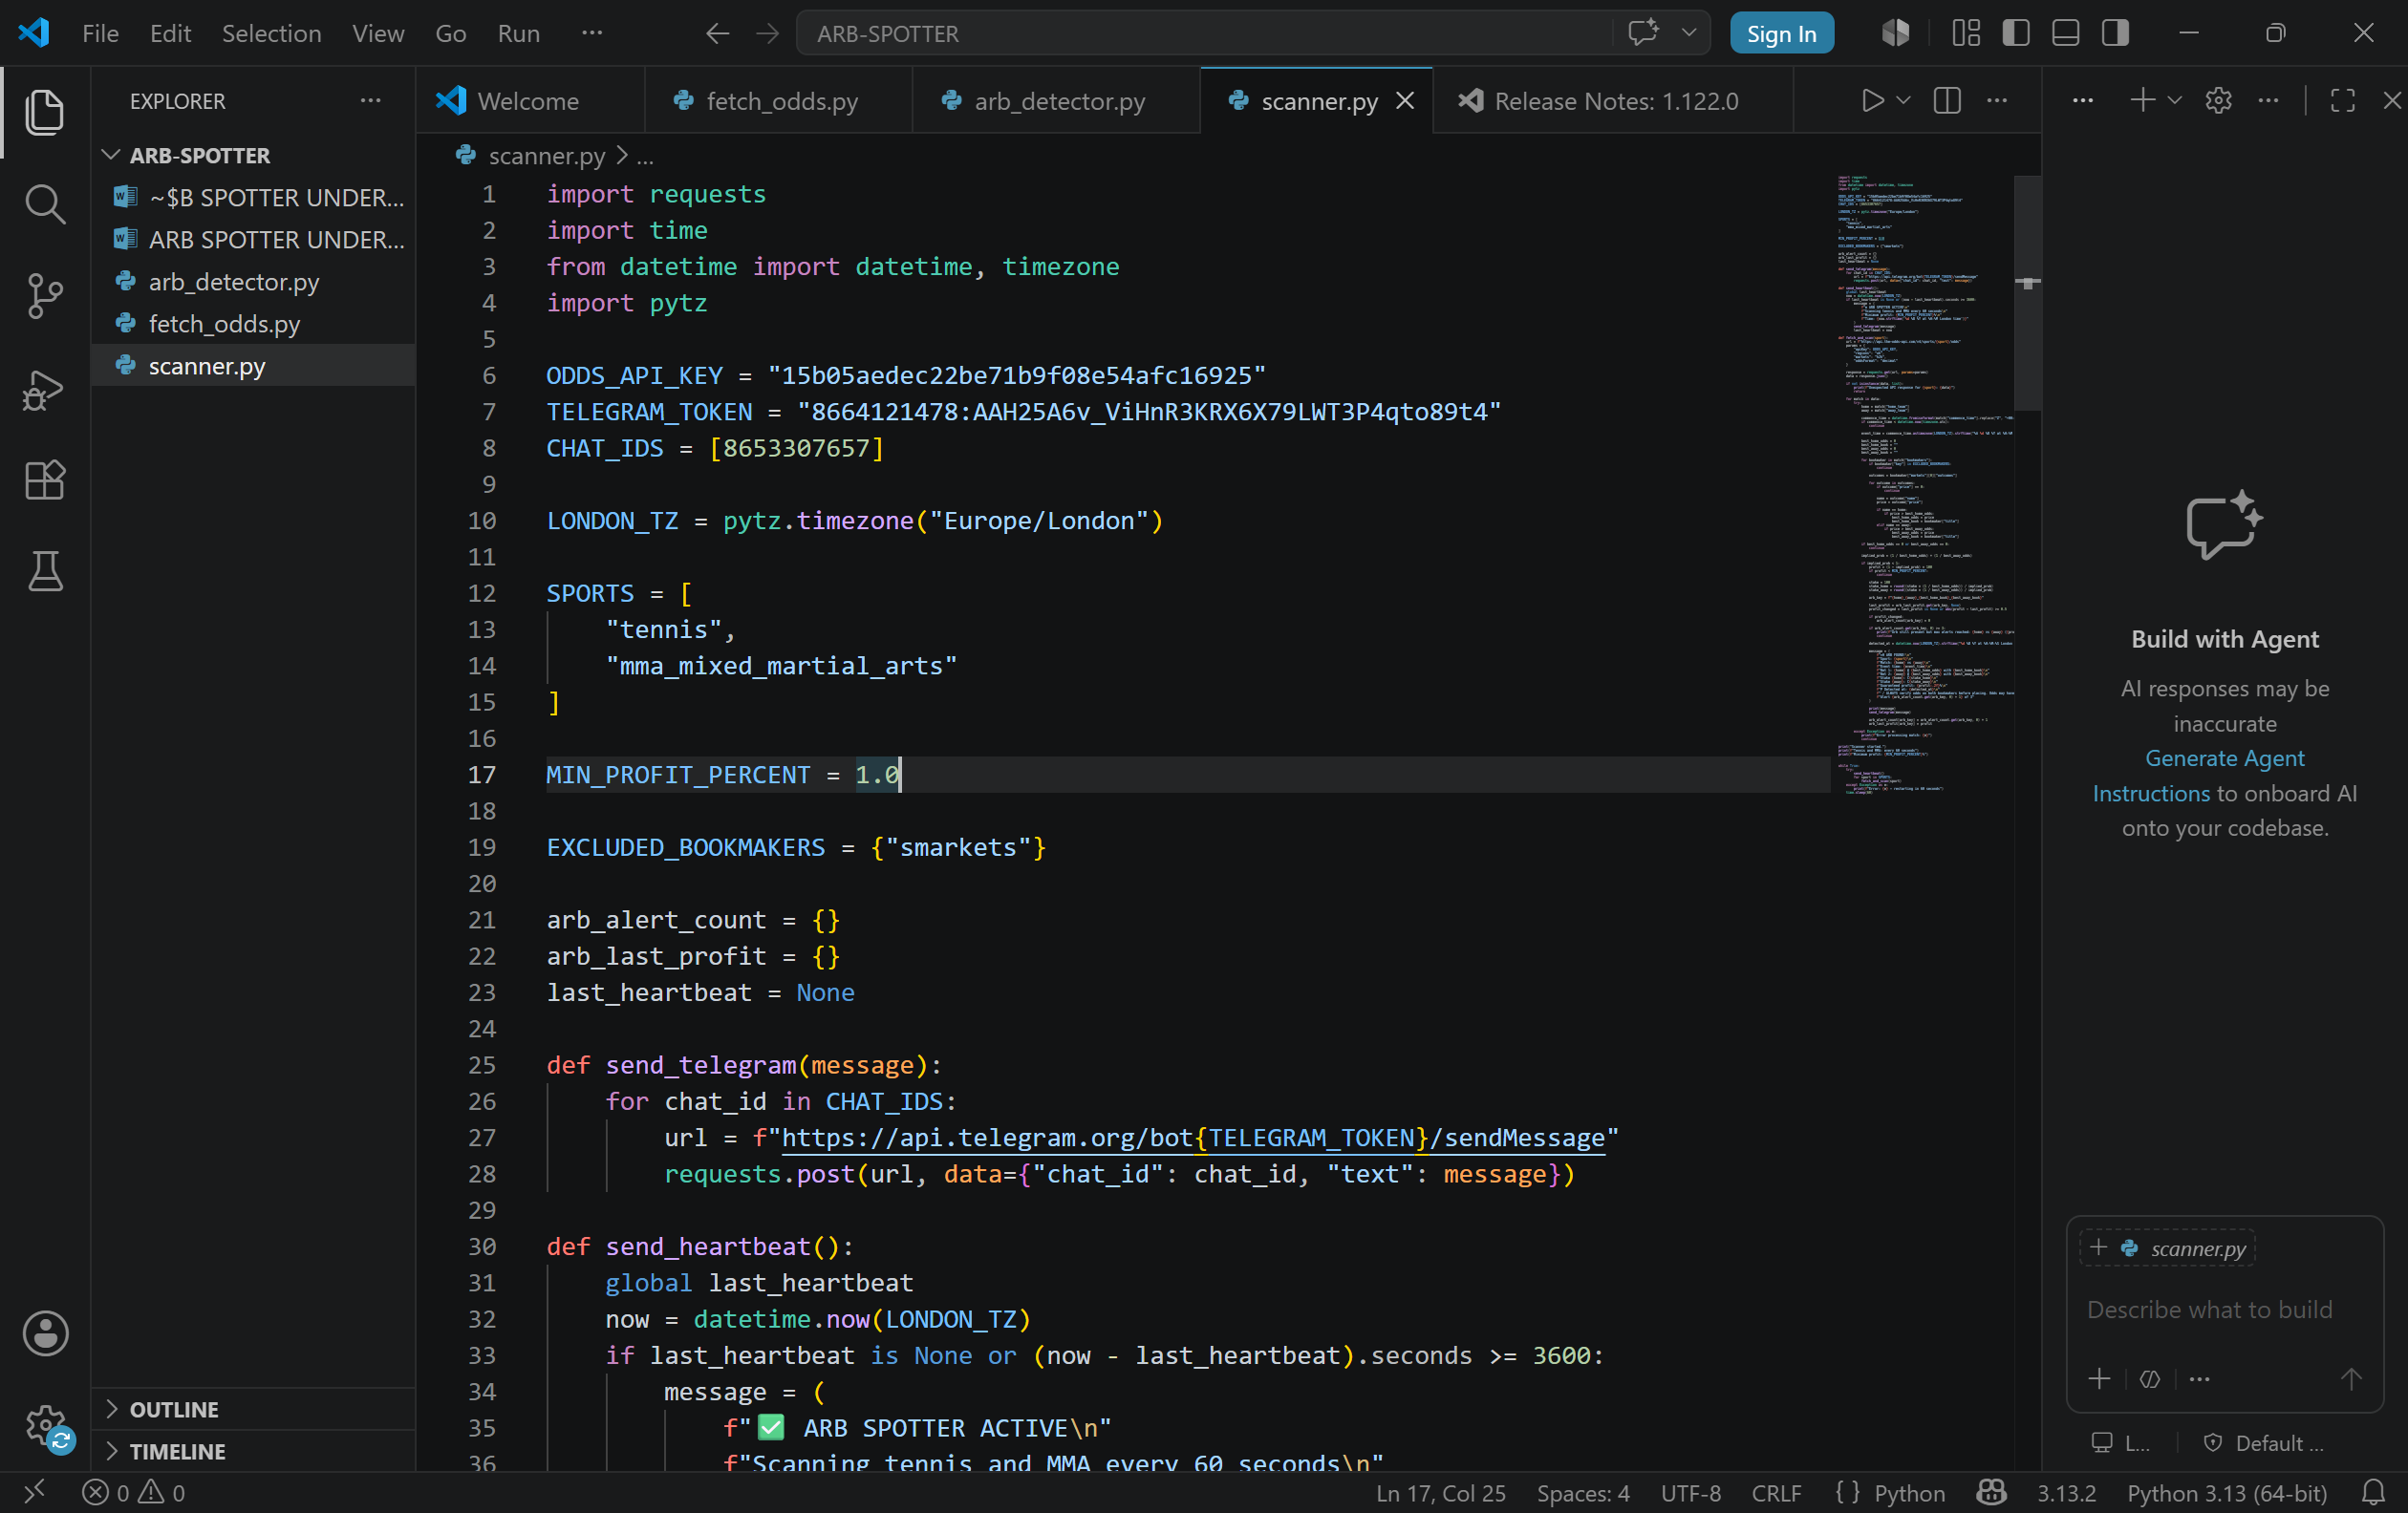
Line 1-4 we are importing all our libraries
line 6-8 variables are created give them a string name
line 10- setting the time zone we are using. Using pytz to set the timezone and storing it in LONDON_TZ.
line 25-28 defining our telegram function sending the link that would be used for our message to our telegram. Loops through every chat_id in our list and builds the telegram API using an f string. It sends to every chat id in the list not just one.
line 30-41 this is our heartbeat function; I created this heartbeat function so that I know that the code is being executed throughout the day. We look at the time of now and last heartbeat is more than 3600 seconds it sends the message again. “Last heartbeat is none” is important since if we’ve not received a heartbeat yet it will send it still, so this will become the first heartbeat. When we create a variable inside a function python treats it as a local variable, it only exists inside that function and disappears when the function finishes
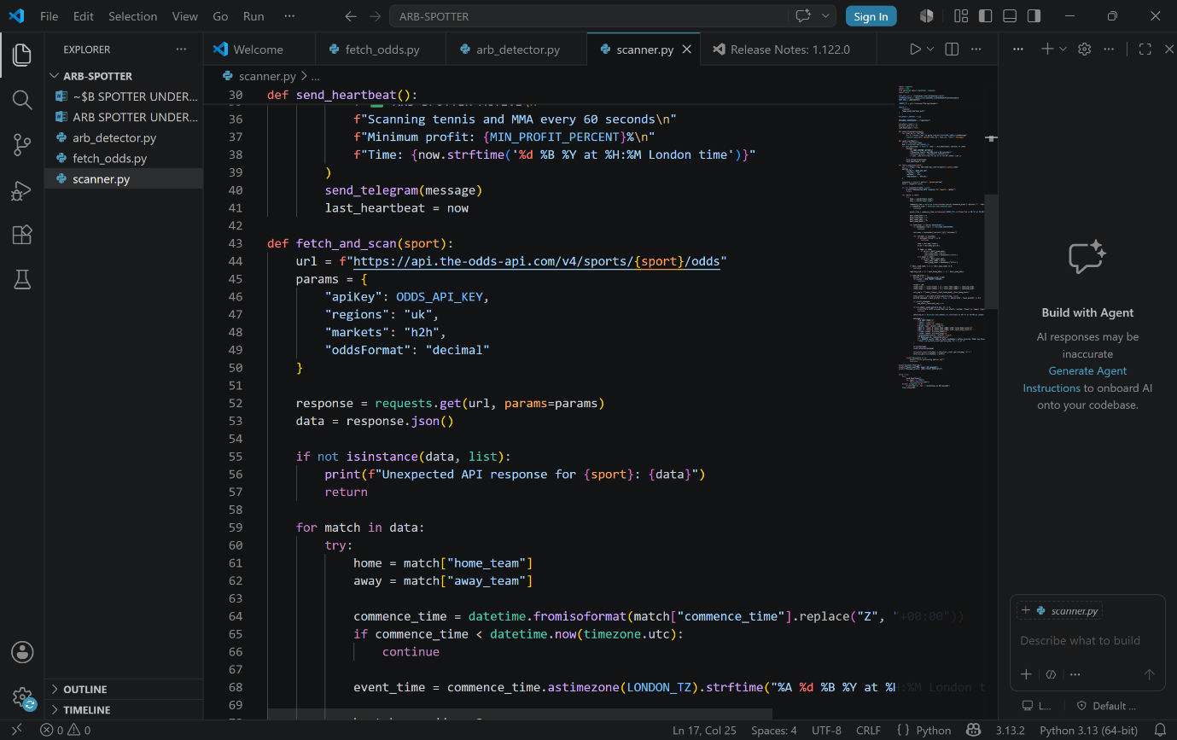
Last heart beat now then makes our now heartbeat called the last heartbeat so it can be compared in the next iteration. It updates the global variables so next time function runs it has something to compare against.
line 43-50: regions, markets,apikey,oddsFormat are fixed by the APIs documentation. We are a building a dictionary of parameters to send with the API request. Uk,h2h and decimal are also predefined values so we are just telling it to search regions and then only include UK.
line 55-57 if not something we expected a message to say unexpected API response to be printed
line 59-66: if commence time<datetime now we will continue and skip the match, this is so we don’t include in play games as I don’t want to use the arbs. Commence time<datetime suggests the event has already started and is in play.
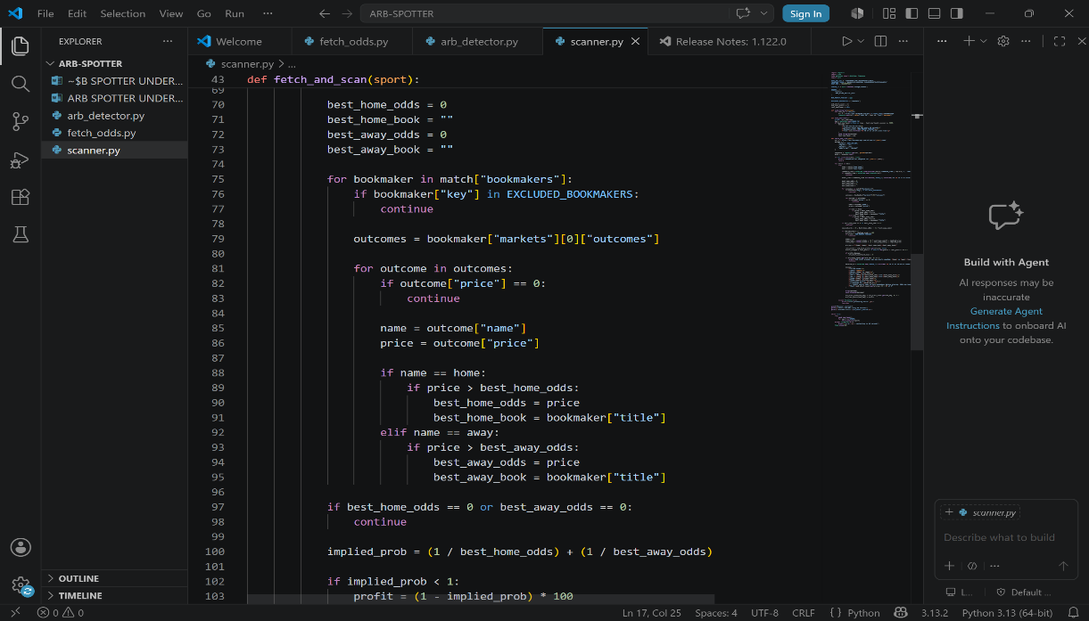
Line 70-73 this is setting up tracker variables before the loop starts. We are setting both to 0 at the start and setting the best home book and away book to empty strings. These act as a starting point that gets updated as you loop through bookmakers.

Line 75-77 if bookmakers key is in the excluded bookmakers we don’t want to include, we continue and look at next bookie.
Line 80-95 we look at each bookie for each game, if the odds is bigger then the best home odds, we now make these the best home odds for this game. We also do the same for the away odds to find the best away odds. If the best home odds or away odds =0 we ignore this game and move onto the next game. If price equals 0 that’s bad/missing data so you skip that outcome. [“markets”][0][“outcomes”] means go into the markets list, take the first team, then get the outcomes form it.
line 97-99 created our implied probabilities variables,
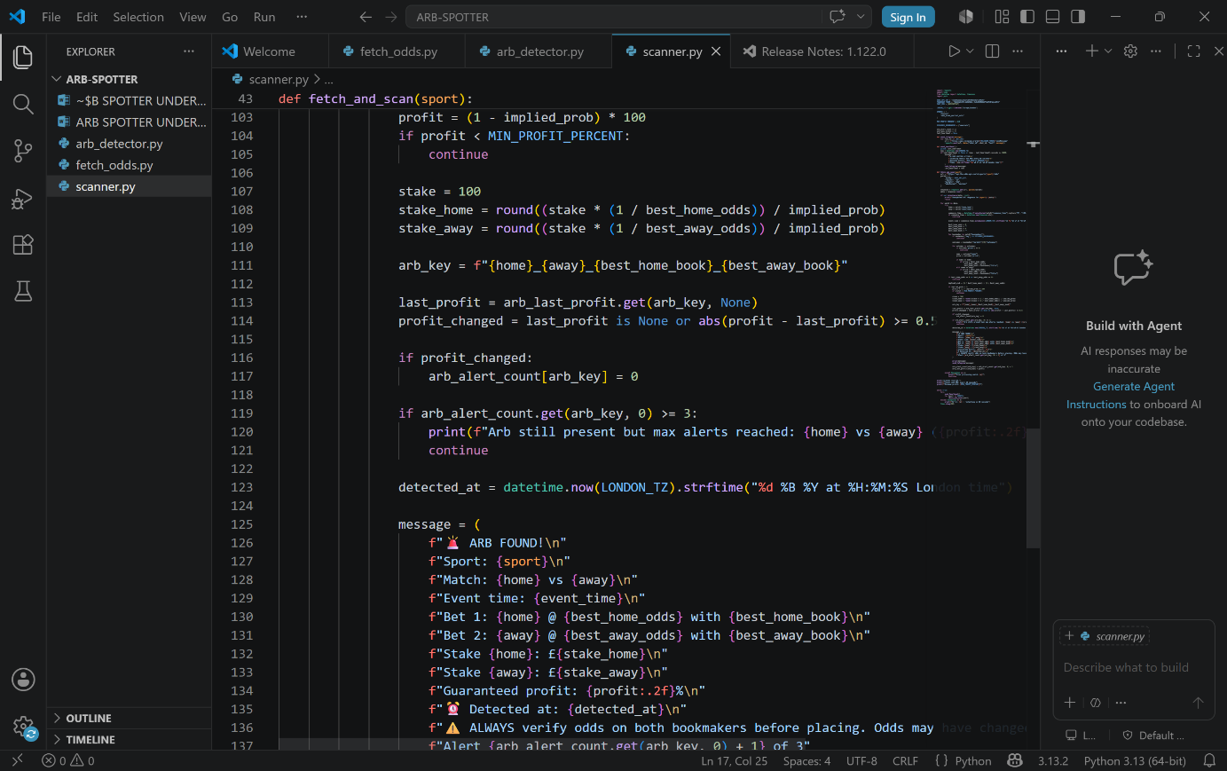
Line 103-105 if the profit we obtained is less than 1% we want to ignore this as its just not worth the profit to place the bet
Line 107-114 we are creating the variables which will be display in the telegram message. Stake we place on home team; stake we place on away team. We use the Kelly proportional staking logic to guarantee profit no matter what. If the profit is no longer there or new profit – last profit has changed by more than 0.5% we reset, it.
line 116-121 if the profit changes we set the alert count to zero. We are coding this, so it only sends the same alert max 3 times. If it changes it resets the alert count. If alert count=>3 we print the message arb still present but max reached so we move onto another arb.
line 123 letting the code know what time we detected the alert.
line 125-137 creating the message which will be printed. What variables it will output
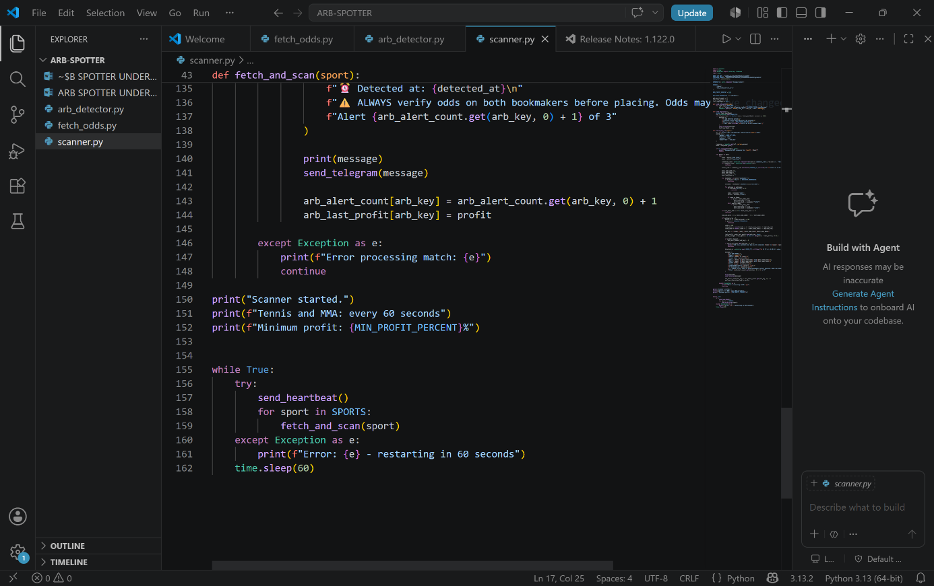
Line 140-141 we defined our send_telegram function at the start of out code. We created our message. This puts the message into our function and executes it. So it will send a telegram.
line 143-144 now updates the arb count the arb last profit which the code will use in the next iteration
line 146-148 this is the except block, if anything goes wrong while processing a match (e.g missing data from API), it catches the error prints it and uses continue to move onto the next match rather than crashing the whole program.
line 150-152 lines it prints to show the code is activated
line 155-162 main loop that keeps everything running. While true runs forever. It calls send_heartbeat(), the loops through each sport calling fetch_and_scan(). If anything crashes the except catches and time.sleep(60) waits 60 seconds before trying again.
6 KEY STEP BLUE PRINT:
1: Import libraries
2: define constant/config variables
3: define your functions
4: filter logic (keep moving if satisfied)
5: execute the output (send message)
6: main loop to keep it running
genuinely a standard structure for any automated monitoring script. Skeleton stays the same
Libraries which was used:
requests: to make http calls to odd API and Telegram API
time: purely for time.sleep(60) to pause between scans
datetime/timezone: to handle and format times correctly
pytz: specifically for London time zone conversion, since the built in datetime module doesn’t handle named time zones like Europe/London
python concepts used and what they do:
def: defines a reusable function so you don’t repeat the code
while true: runs program forever until manually stopped
for loops: iterates though bookmakers, sports, outcomes
if/elif/else: decision making at each filter stage
continue: skips the current iteration and moves to the next one
try/except: catches errors so the program doesn’t crash
global: allows a function to modify a variables that lives outside it
f-strings: build readable strings with variables inserted into them
isisntance(): checks if the data is the type you expect
dictionary.get(): safely retrieves a values without crashing if the key doesn’t exist
round(): rounds stake calculations to clean numbers
abs(): gets the absolute value

