·面包加海苔，自制寿司，健康美味。快来一起DIY吧!
·番茄加鸡蛋，“精”“妙”味无穷，简单健康。
·嗯，伸个懒腰，该起床了。
·还记得大明湖畔的狮子王吗？满满的，童年回忆。
·白雪虬枝，孤狼驻守，王者之风，气贯苍穹。
·黑蓝虎，只闻其存不见其形。由于栖息地的大范围缩减，我们已难觅其踪影，保护环境，还森林之王应有的风姿。
·两只仙子一样的天鹅，轻轻落在暮色苍茫的湖心，伸长了颈子，两喙相触，形成唯美的“心”形，在碧波荡漾的水晶湖上，恋人般低语。
·猫和兔子的恋情
·这是兔子吗？为什么耳朵这么短？
·21个“出卖”父母的孩子。
21个孩子在媒体采访下揭露父母的抽烟、酗酒或者其他不良习惯。
·蒜虾阿尔弗雷多面
只需要黄油、大蒜以及一些自制的，细腻的意大利面酱，就会带来一顿简单的，让你十指大动的晚餐。
·这是我迄今为止吃到过最好吃的迷你巧克力芝士蛋糕
·有愿相随，生命会更加丰盈强盛，即使难免失落的低潮；有愿相随，生命仍有希望开花结果，即使难免冰雪风霜；一句祈愿，无穷生命可以圆满；一声祝祷，万千孤苦可以解脱。
·鲜红的曼陀罗，血一般的爱。

1. The well-meaning daughter who was asked to write a sentence about her mom’s hobbies
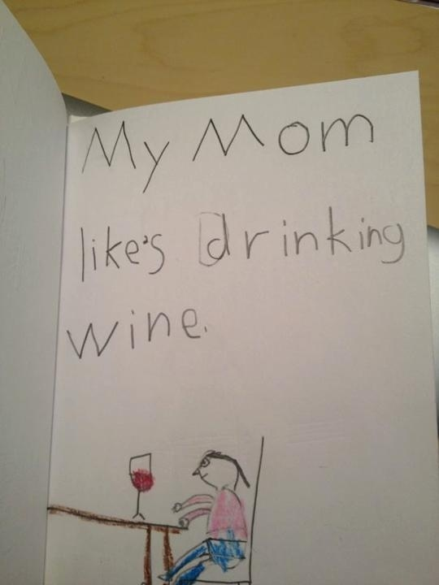
reddit.com

2. The young poet who loves her mom, but not TOO much.

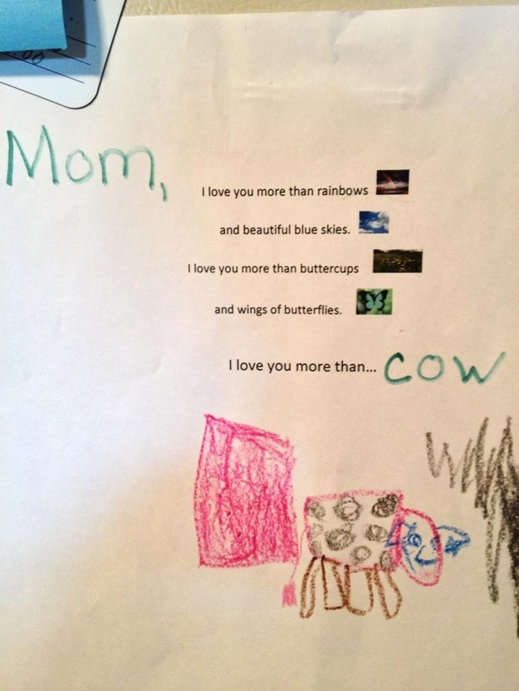
reddit.com

3. The daughter who is not afraid to resort to smear tactics to win a family election.

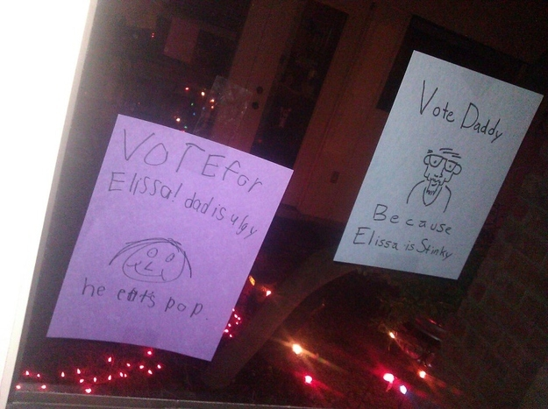
reddit.com

4. The future criminal mastermind who fooled her parents with a forged note from her kindergarten teacher.

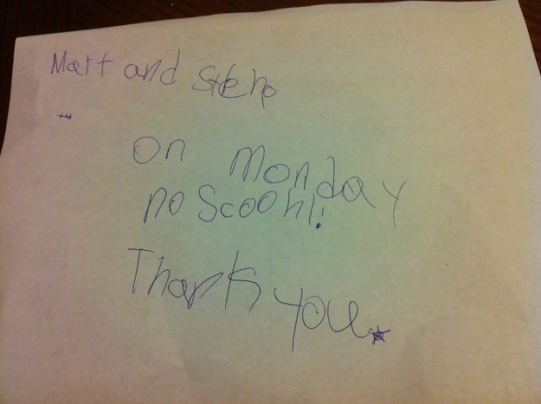
reddit.com

5. Along with her brother-in-arms who brought this note home from the teacher.

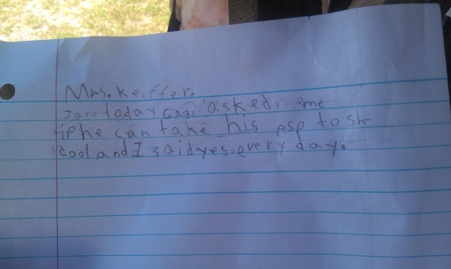
i.imgur.com

6. The young girl who’s getting a head start on using half-assed internet research to do her homework.

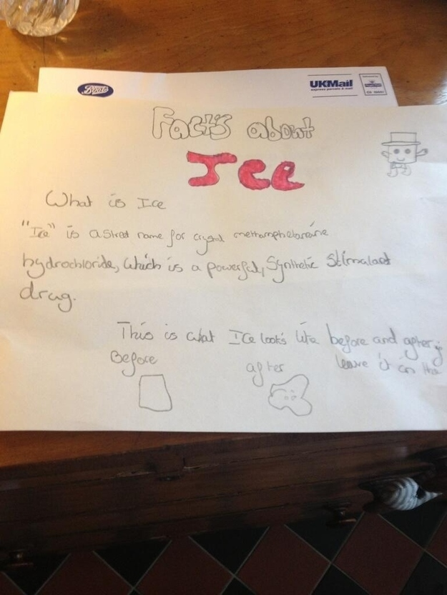
reddit.com

7. And their compatriot, the creative genius who wrote this sick note.

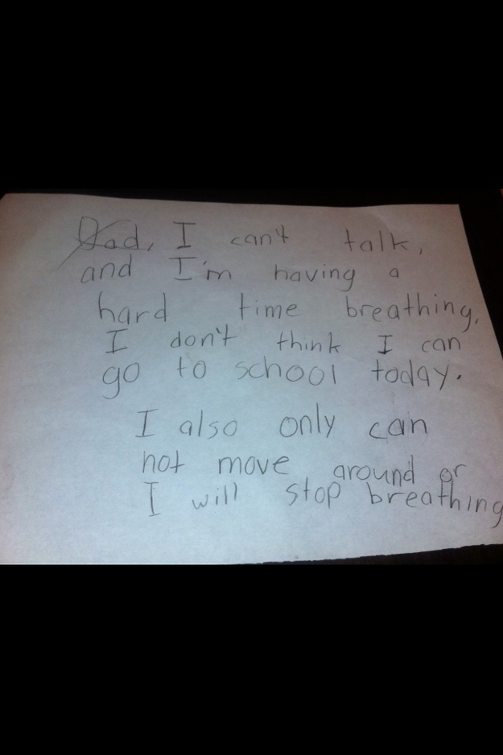
i.imgur.com

8. The second-grader who used science to rat out her dad.

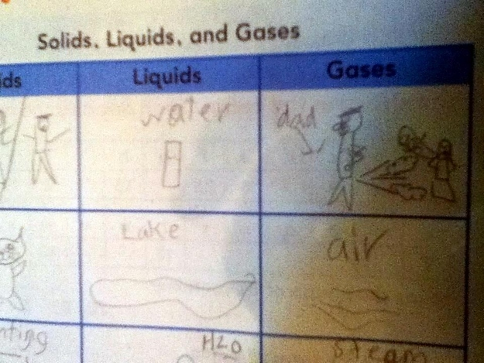
reddit.com

9. The little girl who knows the value of sugarcoating bad news.

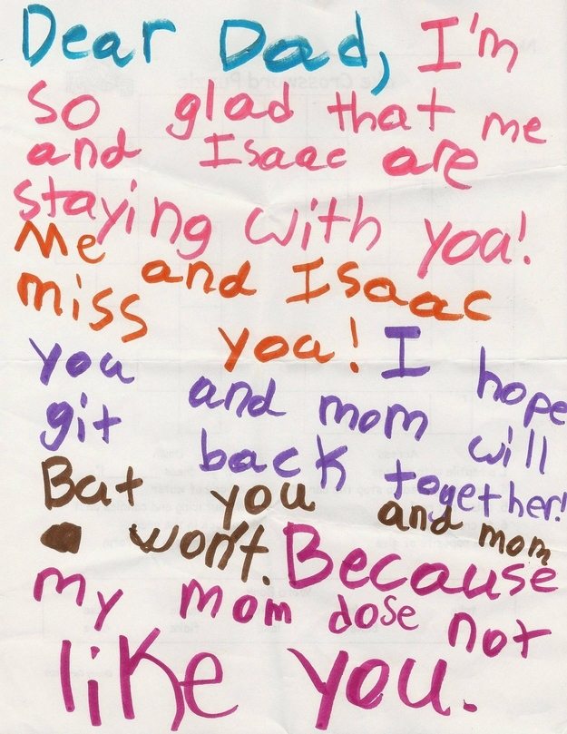
reddit.com

10. And the 6-year-old who’s still perfecting the art.

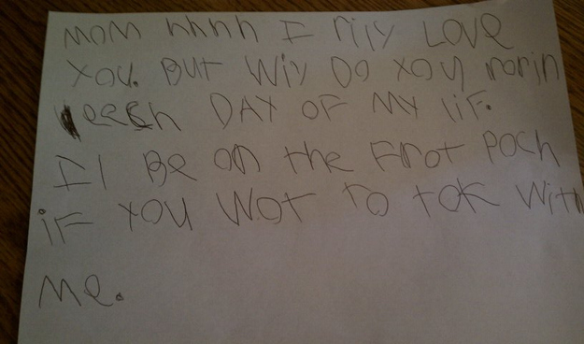
passiveaggressivenotes.com
Mom (sigh) I really love you but why do you ruin each day of my life. I’ll be on the front porch if you want to talk with me.

11. The sweet little girl who likes to greet her mom with a note in the morning.

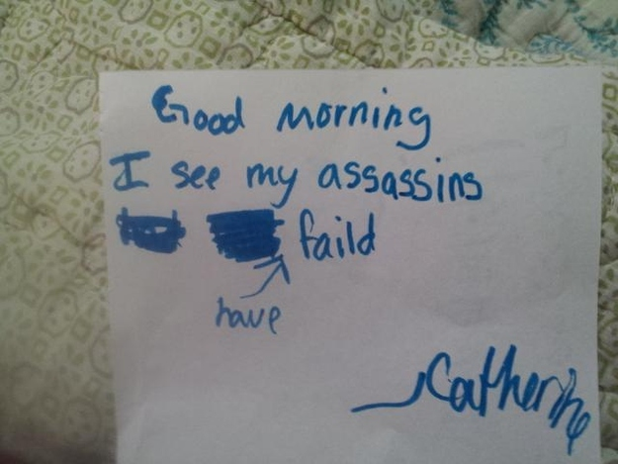
reddit.com

12. The boy who can’t even compliment someone right.

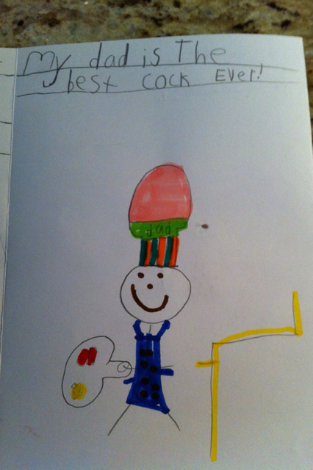
i.imgur.com

13. The 10-year-old who likes to draw speculative pictures of her mom.

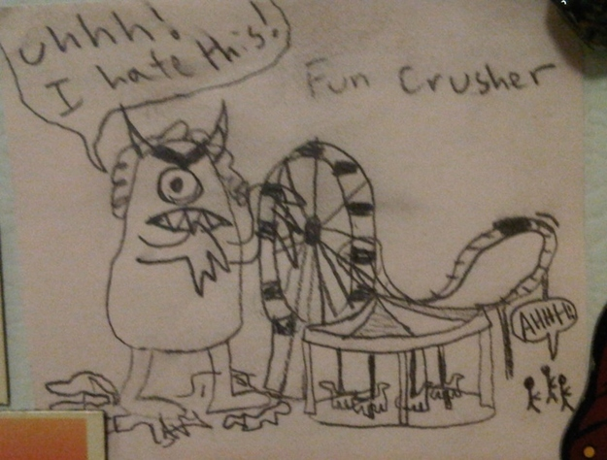
reddit.com

14. The boy who defies his mother’s wishes even if it ends up hurting him.

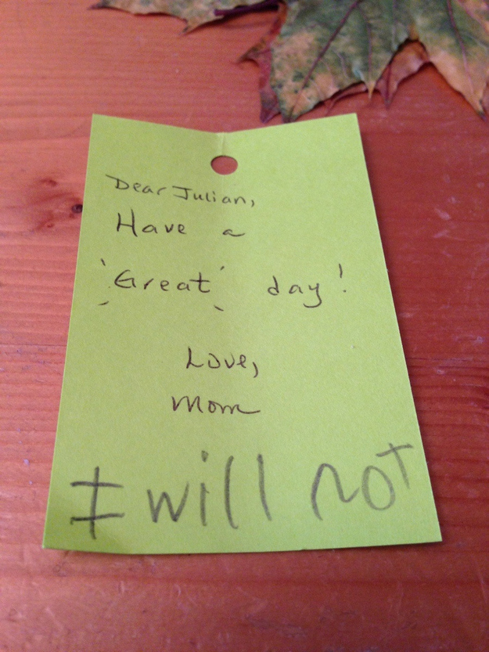
i.imgur.com

15. The young girl who felt that honesty was more important than tact.

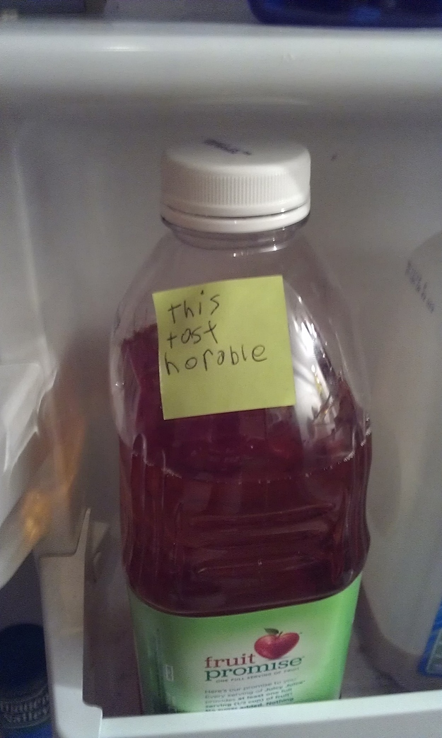
reddit.com

16. And the young man who is not afraid to play favorites.

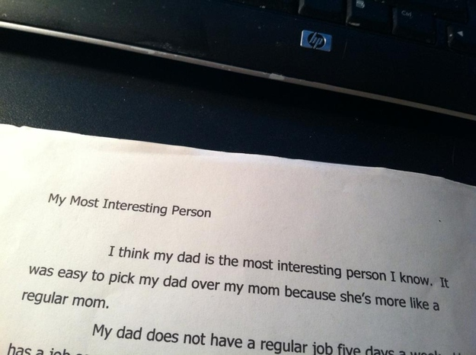
i.imgur.com

17. The daughter who is pretty sure Mother’s Day is conditional.

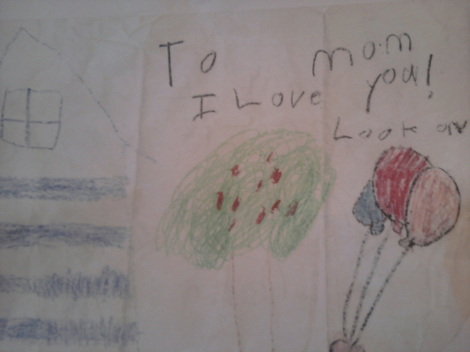
passiveaggressivenotes.com

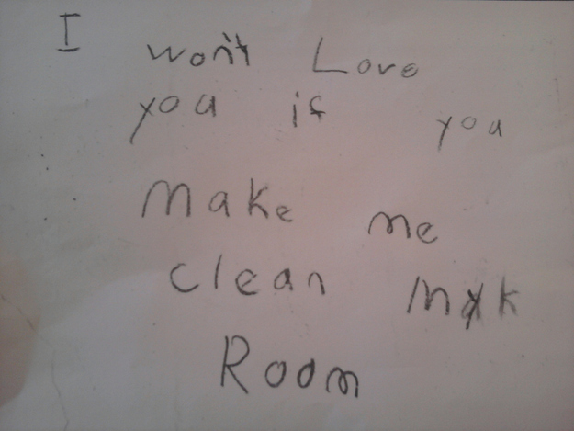
passiveaggressivenotes.com

18. The 7-year-old who publicly outed her mom’s subpar school-lunch preparations.

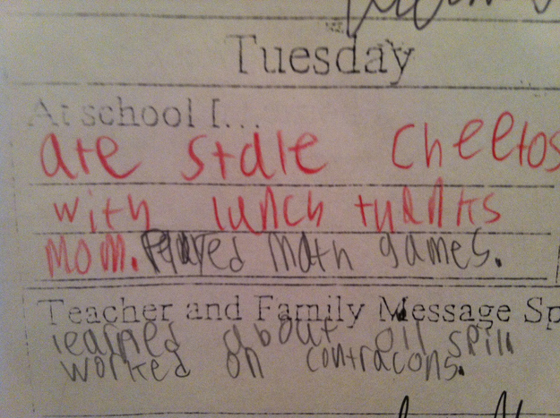
passiveaggressivenotes.com

19. And this young lady who made thesame point with a little bit more tact.

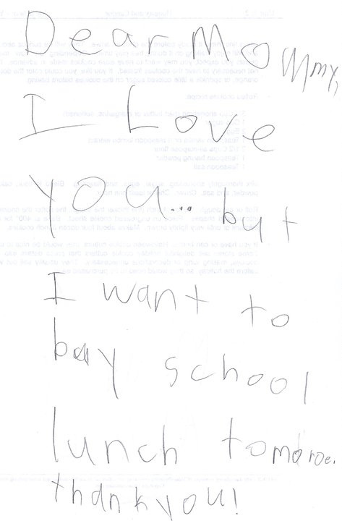
passiveaggressivenotes.com

20.聽The boy who refuses to stand for having a deadbeat dad.

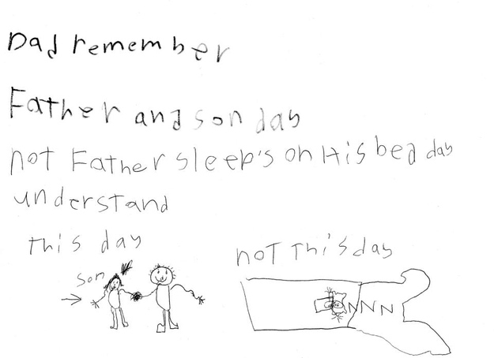
i.imgur.com

21.聽And this 9-year-old whose art speaks eloquently for every child who has ever had their life ruined by well-meaning parents.

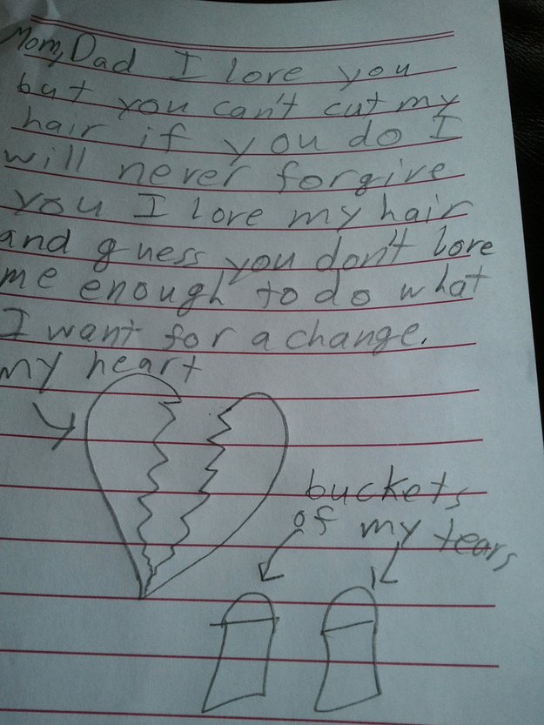
passiveaggressivenotes.com

Are you a parent looking for a laugh about all the crazy things kids do? Sign up for the weekly BuzzFeed Parents newsletter!

