Data Analytics: Bisnis Jasa AI Paling Potensial
Tanggal pembuatan: 26 February 2026 13:15
Dokumen ini berisi hasil scraping terstruktur, ranking peluang sektor jasa AI, chart visual, dan rekomendasi implementasi untuk tim AI enthusiast + developer + builder platform.

Ringkasan Temuan
- Rank 1: Generative AI Integration Service (Opportunity Score 77.35, CAGR 36.97%, market target USD 1206.24B).
- Rank 2: Intelligent Document Processing (IDP) Service (Opportunity Score 60.99, CAGR 33.68%, market target USD 43.92B).
- Rank 3: Conversational AI Customer Automation (Opportunity Score 58.02, CAGR 23.24%, market target USD 155.23B).

Tabel Analytics Utama
Rank | Sektor | Score | CAGR % | Target Market (USD B) | GitHub Repo | HN Hits 12m | arXiv Results
1 | Generative AI Integration Service | 77.35 | 36.97 | 1206.24 | 41,777 | 25 | 4,926
2 | Intelligent Document Processing (IDP) Service | 60.99 | 33.68 | 43.92 | 1,422 | 11 | 7
3 | Conversational AI Customer Automation | 58.02 | 23.24 | 155.23 | 4,812 | 35 | 627
4 | MLaaS Platform & MLOps Enablement | 55.22 | 38.15 | 1599.07 | 79,545 | 16 | 180
5 | RPA + AI Workflow Automation Service | 48.14 | 24.20 | 247.34 | 1,354 | 5 | 72
6 | Predictive Analytics Service | 37.46 | 20.56 | 113.46 | 22,315 | 8 | 441

Visualisasi Chart
1) Opportunity score per sektor
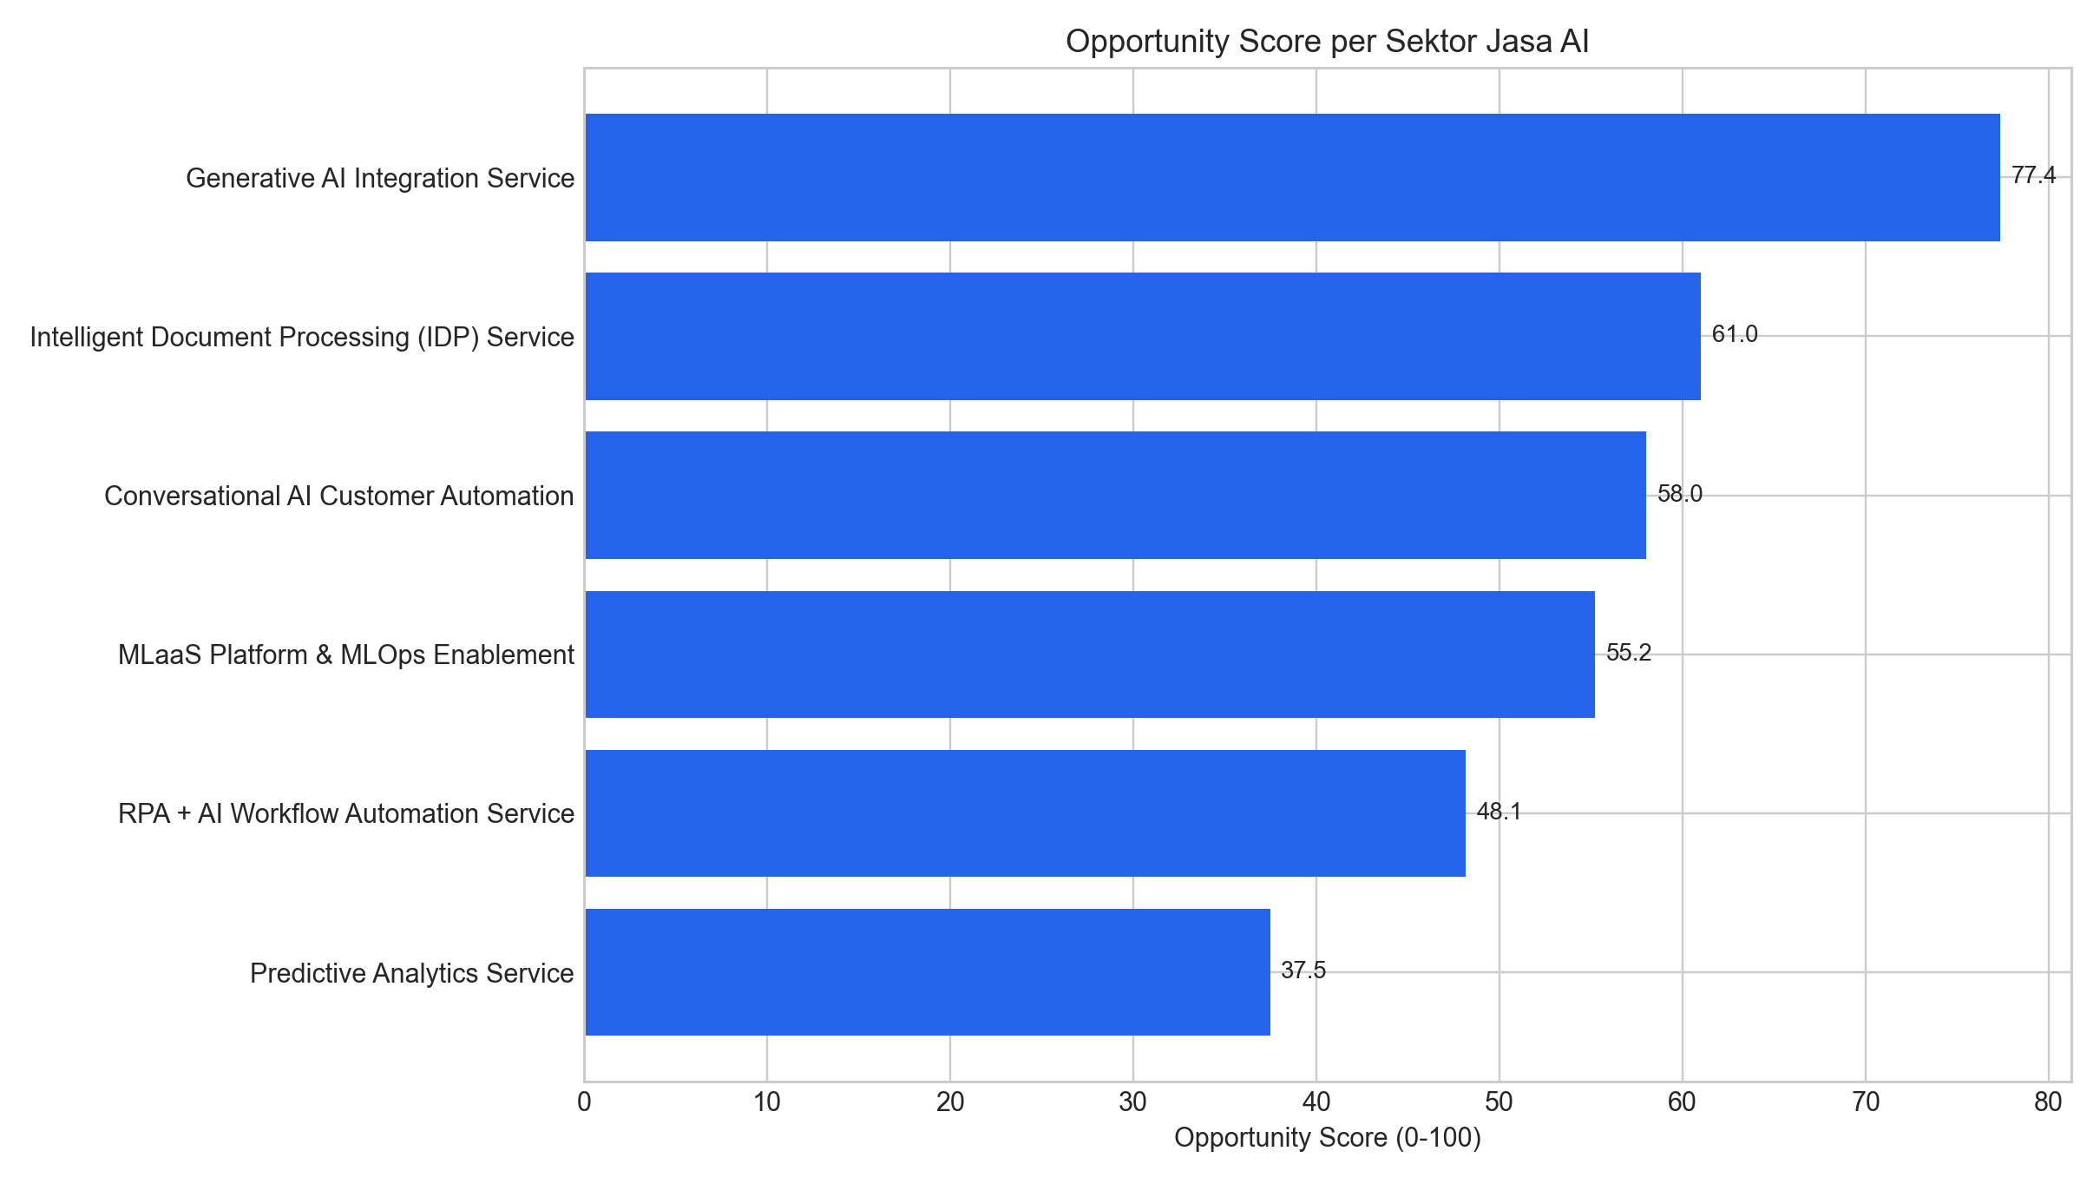
2) CAGR vs market buzz (HN 12 bulan)
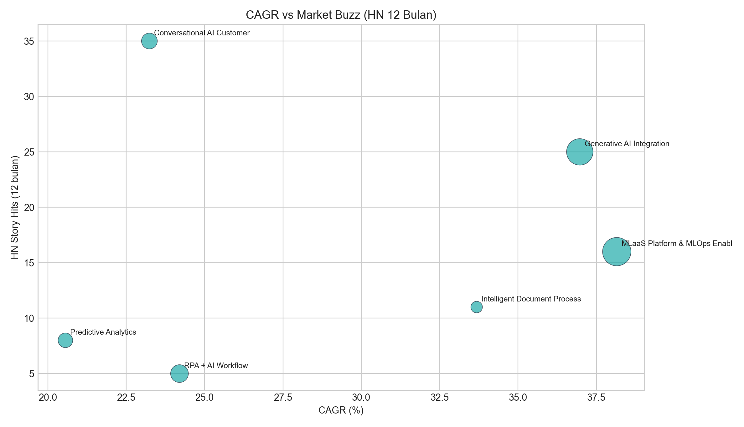
3) Heatmap sinyal normalisasi
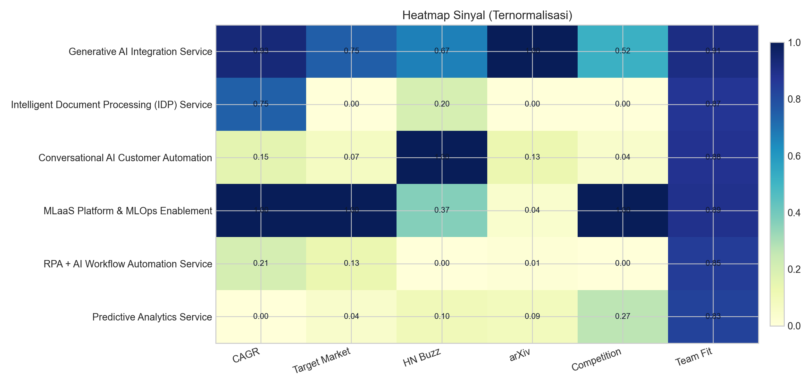

Aksi Implementasi 90 Hari
- 1. Pilih 1 sektor top sebagai wedge market, siapkan paket layanan dan template delivery.
- 2. Jalankan 2 pilot berbayar kecil untuk validasi ROI, lalu ubah jadi studi kasus kuantitatif.
- 3. Productize modul reusable (connector, prompt pipeline, evaluator) untuk meningkatkan margin.
- 4. Terapkan dashboard operasional (SLA, error-rate, cost/token, business impact) untuk scale.

