DataRaker
Elster Event Extract Utility 1.0
Ray Malone
09/08/2014
Contents
Document revision history 2
Changes Made to OucPAMSOutbound_1.0.1 3
Deployment for OucPAMSOutbound_1.0.2 4
Package Dependencies 4
Package Version 4
Deployment Tasks 4
Post Deployment - ACL check (If any) 4
Post Deployment - Reload Properties 4

Document revision history
Date | Description | Author
September 8, 2014 | Extract Utility Documentation | Ray

Overview
The purpose of this utility is to extract Elster meter event information necessary for DataRaker reporting metrics. The current version of Eslter (8) only provides the last meter event reported. Eslter’s MAS service has a report operation that provides all event data. This tool is to be run as a batch to pull reports containing all meter events logged in Elster’s database. It is recommended that this report be run once or twice a day to cut down on resource overhead.

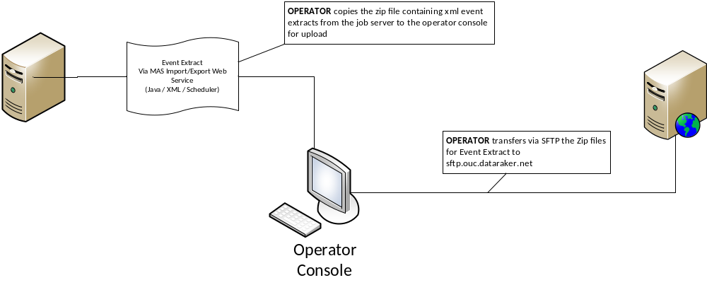

Implementation
- The utility is a java application running on the following stack
  - Java 7 JRE
  - Spring Framework v4
  - Spring Boot v1.1.5
  - Axis2-jaxbri:1.6.2
- Install
  - Extract OUCElsterMas.zip to a directory on the server with no spaces in the path
  - Install Java 7 (preferably in a path with no spaces)
- Configuration
The application.properties file in the [installdir]\OUCElsterMas\bin directory contains application configuration including the following attributes:
default.uri
timezone.id
observe.dst
max.record.count
start.time
end.time
start.index
event.name
report.name
report.path
report.request.filename
report.response.filename
report.file.extenion
user
password
password.is.encrypted
xmlns
write.request.to.file
keep.response.after.zip
LOG.DIR
LOG.LEVEL

The configuration file has comments indicating what values are acceptable
- Running the application
  - The application is run by executing OUCElsterMas.bat
  - The output file will be named elsterExtract[startDate:yyyy_MM_dd]_ [endDate:yyyy_MM_dd].xml and will be compressed in a zip file with the same name except the extension will be .zip
  - If no start.time or end.time are provided, then the report will be run using a start.time of yesterday at 12:00 AM EDT and an end.time of the current date at 12:00 AM EDT
- Elster system password changes
  - If the user password is changed for access to elster, the application.properties file needs to be updated. It’s located in the [install_dir]\bin directory
    - Update the password value to the right of the equals sign (password=password)
    - Set the value of the password.is.encrypted property to “false”
(after the program is run with the new password in place, the program will replace the plain text password value in the application.properties file with an encrypted version of it, then set the value of the password.is.encrypted property to “true” automatically)
- FTP file transfer to DataRaker
  - Data operations will sftp the files to dataraker on a daily basis

