Active Directory Security Lab
Project 1 | Active Directory Configuration and Security Policy Implementation
Name: Raymond Malone

Task 0: Network Configuration
Configured a static IP address for the Domain Controller to ensure consistent network communication.
The system was assigned IP address 10.0.2.15 with subnet mask 255.255.255.0 and gateway 10.0.2.2. DNS was configured to point to the Domain Controller itself to support Active Directory services.
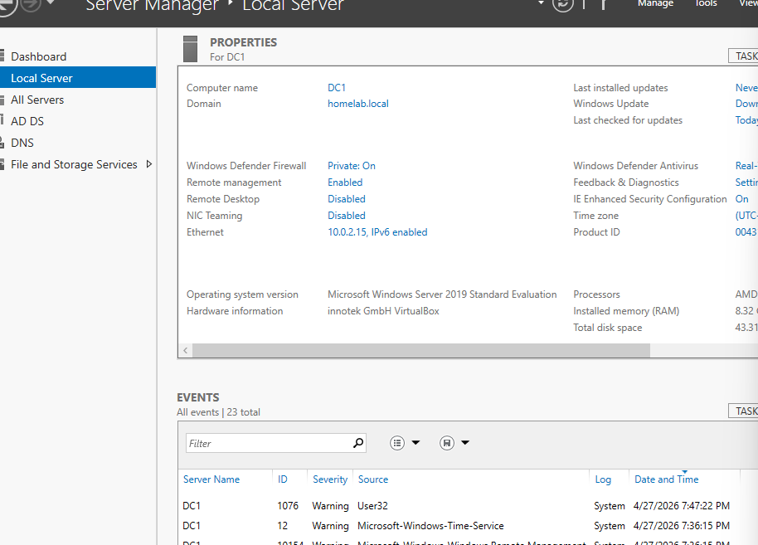
Figure 0: Static IP configuration for Domain Controller (screenshot inserted in final submission)

Task 1: Active Directory Setup and Configuration
Installed and configured Active Directory Domain Services, promoting the system to a Domain Controller and creating the domain homelab.local.
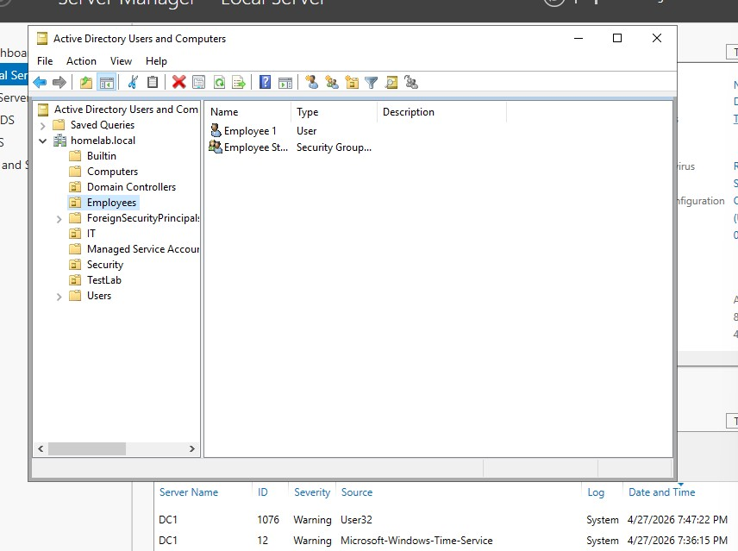
Figure 1: Active Directory Organizational Unit and user/group structure

Task 2: Group Policy Configuration
Created and linked a Group Policy Object (Baseline Security Policy) to the Employees Organizational Unit to enforce security controls.
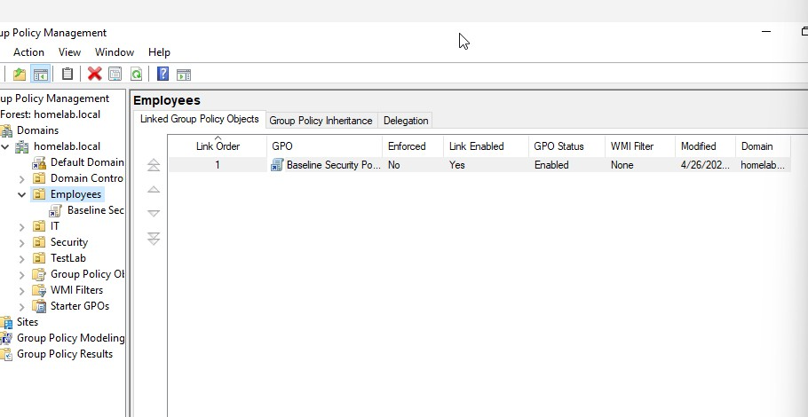
Figure 2: GPO linked to Employees OU
Configured password policies, account lockout settings, and auditing controls to enforce authentication security.
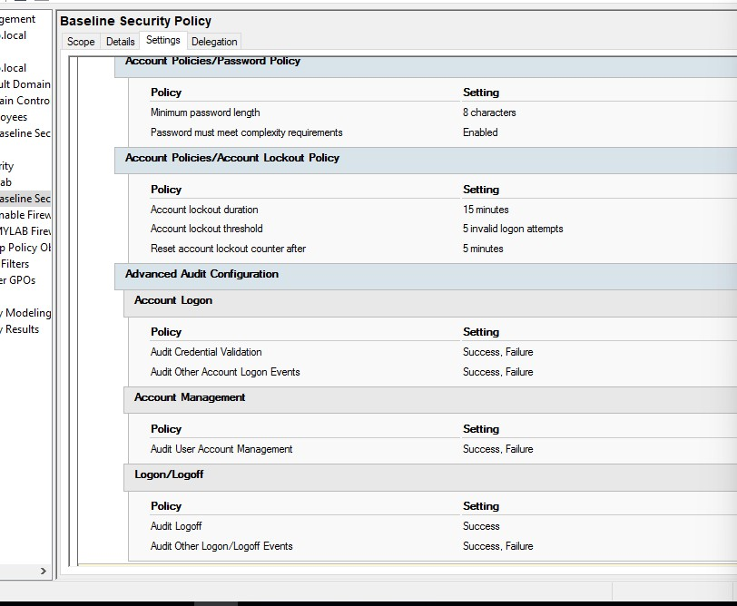
Figure 3: Configured password, lockout, and audit policies

Task 3: Security Monitoring and Validation
Generated failed login attempts to simulate unauthorized access and reviewed authentication logs using Event Viewer.
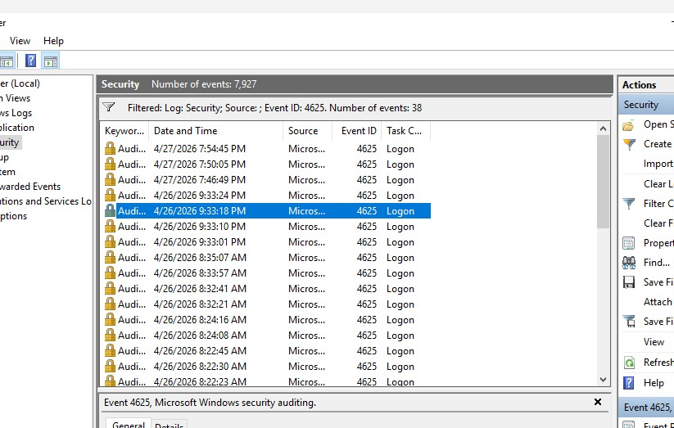
Figure 4: Security Event Logs showing failed login attempts (Event ID 4625)

Conclusion
This lab demonstrates the deployment and security configuration of an Active Directory environment. Network configuration, Group Policy enforcement, and security monitoring were implemented to simulate real-world enterprise security practices.

