**Ray Mannion**

**G00340315 G00340315 @gmit.ie**

**Advance Procedural Semester 2 Project**

Once program is loaded up and ran the user will be presented with a login prompt.

I have hard coded 3 username and password into the code as I had trouble getting data to move from a file into the linked list. I did this to at least have some password security in the code.

As I couldn’t get the read in function to work, there are no text file to read in from, but the program will create the relevant text file when the program is terminated

The names and passwords are:

1. ray 123456
2. tom 654321
3. mary 246810

When a correct username and password is entered, the user is presented with a main menu

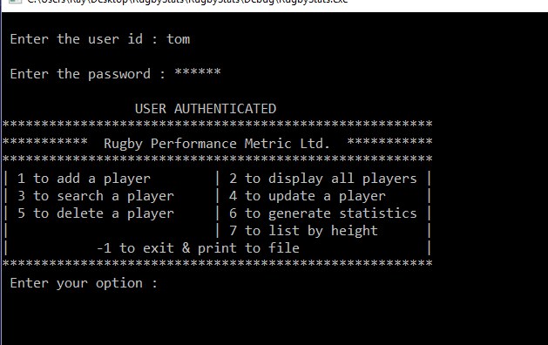

When the user presses 1 the program asks them to enter a irfu number, and then to enter the details of the player.

When the user presses 1 any time after that, the program checks if that number is already used and if it is, it prompt the user that the number is used and please try again.

If the number has not been used it informs the user that it is a valid id and tells them the number will now be assigned to the player who’s details they enter. The program then assigns that number to the player details in the add player function.

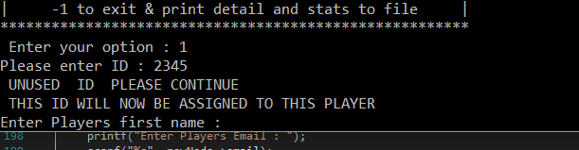

You can then add as many players to the linked list as you wish and the unique irfu number will never be duplicated.

The user can then go through the various options of the menu

Option 2 will show a list of all the players details

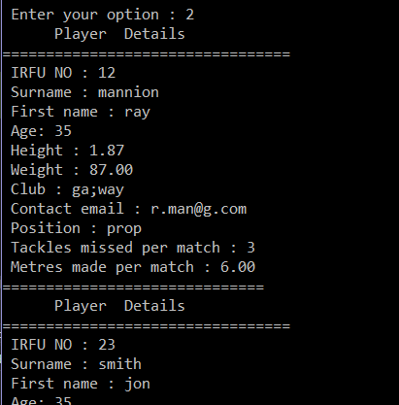

Option 3 allows the user to search for a player using the irfu number or their surname

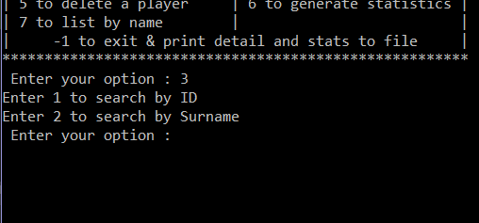

Option 4 allow the user to update a players detail using the irfu number. I tried to get the update function to work with the surname as well, but I had trouble getting it to work, so I left it out. I did not give the option to update the irfu number or the players name as the number is supposed to be unique to the player

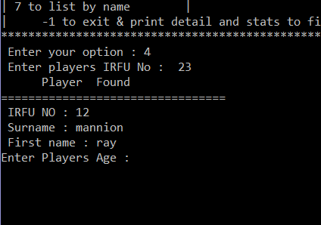

Option 5 allows the user to delete a player by using the irfu number

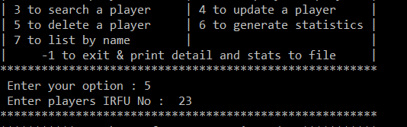

Option 6 will generate statistic for tackles and metres covered by the player information entered into the program. It does this by running through the list and when a players tackles or metres covered meet the condition of the if statement it adds to a count. It then add up all the count to give the total of players. It then divides each count by the total players and multiplies by 100 to give a percentage for each of the criteria

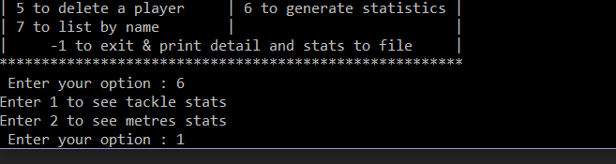

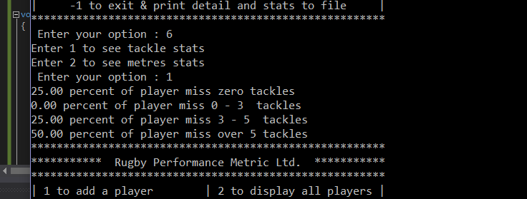

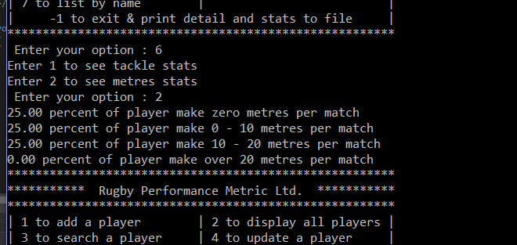

Option 7 list all the player names to screen, it a simpler version of the display all function

And finally option -1 will stop the while loop running the menu and once the loop breaks the print to file and both print stat function are called creating 3 text file. One with all the player details and one with metres stats and another with tackle stats