Solutions and Services Team Tools
AV-QA Team

- Aegis Add Source Documentation

Information:
The tool will do the compilation of the AEGIS source from small sources submission to big source that will be ready for pattern build.

Pre-requisite:
- Should have a working MS Excel install since we will be using excel interop class to import some API to read PRN.

Usage:
- Executable file. Will work if all the value in the configuration file is set.

Configuration File:
PRN – defines the path where the compiledprn.xls is stored or copied to.
OFFICIAL_XML - defines the path where the official tmtd.xml is stored or copied to.
OUT_PATH – defines the path where the OUTPUT tmtd.xml will be created.
SUB_PATH – defines the path where the submission xml will be stored or checked.
MARKERS – defines the full path where the patterns section marker is located.

Flow:
- The tool will initially list all the policy in the current OPR. The path of the current OPR where it will check is defined in “OFFICIAL_XML” entry in the config file.
- Then the tool will list the task in the compiledPRN.xls.
- The tool will now search for DP/NV/MV/RP in the task listed from the PRN file.
- The first task the tool that will execute is the DP. It will drop all the match policy in the internal c# database.
- Next are the NV and RP since both have the same logic. The tool will collect the entire task in the PRN task and match if RP or NV.
- For NV submission, the tool will determine if where the policy should be place base on the sectioning in the big policy (see markers.txt).
- The tool will match if next line after the “Platform32bit”, “Platform64bit” or “Both” is the policy line. The next line should start with <Policy id=. This is to avoid commented policies to be part of the process.
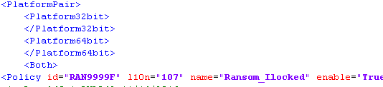
  - If there will an “enter” or a “new line” between the platform and the Policy id then, the tool will fail since it will match the expected policy.
- For MV policy, the tool will again list the entire MV task from the prn task list. The will now search for the policy index number in the current policy database inside the tool. When match, it will drop the policy then replace with the new once from the submission.

Unsupported:
- The tool will not check for other errors like RP-DP inconsistency or PRN reject since it is expected that such rejects were purified before submitting to build.
- IQA rejects are not supported also for this phase but will be supported moving forward.
  - Expected policy id format:
    - <Policy id="RAN9999F"<space>l10n="107"
  - Unexpected policy id format:
    - <Policy id="RAN9999F"l10n="107"

