Advanced Physics Simulation Program for Further Maths

Background to the Problem

Mr. Robinson, Further Mathematics tutor, requires an advanced physics simulation program to improve his teaching methods. The suggested program will be used as an interactive visualization tool, allowing students to observe and manipulate physical systems in real time, therefore helping to build a bridge between mathematical equations and real-life comprehension.

The simulation that I hope to create will represent fundamental concepts from physics and mathematics in the A-level course, including but not limited to:
- Motion of projectiles in two dimensions
- Conservation of energy and momentum
- Collisions with different elasticity
- Simulation of springs
- Approach for electromagnetic like forces
Current System Description

Mr. Robinson's current system uses old technologies that contain many problems:
Add screenshots, ?diagrams
1. Processing Environment:
- Limited graphics capabilities
- Old physics engine implementations

2. Graphical Calculators:
- Very constrained computational ability
- Limited visual representation
- No real-time variable manipulation capability
- No save simulation capability

#Maybe add more comments about this, what I like and what I don`t like
#this could inform objectives
#Add opinion of Mr. Robinson on them

It is hard to use such outdated programmes, they have a lack of the documentation and have lots of performance issues. It is unacceptable for effective STEM learning in the 21st century.

#Add information about formulae that I will use, diagrams that showcase the physics interaction
#Formuale for Hooke`s Law, GPE, KE, EPE, Impulse, 3 Newton`s laws,
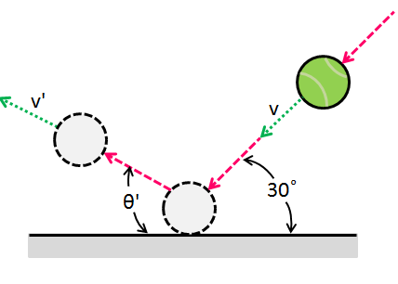
Study.com. (2025). Available at: https://homework.study.com/cimages/multimages/16/capture_248641776826009790839.png [Accessed 13 Oct. 2025].
‌

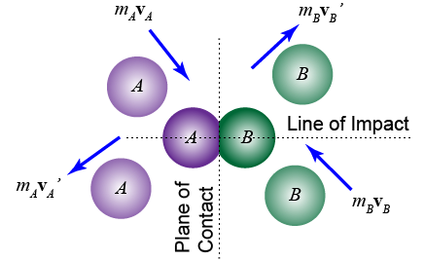
Cloudfront.net. (2025). Available at: https://d3rw207pwvlq3a.cloudfront.net/attachments/000/029/641/original/Capture20.PNG?1540014303 [Accessed 13 Oct. 2025].
‌
‌

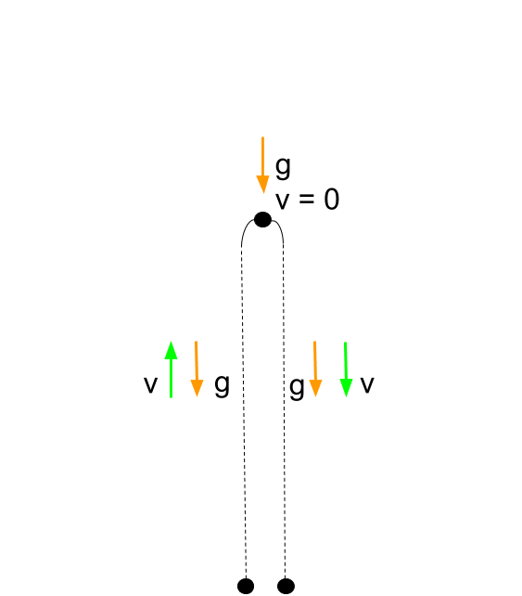
Kastatic.org. (2025). Available at: https://cdn.kastatic.org/ka-perseus-images/9965a9610a7572e882a719117cbe160e4efde12d.png [Accessed 13 Oct. 2025].
Create separate word file for referencing?

Prospective Users, Third Party Users
#Maybe create a survey for further math students to include their opinions on what they would like to #see; ask high quality questions to gather proper information.
Main User (Mr. Robinson)
- Will use the program as a central teaching device during lessons
- Requires intuitive controls to be able to set up demonstrations quickly
- Requires ability to set different parameters in real-time whilst explaining
- Can save information from simulation

Secondary Users (Students)
- Will use the program for self-learning and practice
- Need clean visualization of physical concepts
- Need straightforward interface without significant programming skills

Proposed Solution

Core Simulation Architecture

The solution will include a physics sandbox with the following components:

1. Physics Engine:
- Force driven movement of objects (F=ma)
- 2D vector mathematics for motion calculation
- Collision detection

#Rethink the magnetic feature, may be inappropriate, because it is not taught in A-Level course
2. Object System:
- Projectiles with variable mass and dimensions
- Static and dynamic obstacles
- Elastic strings/springs with implementation of Hooke's Law
- Objects with magnetic like effect
#Rethink the magnetic feature, may be inappropriate, because it is not taught in A-Level course
#More appropriate is to add circular motion, vertical in particular because there is no proper way to #express horizontal, unless creating separate mode for it.
#So then I can expand it with adding simulation of strings/springs
#This may be a point for research as this program can allow showcasing vertical circular motion with #strings/springs
3. Environment Controls:
- Gravitional acceleration with adjustable positive (and negative) values
- Static and kinetic friction coefficients
- Collision elasticity coefficient of restitution
- Electromagnetic field strength controllers

Technical Implementation

Programming Stack:
- Base language is going to be Python, because I need school computer compatibility and it has lots of helpfull documentations and libraries.
- PyGame for physics simulation and real-time rendering
- SQL database to store data about simulation and data received after the simulation.
#- Tkinter for configuration GUI
# I guess I have to optimise them myself? - NumPy for optimized matrix/vector operations

User Interface Features

1. Simulation Control Panel:
- Play/pause/restart controls
- Time dilation (slow motion/fast forward)
#?- Frame-by-frame advancement for precise analysis
- GUI to freely add different types of objects with configurable settings

2. Parameter Adjustment:
- Sliders for real-time variable modification
- Preset configurations for common scenarios
- Save/load functionality for experiment setups

3. Visualization Tools:
- Real-time trajectory tracing
- Vector field visualization
- Energy graphs (KE, PE, total)

Process Diagram
(Should go into Design section, I think)
[Conceptual diagram would illustrate]
1. User inputs/configuration
2. Physics engine processing
3. Real-time rendering
4. Data display and collection
5. Interactive adjustment feedback loop

Data Flow Diagram (Should go into Design section, I think)
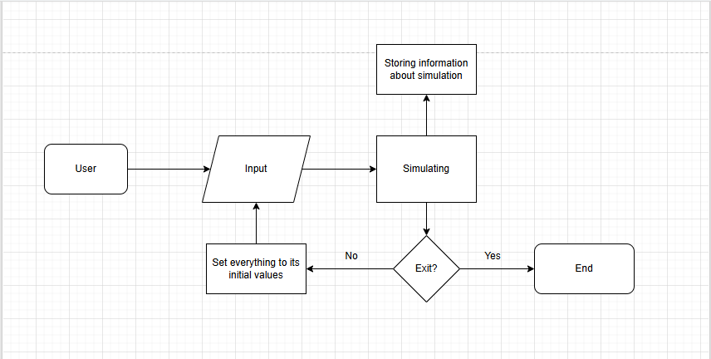
[Conceptual diagram would show]
1. Input → Configuration Module
2. Configuration → Physics Engine
3. Physics Engine → Rendering Engine
4. Physics Engine → Data Logger
5. Data Logger → Visualization Module

Acceptable Limitations

1. Simplified Physics:
- Fluid dynamics (air resistance/water) not modeled
- Two-dimensional simulation only
- Center mass assumption

2. Performance Constraints:
- Limited simultaneous objects (<100)
- Fixed time-step simulation
- Basic collision geometry (circles/rectangles)

3. Visual part:
- Simplified object representations
- Single texture that wraps the object

Objectives and Features

Core Requirements
1. Main features of simulation:
#THE MOST IMPORTANT PART, BECAUSE PROJECT WILL BE DETERMINED IF IT IS A-LEVEL STANDARD
#Brake down objectives; add numbering so I can refer to them easily in Technical Solution and Design.
#Example of breaking down is on Page 35 of Tackling A-Level Projects book.
- Projectile motion with/without drag/friction
- Elastic collisions with momentum conservation
#may be achievable- Demonstrations of simple harmonic motion
#?- Fundamentals of orbital mechanics

2. Program-user interaction:
- Drag-and-drop object placement
- Assignment/change of properties of objects
- Save and load for key information gathered from simulation

3. Measurement and Analysis Tools:
- Real-time logging of data
- Exportable data formats (JSON)
- Graphical analysis overlays (MatPlotLib)

Evidence of Analysis

#Key Quotes from Mr. Robinson Interviews: (translate from audio file) (Qualitative research)
#Highlight key parts and state that they will need to be included in the objectives
#Make a spreadsheet of questions of type Yes/No (Quantitative research)

Development Roadmap

Phase 1: Core Physics Implementation
1. Basic object movement under gravity
2. Collide system
3. Minimum UI for parameter adjustment

Phase 2: Polish and Expansion
1. Advanced visualization functionality
2. More physics interactions
3. Sharing and collaboration capabilities

This entire set will overhaul physics learning in Mr. Robinson's class, replacing traditional tools with an interactive, visually oriented learning system that will help students to familiarise themselves with the movement of objects in space.

#May be a good idea to include a prototype of physics engine and UI, and then clarify that main point of #it was to show the physics interaction, and not saving key info about simulation that I can do later.
#Analysis should show how I went from idea of creating a project for Further Maths tutor to a complete decision for the solution
#Check the Analysis with Page 37 of Tackling A-Level Projects book.
