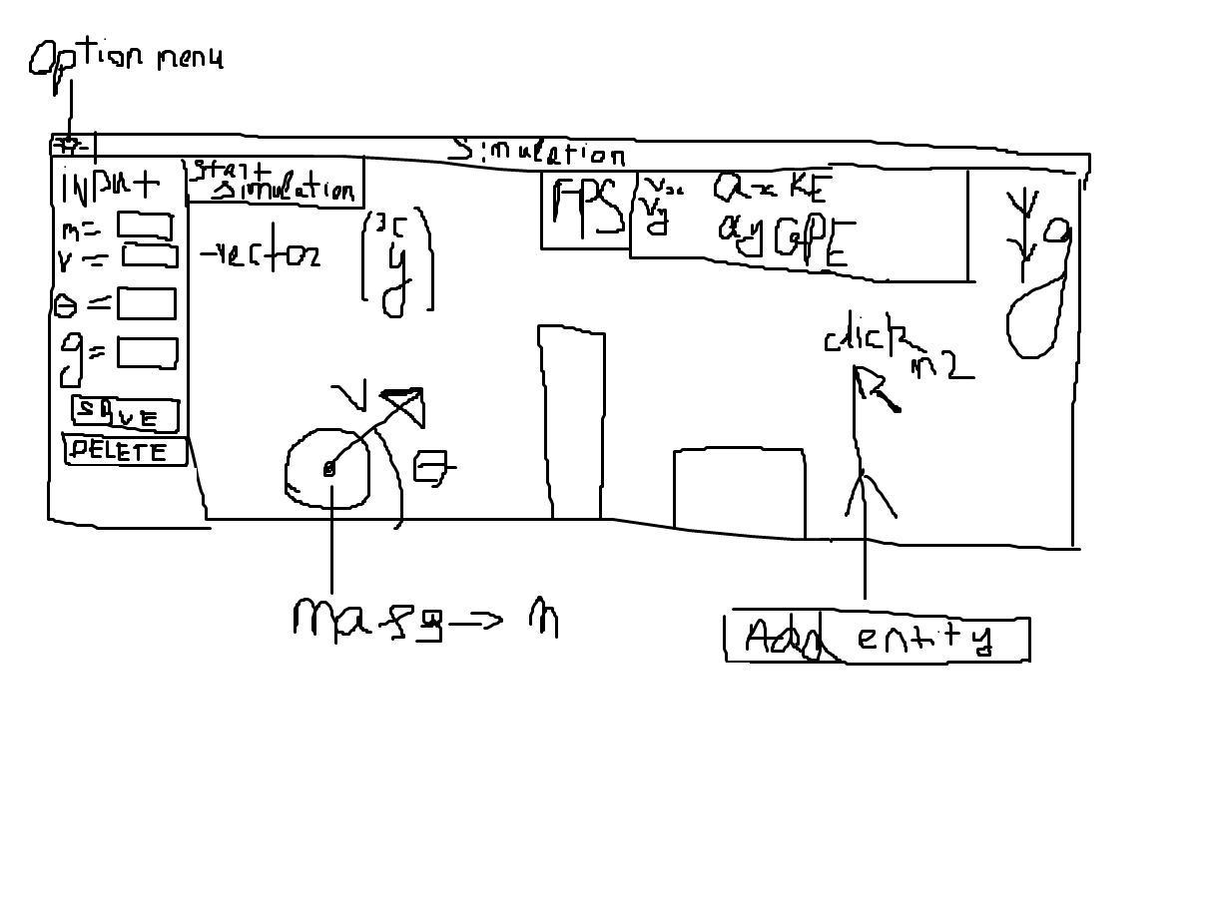Design
Menu:
I need to create comfortable for use menu where user can change input settings. Like where to save simulation, fps(?).
I need to create menu where user can choose entities and assign their types as moving or static objects, I would like to create a gui where user can load his own images to entities and place them wherever he wants and . I would like to create a changeable dimensions of entities. Sensible thing to create is a grid for easier placement of entities. I would like to create a changeable dimensions of field where simulation is going on (zoom in, zoom out), so the user could see everything that is going on.
I would like to create placement of entities with mouse like drag-n-drop. Therefore, I need to create deleting of entities with mouse. Create button for full clear of field.
Need to create a menu with summary of the data that is received from the simulation and update every frame.

User can delete or update objects using ObjectManager:
Need to create an input window so that user can input different variables for objects. Create button save changes to properly assign new attributes to the object.
Create bind for Mouse2: when user clicks mouse2 over object the input menu changes to attributes of current object. To change the gravity or background image user needs to click Mouse2 on empty space.
To save results of simulation I need to have a json file with all of the input details for every object, time start and end of the simulation and also screen recording of the simulation. To properly redo the simulation I need to add special button where I can upload the json file with all input details. To do the recording I need to add ScreenRecorder module.
Create database to store simulation results? (Can I create a pipeline to upload recordings directly to the cloud (avi files))

Classes:
Class Entity(dimensions, image, group(of entities)) inherited from pygame.sprite.Sprite

Class MovingObject(mass, velocity, acceleration, vertical_displacement, horizontal_displacement, elasticity) inherited from Entity

Class StaticObject(elasticity) inherited from Entity
Class OptionMenu(window) class that have menu where user can change fps, directory to save the simulation and a button to upload json file of inputs.
Class DataSummary(window) (add functionality to support different objects (?))
Class ObjectManager (window, targetedObject) in input window user needs to see current attributes of the object and have window to enter new values. User can change dimensions of sprite, image and all of the initial attributes of MovingObject and StaticObject.
User can click Mouse2 on an object to change ObjectManager targetedObject to which he clicked on. To change gravity or background image user needs to click Mouse2 on an empty space. After user has entered all the values he can press Save Changes button to assign new values for attributes of an object.

Def CalculateCollision(obj1, obj2) -> attributes to change for both objects
Class Mouse(posx, posy) class to get position of the mouse. Bind Mouse2 for changing ObjectManager targetedObject and if Mouse2 was pressed on an empty space change targetedObject to window, so the user can change background image and gravity and field dimensions, also, on the place where user clicked, create window to add an entity to the field. Bind Mouse1 to drag-n-drop an object.
#euler`s half step for more precise calculation of physics
#timestamping so the rendered time == real time.
#separate fps for render and simulation
#separation of movement into vertical and horizontal -> 2d vectors for movement

#add entity relationship diagram
#dataflow diagram
#explain? version control via github?

