1. Analysis

1.1 Problem Background
Being a Further Math student is already challenging by itself, but it is even more difficult without any visual and interactive representations of questions. I was studying Further Math in Year 12 and I know how hard it can be to get your head around the question, so I decided to help my Further Math tutor with representing questions in an interactable and dynamic way.
After our first dialogue I understood that: Mr Robinson, Further Mathematics tutor that requires a physics simulation program to improve his teaching methods and make students life easier. The suggested program will be used as an interactive visualization tool, allowing students to observe and manipulate physical systems in real time, therefore helping to build a bridge between mathematical equations and real life comprehension.
Therefore, program will be based on these topics of Further Math Mechanics topics:
-Momentum and collisions
-Work, Energy and Power
As these parts of the Mechanics course are the hardest to understand.

1.2 Description of the current system
Now Mr Robinson draws diagrams for questions on the board that help students understand what happens in a complex Further Math Mechanics question. This method represents static diagrams that don’t encourage students to connect mathematical equations with physical phenomena. This method lacks impact that is needed to convey real life physics. I believe that if students can get proper real time simulation, they will start getting better grades and understanding of perplexing tasks.
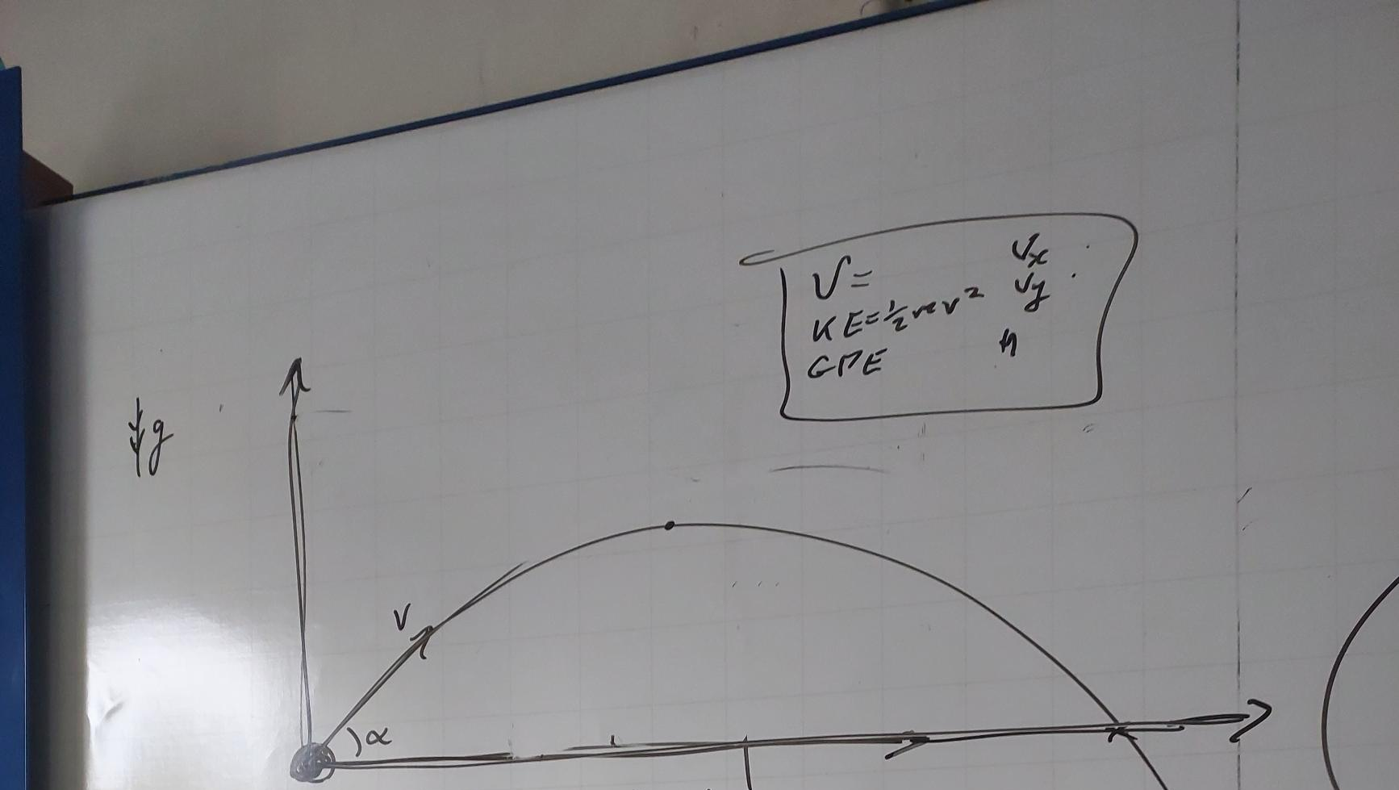

1.3 Prospective user(s)
Mr Robinson is the main prospective user as I am developing the program specifically for him. Additionally, he walks through the complex A Level topics and gives them proper Further Math questions.
But as this program is also for students, meaning it could be shared with them by Mr Robinson via School Website (Firefly) or Email, so they can use it at home and have a little play around the physics.
Main use case is displaying on the big board in the centre of the class via projector or on a computer screen.

1.4 Proposed solution
Program that starts on the user`s computer that produces interactable physics engine. All school computers have only 60 Hz refresh rate so the lowest limit for the frame rate should be 60 per second, as this program should be optimised enough to sustain 60 FPS at a school computer. As it will be used at school at school computer the program needs to be preinstalled and the all the libraries should be default, therefore I will be using Python with PyGame.
From interview with Mr Robinson, I understood that I must create three main simulations as these are the most problematic questions for students. As well as smooth graphics he wants to be able to stop, slow down and restart the simulation and change inputs for the objects and environments.
Simulations:
- Friction Simulation
- Rebounds Simulation
- String Simulation
All these simulations must have understandable UI for both teacher and students.

1.5 Process diagram
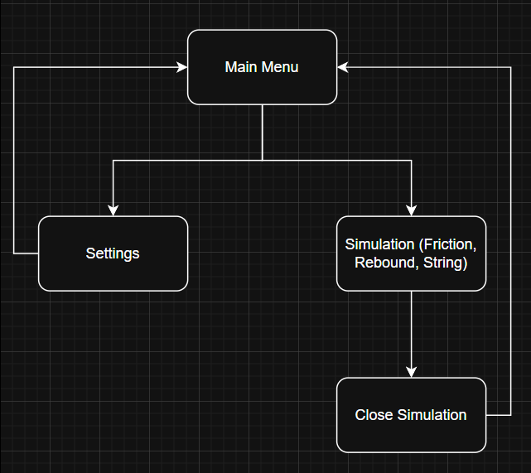
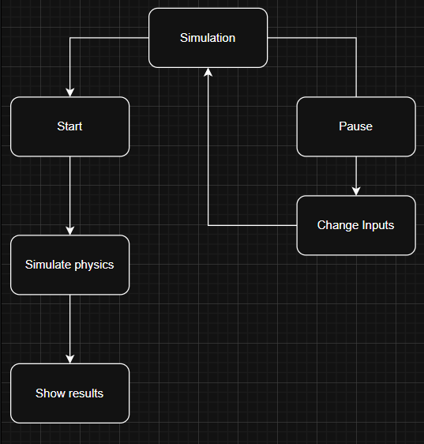

1.6 Data flow diagram
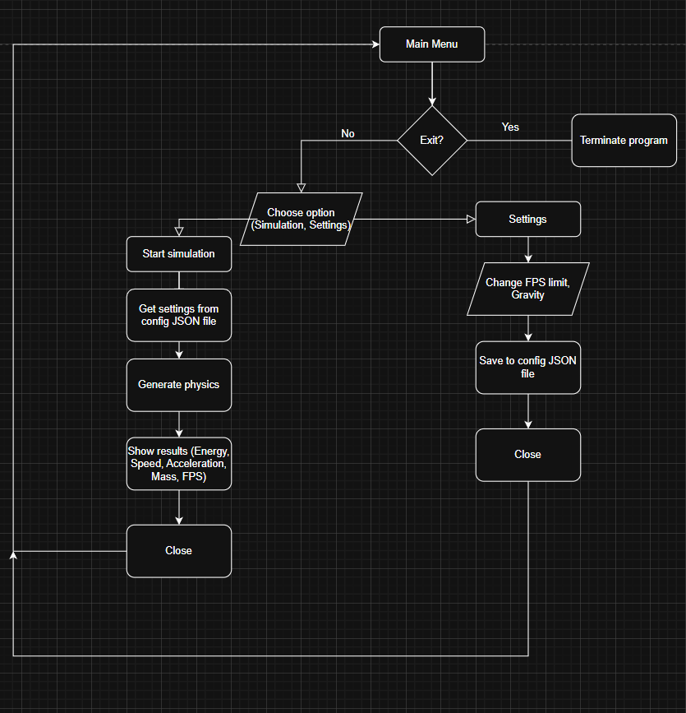

1.7 Acceptable limitations
After discussion with Mr Robinson, we came up with these limitations, as this is essentially a simple educational program for A Level Further Math Mechanics course:
Simple pygame graphics
Moving objects are circles with centre of mass in the centre of the circle
Program window resolution is 1280x720 pixels
No air resistance
No static friction for friction simulation
No mass for string for string simulation
Maximum of three particles for rebound simulation
Maximum of three strings for string simulation

1.8 Objectives
1. Create correct render of events and mathematically correct physics that are rendered smoothly and calculated correctly regardless of FPS using separate PHYSICS_FPS.
2. Create intuitive UI so the user can change most of the inputs and interact with the simulation.
1. Adding objects
2. Deleting objects
3. Changing parameters of the objects
4. Change parameters of the simulation
5. Change pace of the time
3. Create three separate simulations with proper rendering and physics calculations with separating visual and physical calculation
1. Friction simulation
1. Create moving of the object along the plane that is rotated by a certain angle with acceleration calculated using components of the weight of the object and friction coefficient the is decelerating the object.
2. Rebounds simulation
1. Create moving of the objects (max of 3) in the space with correct rebounds from surfaces and other moving objects with changeable elasticity of collisions.
2. Bonus objective is to create a rebounds between objects.
3. String simulation
1. Create moving of the object that is hanging from the string with changeable natural length and modulus of elasticity via calculating the tension that is produced by the string.
4. Correct calculation of gravity, friction, speed, acceleration, energy and etc. via SUVAT equations and other math formulas.
5. Displaying program calculations results and simulation state with time scaling:
1. Friction simulation: velocity, acceleration of the object, plane angle, friction coefficient and mass of the object
2. Rebound simulation: for every moving object it`s velocity, energy, height from the ground and mass
3. String simulation: for every string it`s tension, extension, elastic potential energy; for moving object velocity, acceleration and mass
6. Create pause/resume, time scale feature for every simulation.
7. Create saveable parameters that are shared for all three simulations: FPS, PHYSICS_FPS, GRAVITY.
8. Trail of objects for rebound and string simulation so the user can see how object was travelling in space.
9. Create correct separation of logical and physical calculations of positions of objects in space.
10. Create clear visuals so the user understands what happens to the objects on the screen.
11. Create menu from where user can change FPS and gravity for the simulation and start simulations.

1.9 Evidence of analysis
Log of my interview with Mr Robinson:
Q: How accurate does the physics need to be?
Ans: “It needs to match A-Level specification exactly - so coefficient of restitution formula, μF for friction, Hooke's Law. But we can simplify air resistance isn't in Further Maths spec, so ignore it. Focus on getting the core mechanics perfect rather than adding lots of elements.”
Q: What about usability for students?
Ans: “Keep it simple. Big buttons, clear labels. Instructions and settings menu on the side of the screen.”
Q: What features would make this useful in your classroom?
Ans: "Ability to pause and step through frame-by-frame would be essential - I need to explain what's happening at key moments. Also, displaying the actual force vectors and energy values on screen, not just showing the motion. Students need to see the numbers matching their calculations."
Q: What specific topics do your students struggle with most in mechanics?
Ans: “Definitely friction on slopes and collision problems. Students can plug numbers into formulas but don't understand why objects slide at certain angles or how energy is lost in collisions. They also struggle with understanding where object is travelling so trail and arrow with direction of motion would help enormously.”
Books:
See references 3. And 4.

Mathematical formulas that I will use to calculate physics include:
Energy calculation formulas:
KE = 0.5mv^2 where m=mass, v=velocity
GPE = mgh where m=mass, g=gravity, h=height
EPE = 0.5kx^2 where k=spring constant, x=extension of the string
F=ma where m=mass, a=acceleration
Conservation of linear momentum
Tension in string F=kx
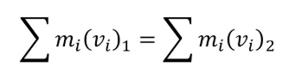
SUVAT equations
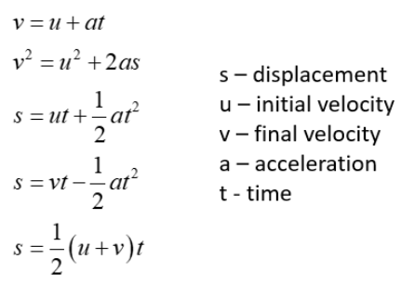
Dot product and vector calculations formulas like scalar multiply or vector addition and etc.
Prototypes of physics calculation
ss
