2. Design

2.1 Overview
Main objective is to create three separate physics simulations with comprehensive UI and changeable parameters and a menu where user can choose to alter general settings of the simulations, like FPS, Gravity or enter one of the three simulations.
In simulation HUD should be displayed in the left side of the screen.
When right clicking the object, settings window should appear in the left side of the screen where user can change parameters of the object and can see the instructions for the specific simulation.

2.2 General system for all simulations
HUD: Should be displayed in the left side of the screen with all relevant information for a specific simulation.
Force driven moving for objects: Object->Force->Acceleration->Velocity->Position
Fixed timestep: timestep is calculated using delta time to maintain the proper work of the simulation and correct physics calculations.
Coordinate System is divided into logical (meters) and visual (pixels) to maintain proper calculations of physics as math formulas mostly use meters for correct calculations.
Frames Per Second are dived into Render FPS and Physics FPS this is an industrial approach that is used by physics engines universally.
Direction vector – an arrow from the centre of the object that show where object is travelling
Moving object – a circular particle with a given radius that is affected by environment
Static object – a rectangular object with a given width and height
The simulations will be created in the way they could explain these questions. (see references 3.)
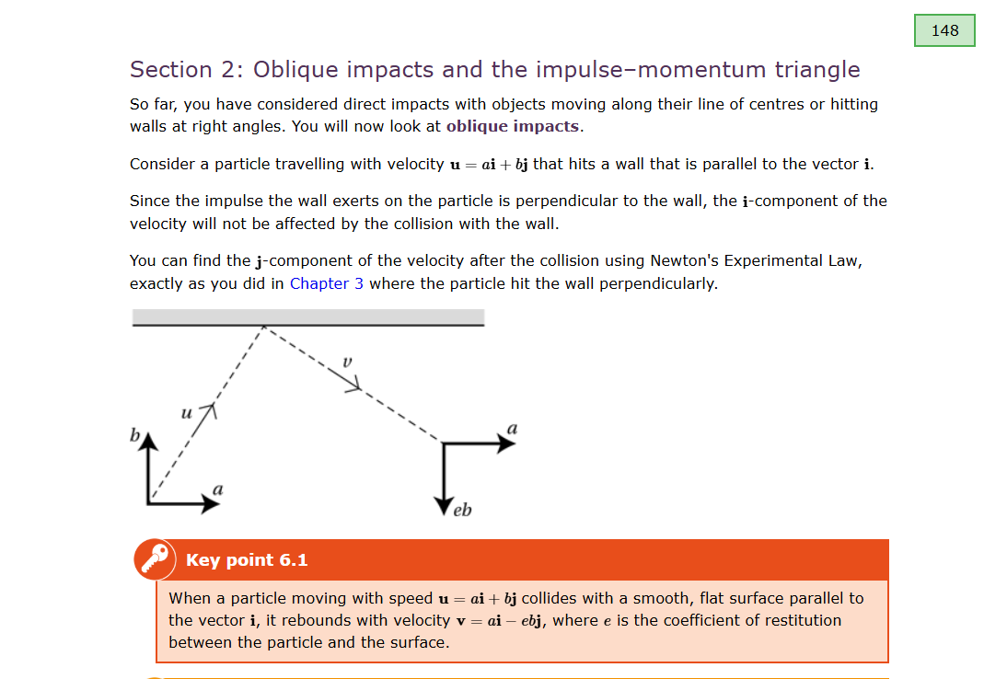
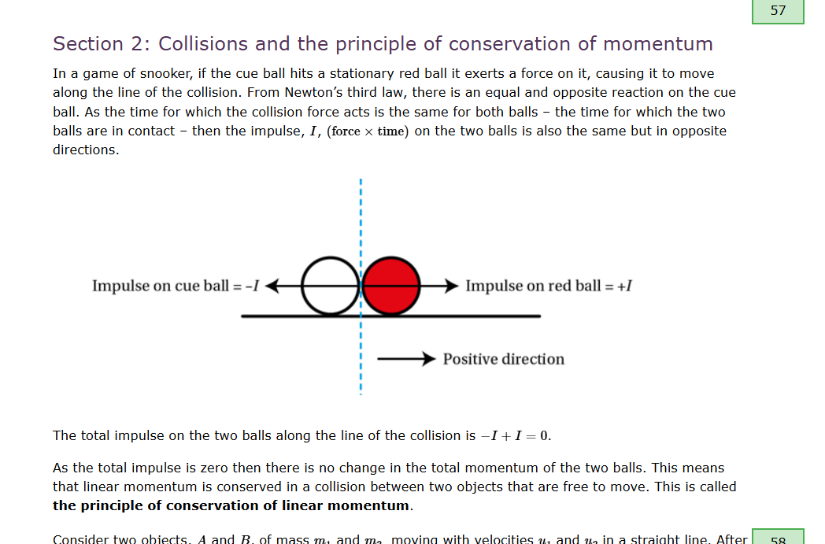
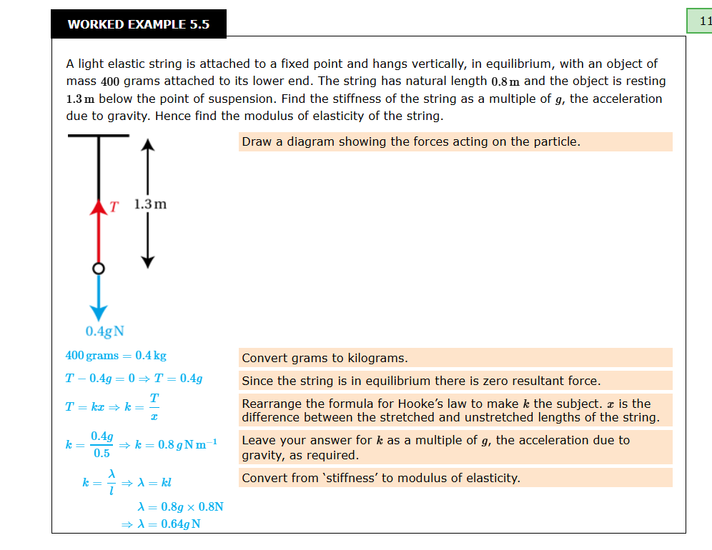
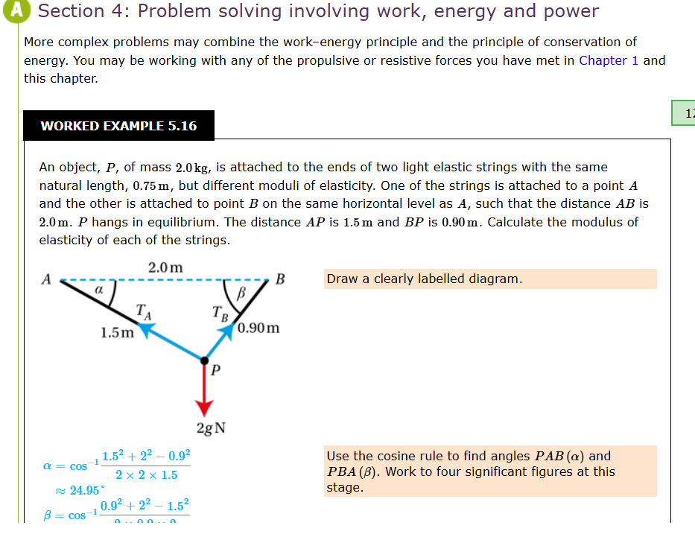
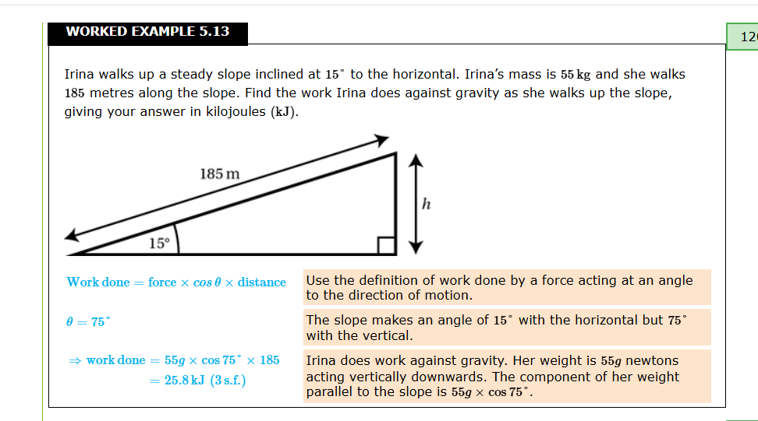

2.3 IPSO Chart
Simulation | Input | Process | Storage | Output
Friction | • Right-click (edit parameters)  • Left-click (Drag-and-drop objects)  • Keyboard (F=pause, R=reset) | • Decompose gravity into components  • Calculate normal force N = mg cos(θ)  • Determine friction F_friction = μN  • Net force F_net = mg sin(θ) - F_friction  • Update physics -> find new position  • Update visual position | • Ball object (position, velocity, mass, radius, velocity)  • Plane angle  • Friction coefficient  • Config file (JSON) | • Rendered plane and object  • Direction vector of moving object  • HUD text (velocity, distance)
Rebound | • Right-click (edit parameters)  • Left-click (Drag-and-drop objects)  • Keyboard (F=pause, R=reset, A=add object, S=delete object) | • Detect circle-circle collisions  • Detect circle-wall collisions  • Calculate impulse J = -(1+e) v_rel_n / (1/m1 + 1/m2)  • Update physics -> find new position  • Update visual position | • Ball objects (position, velocity, mass, radius)  • Wall objects (edges, elasticity)  • Trail points (set of coordinates)  • Elasticity coefficients | • Rendered balls and walls  • Edge normals  • Direction vector of moving object  • HUD (energy, speed)  • Trail points
String | • Right-click (edit parameters)  • Left-click (Drag-and-drop objects)  • Keyboard (F=pause, R=reset)  • Mousewheel input for changing the zoom on to the simulation plane. | • Calculate extension  • Calculate tension F = kx (if x > 0, else string is slack)  • Calculate angle to anchor  • Resolve tension into (F_x, F_y)  • Update physics -> find new position  • Update visual position | • Anchor position of the string (fixed)  • Particle state (position, velocity)  • String properties (Natural length, Elasticity Modulus)  • Camera offset (pixels)  • Trail points | • Rendered balls and strings  • String line (red if extended, blue if slack)  • Direction vector of moving object  • Anchor (green dot)  • HUD (extension, tension, period)  • Trail points

2.4 Menu
I want to create a simple menu where you can choose simulation and change general settings of the simulations – FPS and Gravity.

2.4.1 Settings
FPS for simulations can be changed.
Gravity for simulations can be changed.
When settings are saved, program is restarted to ensure that settings are applied correctly.
When simulation is chosen, menu closes. Every simulation should have a button to return to Menu.
Refresh rate for menu is 60 FPS.

2.4.2 Launcher.py
Core of the program that starts the menu from where the simulations and settings can be entered.

2.4.3 Main_menu.py
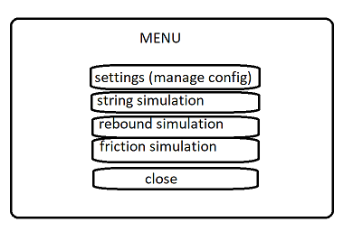
Has buttons of simulations, settings and exit from the program. Settings are opened in the left side of the menu where FPS and Gravity for simulations are entered, when user saves changes program is restarted via subprocesses to ensure that settings are applied correctly. Simulations are started via subprocesses to not mess up the pygame window logic.
Restart: subprocess.run([sys.executable] + sys.argv)
Simulation start: subprocess.run([sys.executable, str(simulation)]) where simulation is absolute path to file of the simulation.

2.4.4 Config_manager.py
Manages the config.json file that saves information about screen size, physics for simulations and colors in tuple(r,g,b). It loads, saves and exports data from config.json.

2.5 Simulations
All simulations are rendered with crucial parameter PIXELS_PER_METER to establish correct physics calculation to render on the screen.
X is horizontal, Y is vertical parameters of the simulation.
All simulations should be paused and resumed with F key.
All simulations should be reset with R key.
All simulations should have changeable time scale to slow down or speed up the simulation.
All simulations should have a settings window opened with right click on the object where user can change parameters and a HUD with all needed for that simulation information about moving object.
Friction simulation and Rebound simulation will calculate the position of the moving object using SUVAT equation: s=(v+0.5a*t)*t as the acceleration in those simulations is constant.
String simulation will calculate the position of the moving object using more general equations:
v=a*t, s=v*t
Time for position calculation in all simulations is delta time between frames (1/PHYSICS_FPS).
By default all simulations have moving object present with 0.25 meters radius.
Working areas:
friction simulation -> a plane where object slides
rebound simulation -> area between walls that are on the sides of the screen
Trail of moving object in rebound and string simulations is created to keep track of movement of an object in space, it is processed by adding a point into set of points at every frame of the simulation.
In all simulations should be a exit button that exits the simulation and opens the main menu.
As I want to create drag-and-drop and settings window opening feature for particles (moving object and string) and strings they need to have a click_hitbox, which then can be used to process if user has clicked on an object. Click_hitbox will be a largest inscribed square into circle as moving object and string anchor are circles.
Left click -> move object. Right click -> open settings.

2.5.1 Objects.py
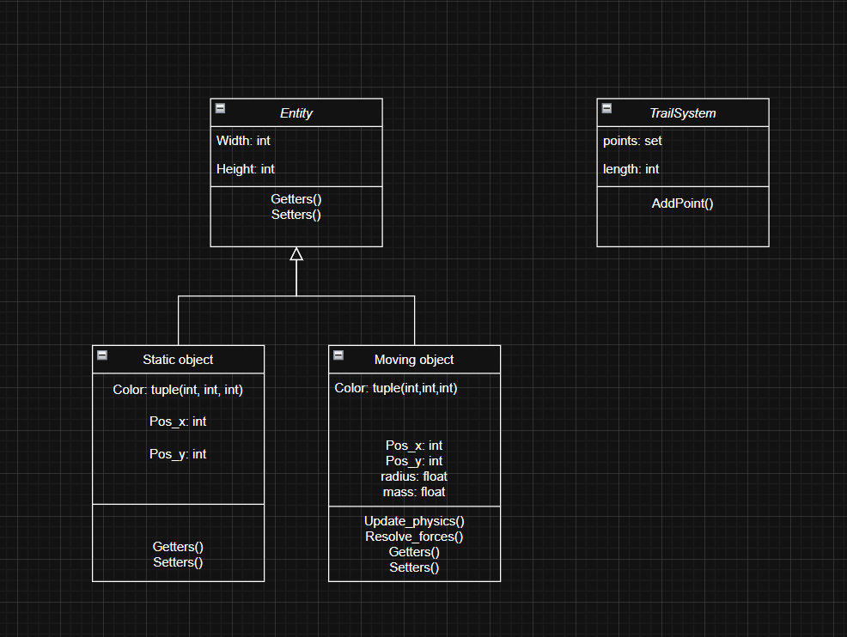
All moving objects in simulation have division of position into logical and actual on the screen. They have sync_to_visual methods, update_visual_position to synchronize the logical and actual position on the screen.
LOGICAL = ACTUAL/PIXELS_PER_METER

2.5.2 Main.py
In all simulations there will be a close button, default objects that are present and a main loop that handles the pygame window (drawing, refreshing).
Main loop has a default pygame event loop that processes user inputs and a physics loop that processes physics for the objects in the simulation.
Mymouse.py
A simple file that gives sensible names to pygame functions for mouse press and mouse position on the screen. Also it has a draggable_object that stores the object that was clicked by user to move it:
pygame.mouse.get_pressed(num_buttons=3)[0] where index is a button pressed – lmbn is 0, mwb is 1 and rmb is 2.

2.5.3 Ui.py
This file in all simulations is responsible for creating a window on the right side of the screen when user clicks on an object which parameters can be altered or if nothing was clicked it opens a settings menu for current simulation. It also provides necessary instructions for current simulation.

2.6 Friction Simulation
Friction simulation should have a plane with changeable angle of inclination, surface friction and a moving object that moves on the plane due to gravity with given velocity, acceleration (or deceleration if friction is greater than gravity component).
I am not going to simulate the direct contact with the surface, instead I will just simulate the direction of movement of an object above the rotated plane under it.
Plane can be turned from -90 to 90 degrees as only for these values’ friction is appliable. Essentially if there is no normal reaction to the plane there will be no friction.
To ensure that object is always visible on a plane I will set it to the start of the plane when it reaches the end of the plane.
HUD:
- Current FPS
- Physics FPS
- Distance travelled
- Velocity X, Velocity Y
- Acceleration X, Acceleration Y
- Mass of the object
- Friction coefficient
- Angle of the plane

User inputs:
- Moving object: mass, velocity along the plane.
- Simulation: time scale, angle of the plane, coefficient of friction of the plane.
Physics:
Decompose weight of the object into components: parallel to the plane, perpendicular to the plane.
Find normal reaction -> weight_perpendicular*cos(angle)
Find force parallel to the plane that creates acceleration for the object downwards-> weight_parallel*sin(angle)
Find friction force parallel to the plane that creates deceleration for the object -> coeff_of_friction*normal_reaction
Friction force is only applied if the object is moving.
Object velocity is rounded to zero when it decreases to small values(<0.1) to prevent infinite movement.

2.6.1 Friction.py
Has friction_manager class that calculates the physics for the simulation.

2.6.2 Object.py
Static object has _compute_edges method to find corners and edges of the rotated rectangle
https://stackoverflow.com/questions/41898990/find-corners-of-a-rotated-rectangle-given-its-center-point-and-rotation

2.6.3 Main.py
Also has helper function to place object directly on the plane and functions to ensure that objects always stays on the plane.
Get_closest_point_on_line
Set_object_on_plane
Check_border_collision
Set_object_before_plane this function is called when object hits the border to be moved to opposite border.

2.7 Rebound simulation
Rebound simulation will have 4 walls at the sides of screen with an inputted elasticity coefficient by user; moving object that is affected by gravity and inputted horizontal and vertical velocity. Impulse of collisions of objects (maximum of 3) between each other will be calculated and applied to objects to simulate real life behaviour. Objects can be added and deleted by user.
HUD:
  - Current FPS
  - Physics FPS
  - For every object:
    - Distance travelled
    - Velocity X, Velocity Y
    - Mass of the object
    - Height in meters from the ground
    - Kinetical Energy
    - Gravitational Potential Energy
User inputs:
- Moving object: mass, velocity x, velocity y, radius
- Simulation: time scale, mode (1D or 2D, 1D=no gravity), elasticity of borders, elasticity of collisions between moving objects

Physics:
Moving objects are affected by gravity (downwards acceleration).
Collisions between objects (circular particles)
Checking:
- Check for collision: dist < r1 + r2 (dist = distance between centers of the circles)
Resolving:
- Prevent duplicate resolution by tracking already resolved collisions
- Calculate collisions normal: (c2-c1) / dist
- Calculated relative velocity of objects along the normal: v_rel_along_normal =dot_product( (v1 - v2) normal)
- Calculate Impulse of the collision with velocity along the normal and elasticity coefficient: J = -(1 + e) * v_rel_along_normal / (1/m1 + 1/m2)
- Apply impulse to both objects:
New_v1 = v1 + (J/m1)*normal
New_v2 = v2 + (J/m2)*normal

Collisions with surfaces:
Checking:
- Check if the object has hit the wall via dot product of velocity and normal
Resolving:
1. Calculate Impulse with normal of the wall and elasticity coefficient
- Apply impulse to the moving object

References where I got the general idea of resolving forces for rebound simulation:
https://www.physicsforums.com/threads/calculating-impulse-due-to-rigid-body-collision-with-friction.186335/
https://www.damtp.cam.ac.uk/user/reh10/lectures/ia-dyn-chapter5.pdf
https://www.gamedev.net/forums/topic/465248-calculating-impulse-due-to-rigid-body-collision-with-friction/
https://en.wikipedia.org/wiki/Impulse_(physics)
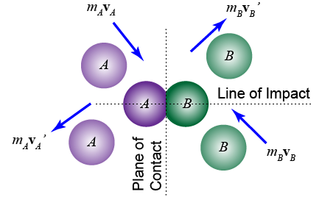
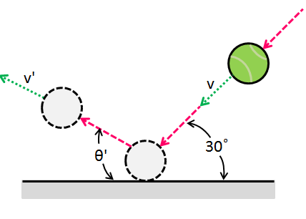
Picture references:
See references 1. And 2.

2.7.1 Vectors.py
This file has necessary math operations to calculate vectors:
Dot_product
Vector_add add one vector to another
Vector_subtract subtracts one vector from another
Scalar_multiply multiplies each vector value by a value
Vector_length calculates length of the vector
Distance_between_points calculates distance between points
Normalize _vector normalizes given vector

2.7.2 Collisions.py
Have such functions as get_line_normal and distance_point_to_line.
For collisions it has methods for checking and resolving collisions:
Check_circle_collisions and check_wall_collisions
Resolve_circle_collisions and resolve_wall_collisions

2.7.3 Main.py
Physics loop that is in the main loop of main.py has 5 steps:
1. Check wall collisions
2. Apply gravity if mode is not 2D (1D=no gravity)
3. Update moving objects position
4. Check circle collisions (collisions of moving objects)
5. Check if the moving object is not going to rebound by calculating if the rebound is bigger than a threshold (2 centimetres) if not -> stop the object.

2.8 String simulation
String simulation will have a single moving object attached to a strings (maximum of 3). Tension is calculated using Hooke`s law and T=kx where x is extension in the string and k (modulus of elasticity divided by natural length) is spring constant. Tensions of the strings are combined, and then general force is resolved by moving object. String is assumed to have 0 mass so there is no need to simulate it`s movement. Strings can be added and deleted by user.
HUD:
- Current FPS
- Physics FPS
- For moving object:
  - Distance travelled
  - Velocity X, Velocity Y
  - Acceleration X, Acceleration Y
  - Mass of the object
- For every string:
  - Tension
  - Extension
EPE (Elastic potential energy)
User inputs:
- Moving object: mass, velocity x, velocity y, radius
- Simulation: time scale
- String: natural length, elasticity modulus
- Mouse grab on right click: all objects are translated in reversed direction of user mouse movement.
- Mouse wheel: PIXELS_PER_METER is changed by 5, creating zoom feature.
Physics:
Moving object is attached to string and affected by gravity.
Tension in the string is calculated using Hooke`s law F=kx
x = extension of the string, calculated by taking distance between moving object and string anchor and subtracting natural length of the string: sqrt((x1-x2)**2 + (y1-y2)) – natural_length. If extension is negative then tension is 0 as string becomes slack.
K = spring constant and calculated by dividing modulus of elasticity by natural length of the string. All of these parameters are given by user.

2.8.1 Static objects
This simulation does not have any static objects as there is only moving object hanging from the strings.

2.8.2 Camera
It has new variables and logical that allows user to move the simulations by holding rmb (camera pan) and zoom out/zoom in into simulation by changing the PIXELS_PER_METER variable using the mouse wheel (+5 when scrolled up, -5 when scrolled down).
Positions of strings, trail and moving object are than adjusted by the position of the camera (camera_offset).

2.8.3 Strings.py
Class string that has anchor position coordinates, logical position of anchor coordinates, modulus of elasticity, natural length (length when string is slack), current extension, and a hitbox that is needed to check if the user has clicked on the string. It has relevant methods that allow the program to calculate the tension, extension of the string, and elastic potential energy. All of this information is then displayed for each string, so the user at any given moment could stop the simulation and see what values each string has. Strings can be position via drag-and-drop using lmb. Settings menu is opened by clicking rmb on the string. String can be added by clicking A (maximum of 3 strings) and deleted by clicking S on the string. The colour of the string becomes red when extension is bigger than zero.

