3. Technical Solution
File Name | Purpose | Appendix Number
Config.json | This file stores the parameters for the simulation. | 6.2.4.1
Launcher.py | This file launches the main menu, therefore the root file of the project | 6.1.1
Main_menu.py | This file constructs the main menu of the program where user can press buttons to either:  Start simulation  Open settings and change them  Exit program  When settings are saved program is restarted | 6.1.2
Config_manager.py | This file manages the config by storing and exporting values from config.json file | 6.1.3
Mymouse.py | This file has draggable object that allows, the program to keep track of which object the user is holding | 6.2.0
Friction simulation |  | 6.2.1
Friction.py | This file has friction manager that calculates physics for the friction between plane and a moving object | 6.2.1.1
Main.py | This file has main pygame loop where user inputs and physics of the object on the screen are processed, also has initial instances for the default objects in the simulation | 6.2.1.2
Objects.py | This file has objects classes for simulation. | 6.2.1.3
Ui.py | This file the UI that is called when user clicks rmb on the object. | 6.2.1.4
Rebound Simulation |  | 6.2.2
Collisions.py | This file has functions for calculation the collisions between object-object and object-wall | 6.2.2.1
Vectors.py | This file has functions for mathematical operations with vectors that is used by collisions.py | 6.2.2.5
Ui.py | This file the UI that is called when user clicks rmb on the object. | 6.2.2.4
Main.py | This file has main pygame loop where user inputs and physics of the object on the screen are processed, also has initial instances for the default objects in the simulation | 6.2.2.2
Objects.py | This file has objects classes for simulation. | 6.2.2.3
String simulation |  | 6.2.3
Strings.py |  | 6.2.3.1
Main.py | This file has main pygame loop where user inputs and physics of the object on the screen are processed, also has initial instances for the default objects in the simulation | 6.2.3.2
Objects.py | This file has objects classes for simulation. | 6.2.3.3
Ui.py | This file the UI that is called when user clicks rmb on the object. | 6.2.3.4

3.1 Key algorithms of the parts of the program
To see whole code for this parts of the program use the table above.

3.1 Menu
This part of the program creates a menu from where user can start simulation and change settings for the simulation.

3.1.1 Config_manager.py
Has a fixed screen size and it loads the config from the json file.
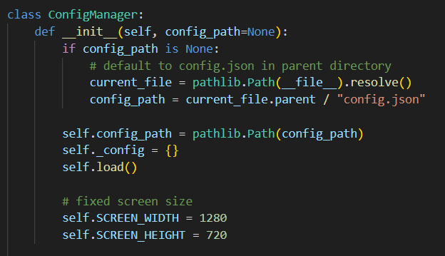
Saving values to json file
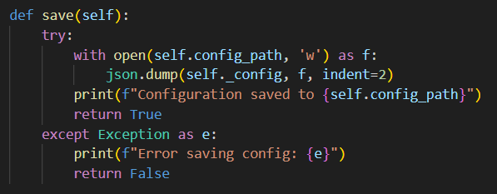

Loading values from json file
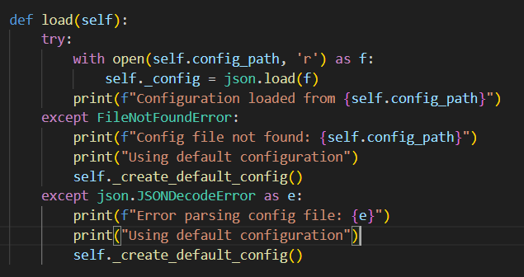
Methods to get/set values of the json file
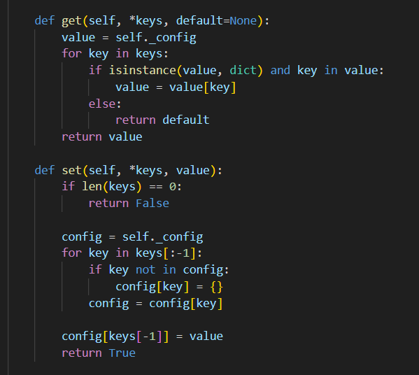
All getters are done this way, it allows the value to be accessed like attribute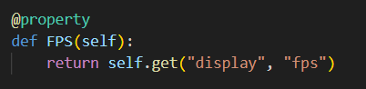
All setters are done this way, it allows the value to be set like attribute
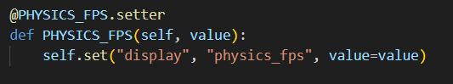

3.2.2 Main_menu.py
Restarting the menu and simulations start are done via subprocess to not mess up the pygame window logic. 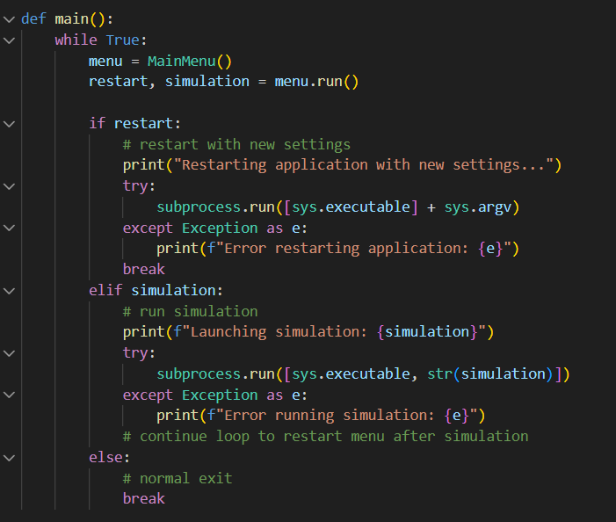

3.2 General Simulations structure

3.2.1 Objects.py
Entity class with height, width being in pixels for pygame
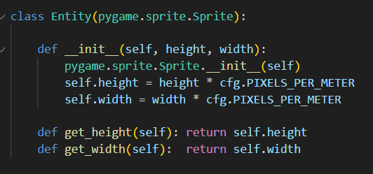

Static object for rebound and friction simulations.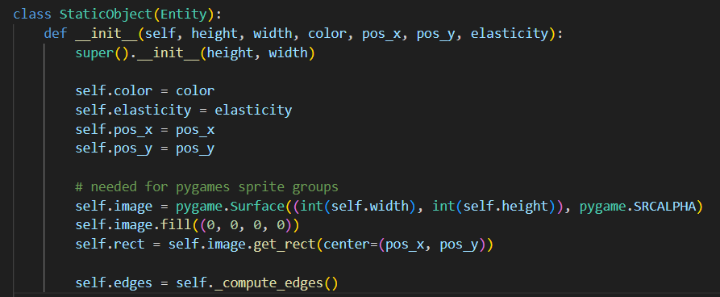
Moving object for every simulation where physics are updated
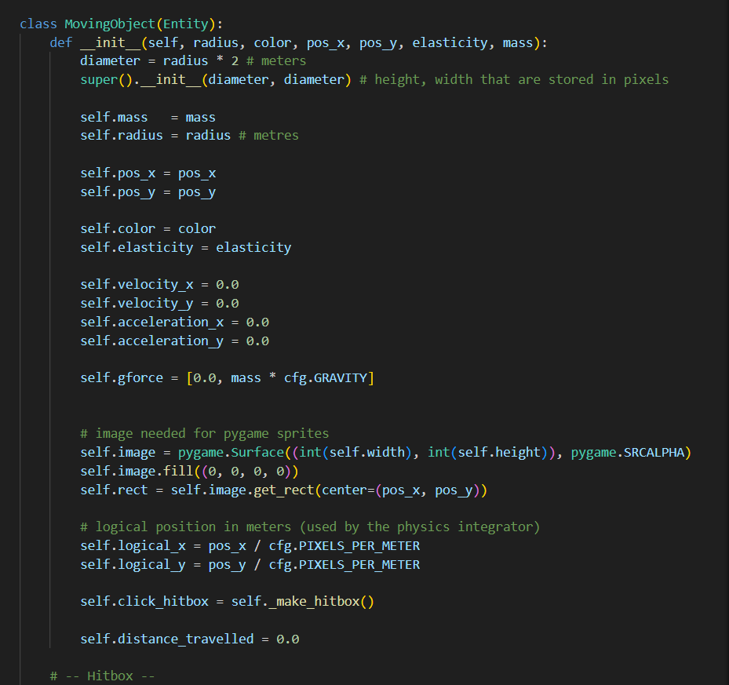

Friction and rebound simulations (constant acceleration)
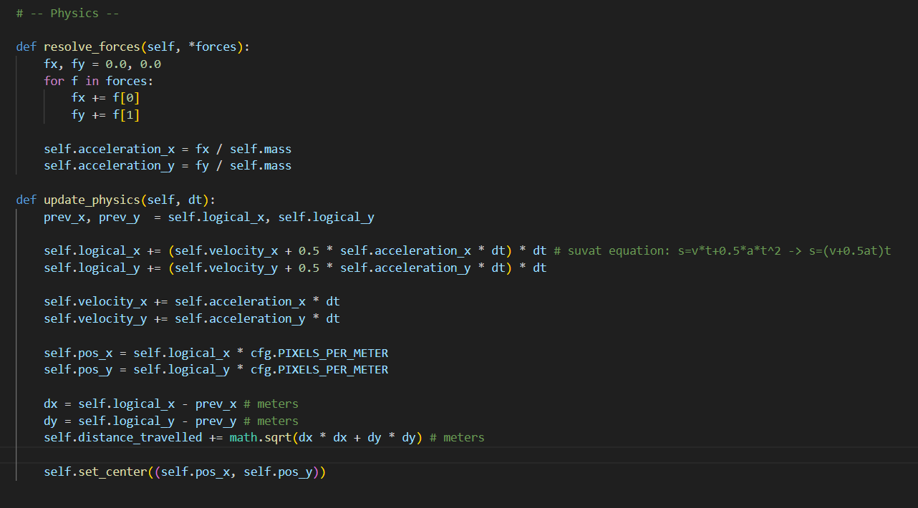
String simulations (non-constant acceleration)
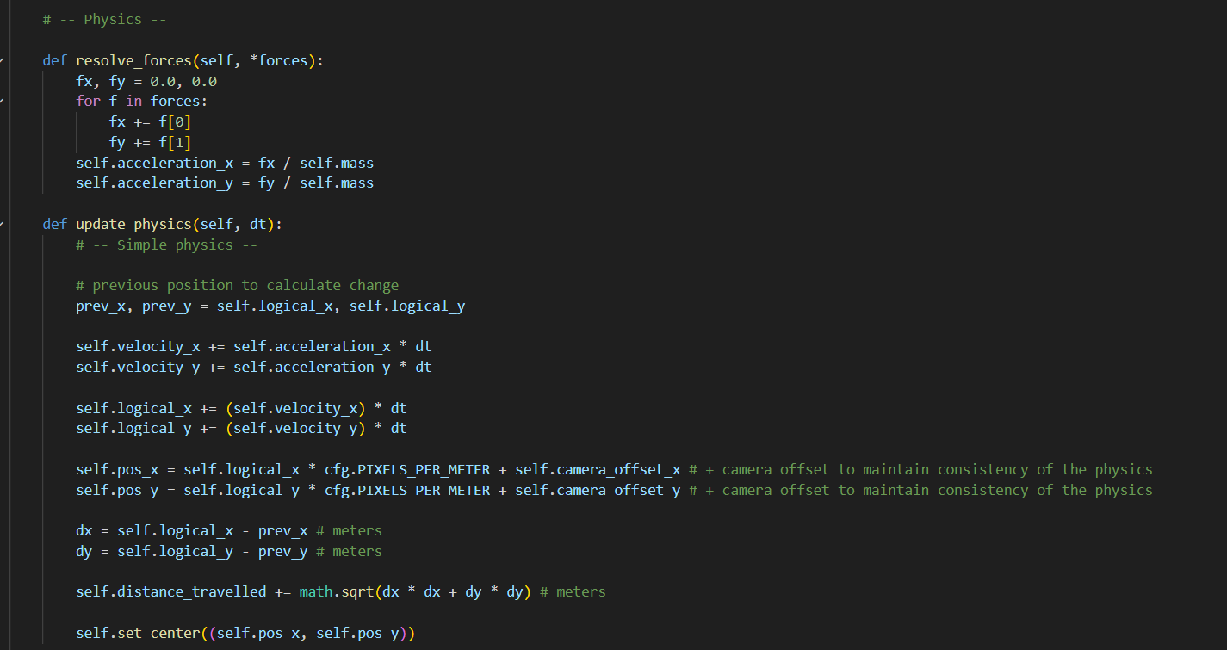

3.2.2 Ui.py
Ui.py in all simulations are done in similar way:
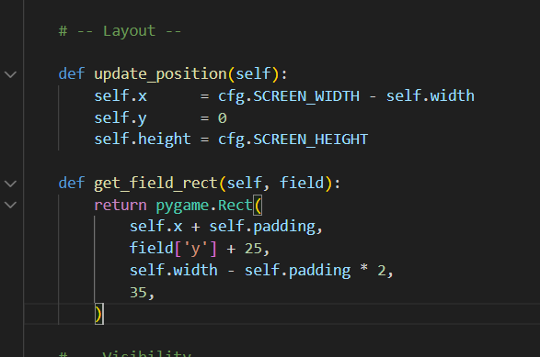

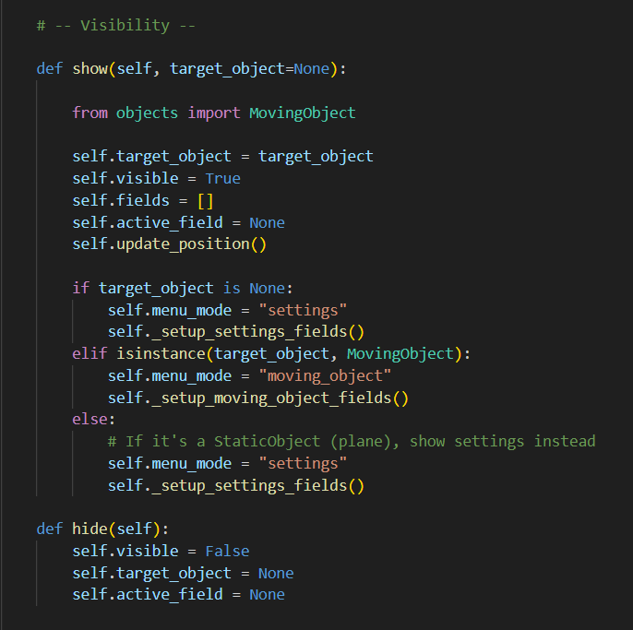
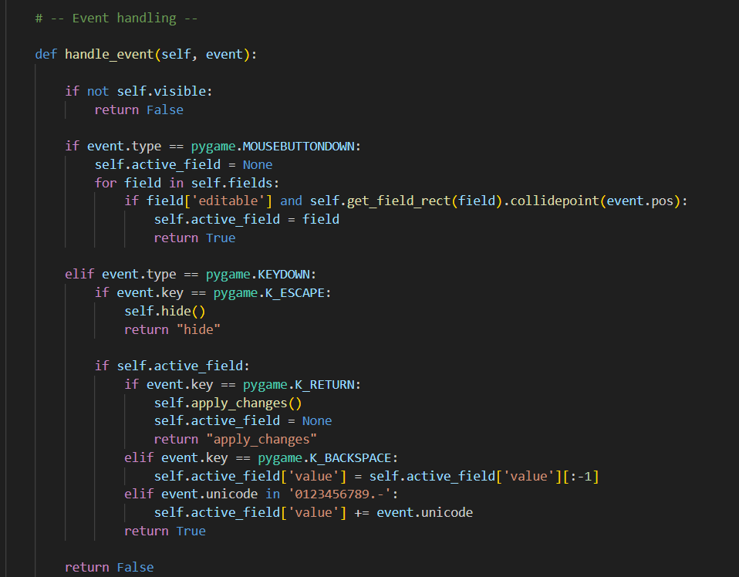
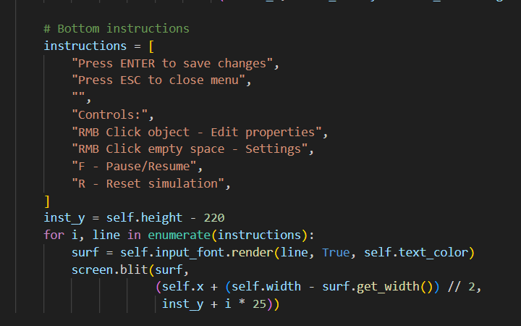
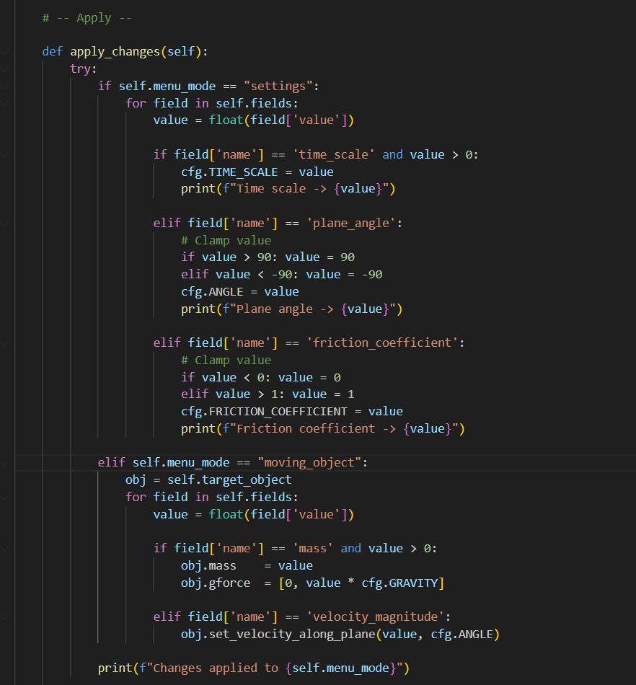

3.2.3 Main.py
All mains have similar structure:

Close button class to return to menu
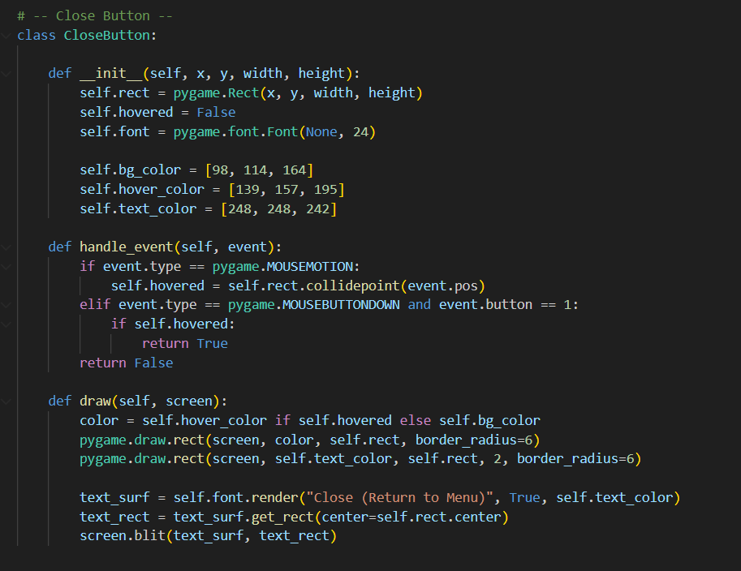
Main loop which draws the window and calculates physics, at the start of each loop time elapsed since last iteration is calculated:
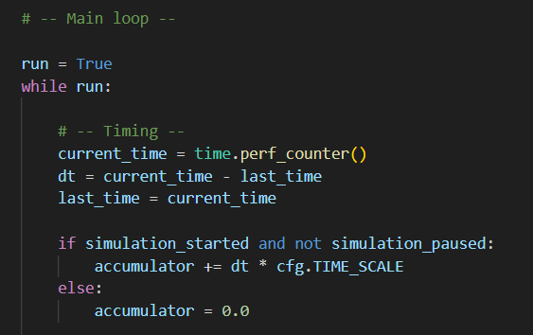
Then there is event loop for user inputs in this kind of structure:
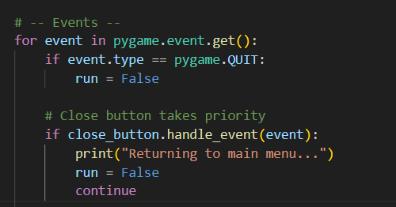
Drag-and-drop on example of friction simulation
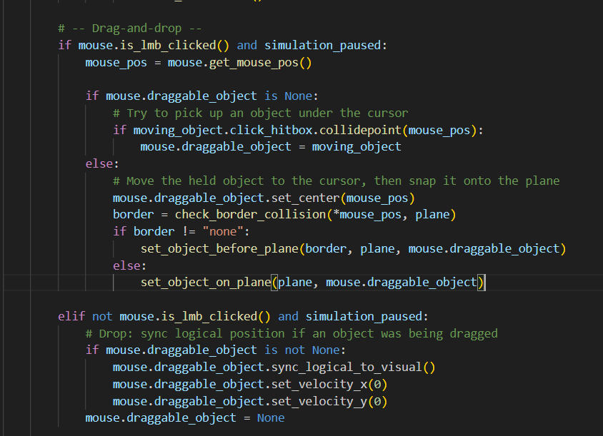
Physics loop inside main loop on example of friction simulation
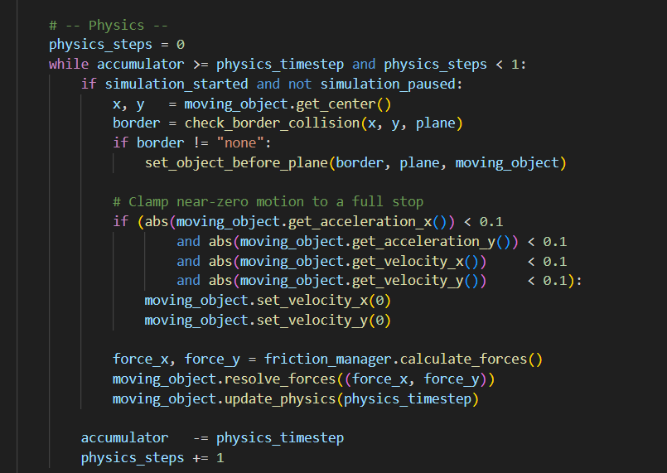
And then render of objects, direction of motion of the object, HUD, UI on the screen:
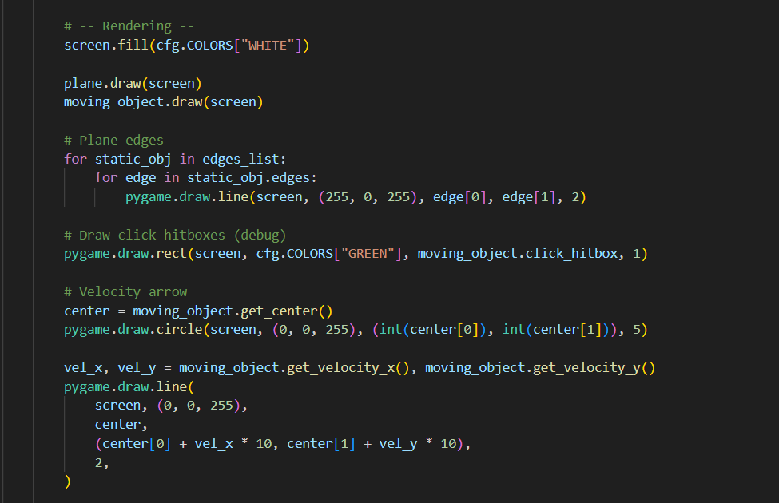
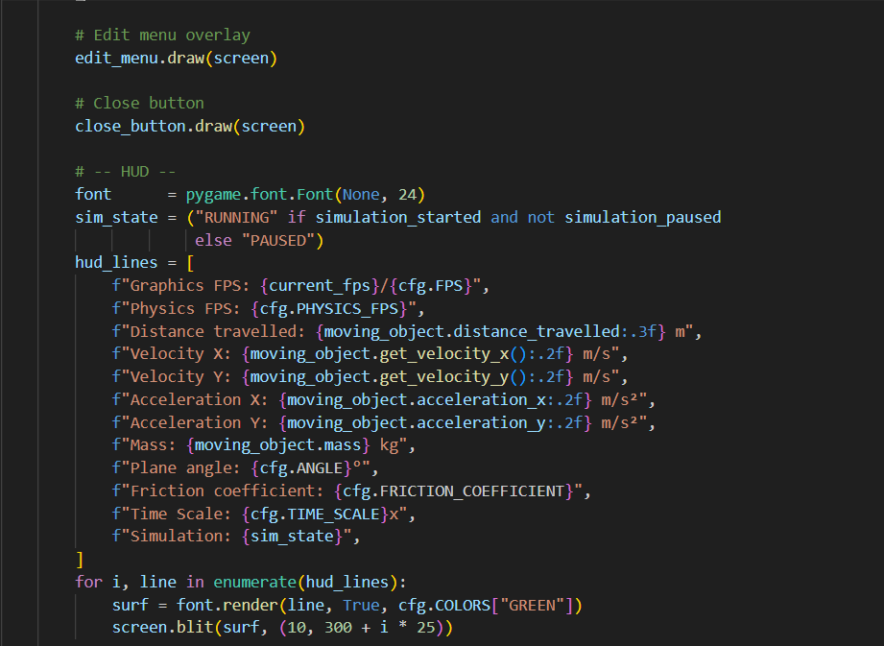
And and fps counter to see the performance of the simulation:
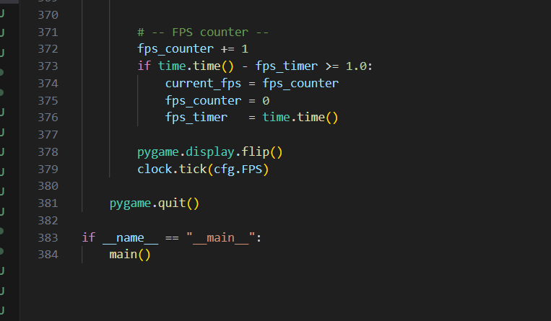

3.3 Friction simulation

3.3.1 Friction.py
This file manages physics for the simulation and calculates acceleration that has to be applied to the moving object.
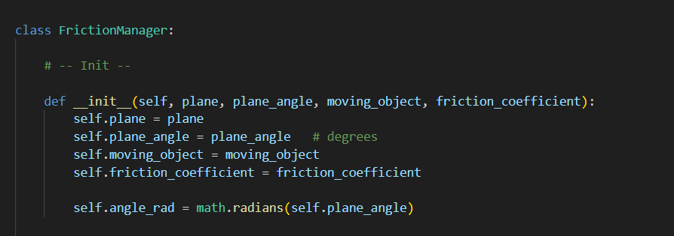
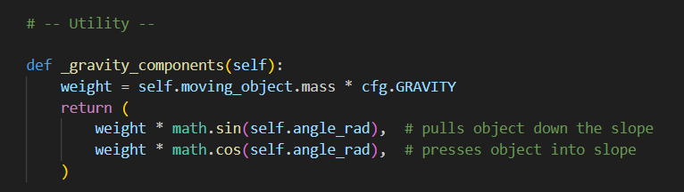
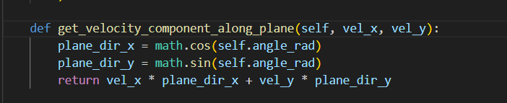
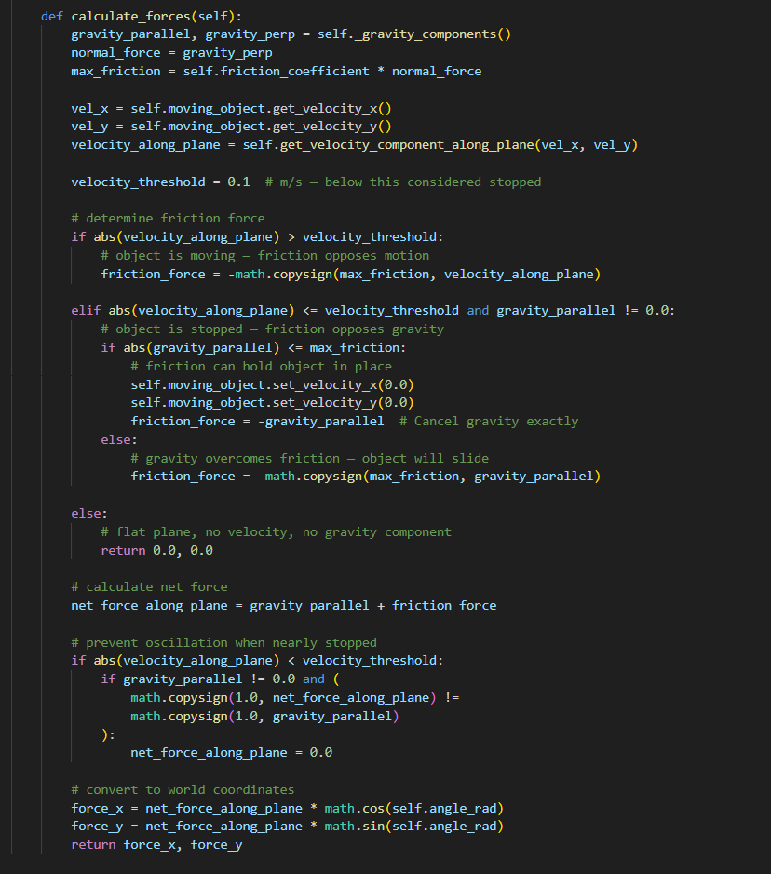

3.3.2 Main.py
Physics application in main pygame loop
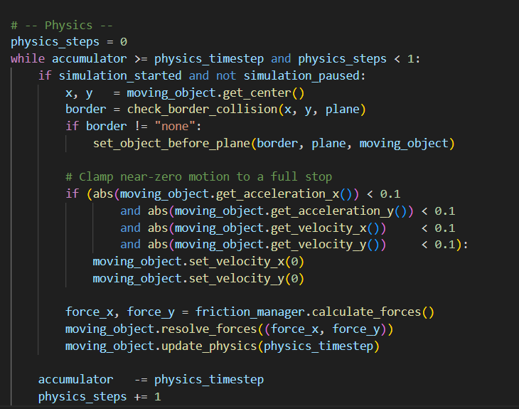

3.4 Rebound simulation

3.4.1 Collisions.py
Geometry helpers functions to help calculate the physics
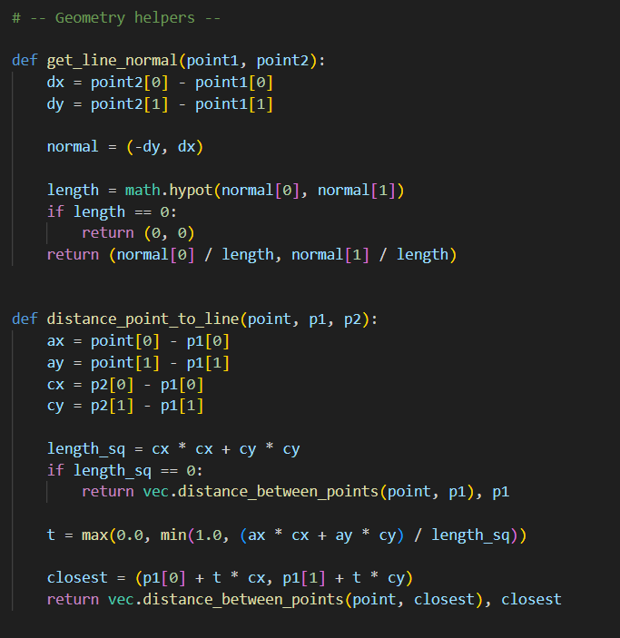

Circle-circle collisions and resolving the collision
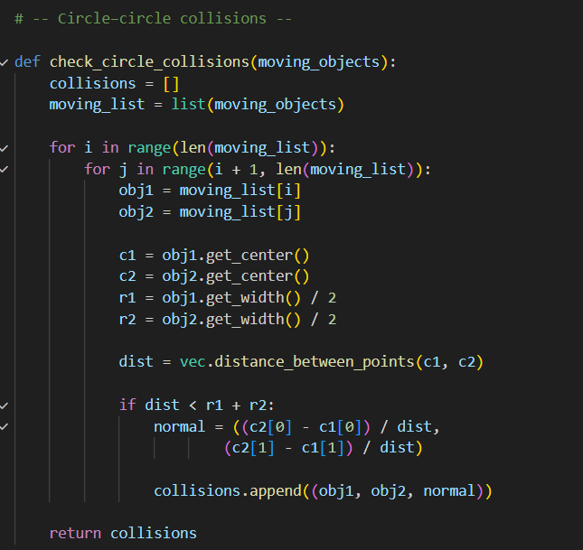

Resolved collisions are stored in a set to prevent resolving them again.
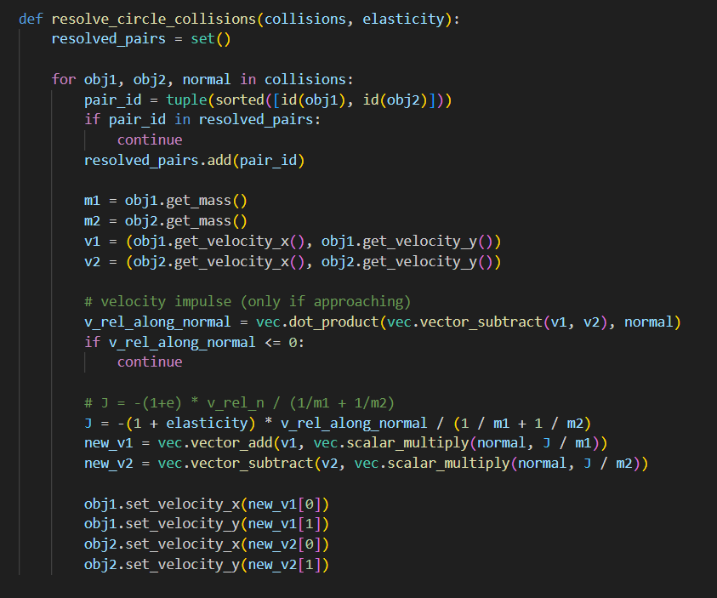

Circle-wall collisions and resolving them
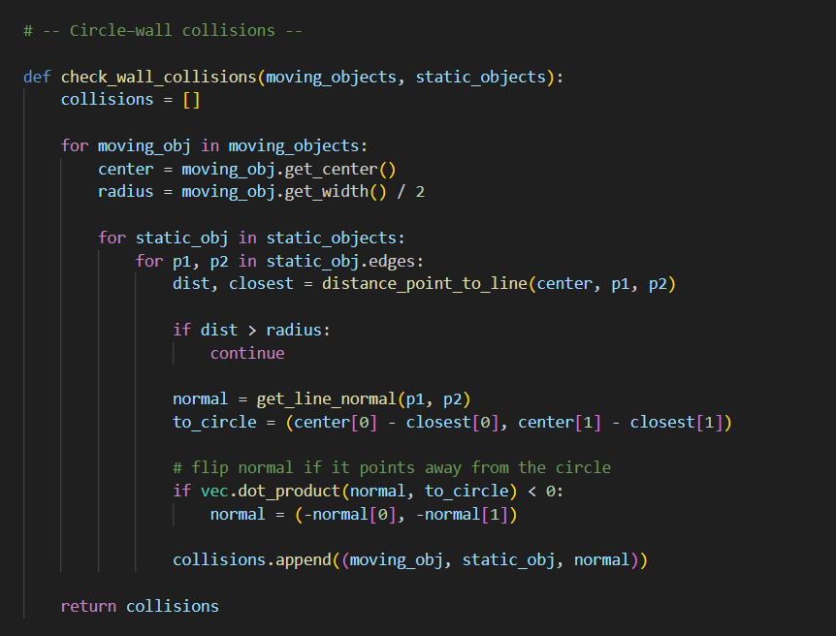
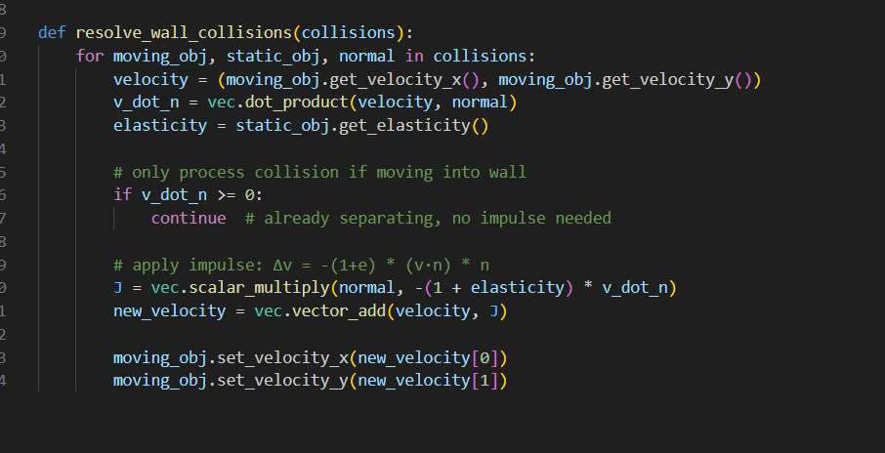

3.4.2 Main.py
Physics loop in main pygame loop that checks for mode of the simulation, checks and resolves the collisions with collisions.py and checks if there is no rebound to stop the simulation.
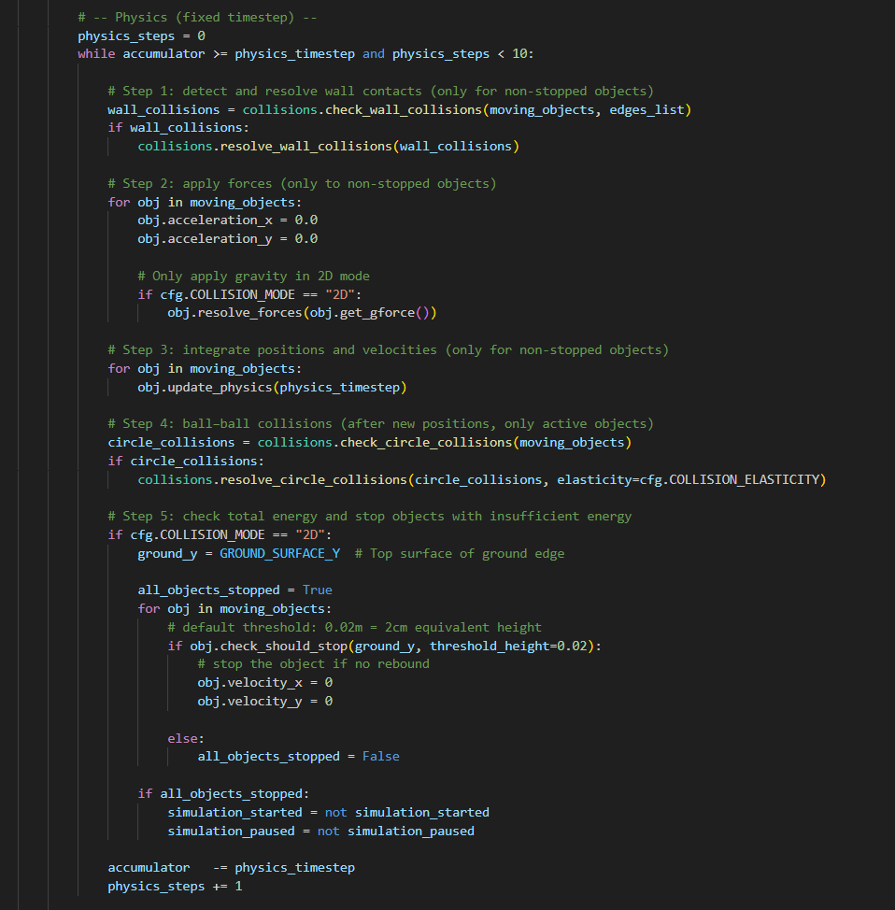

3.5 String simulation

3.5.1 Strings.py
Strings class that creates string object on the screen and calculates physics for the string that is then applied to moving object.
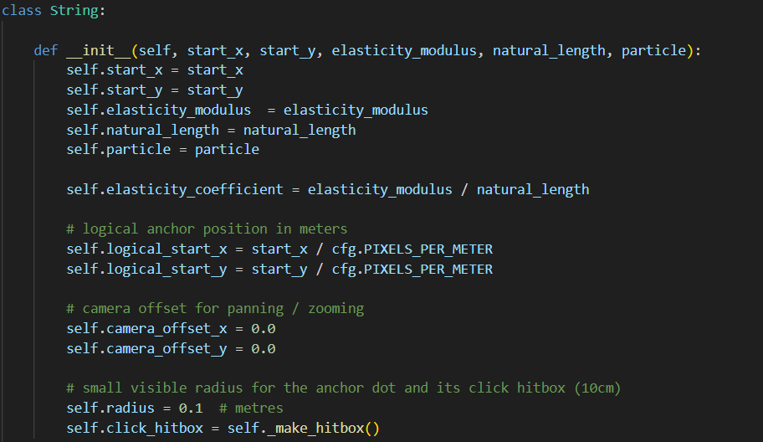
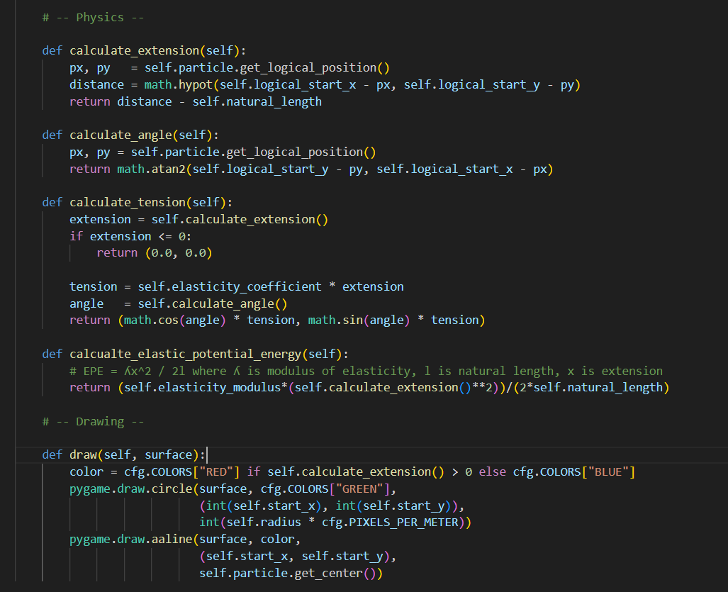

3.5.2 Main.py
Physics in main pygame loop that sums app the tensions from all strings
