Assignment 2
Lei (Raymond) Chi
Both full adders in carry look ahead adder and ripple carry-in adder is set to be #7(7ns) on the assign cout and sum.
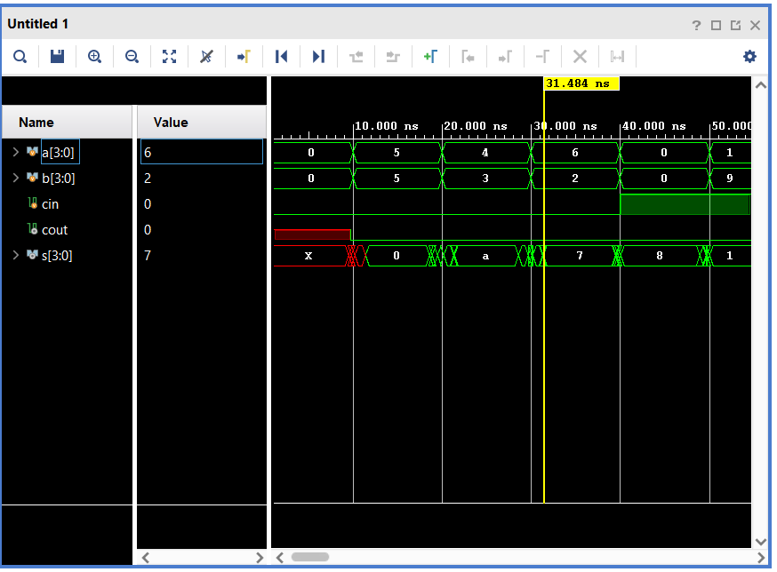
The above is the propagation of ripple carry in adder, as you can see, the delay is around 11.484ns.
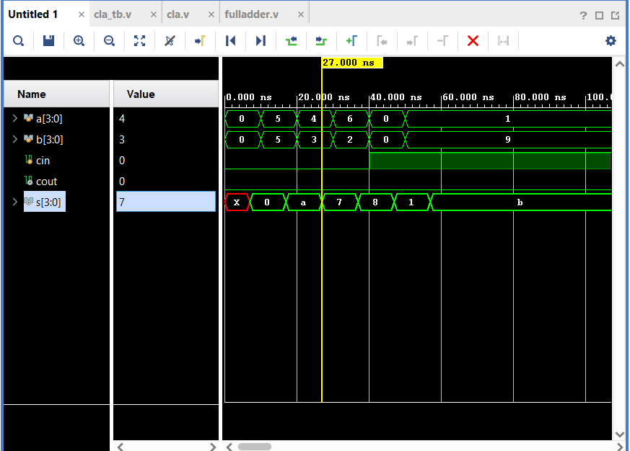
The above is the propagation of carry look ahead adder, as you can see, the delay is around 7ns. 7ns of delay in carry look ahead compared to 11.484 ns, which means carry look ahead adders has a lower delay comparing to ripple carry-in adders.

